**Frequently Asked Question (FAQ)**

**Q1. How we can set our career planning?**

**Answer:** Career planning is a lifelong process, which includes choosing an occupation, getting a job, growing in that job, possibly changing careers, and eventually retiring. This may happen once in our lifetime, but it is more likely to happen several times as we first define and then redefine ourselves and our goals. Effective career planning prepares you for the world of work before you graduate and puts you on the right track as early as your first year.

Four Steps of Career Planning:

* Knowing you
* Exploring options
* Matching with options
* Going for action

You can follow the job search process below to justify your career planning:

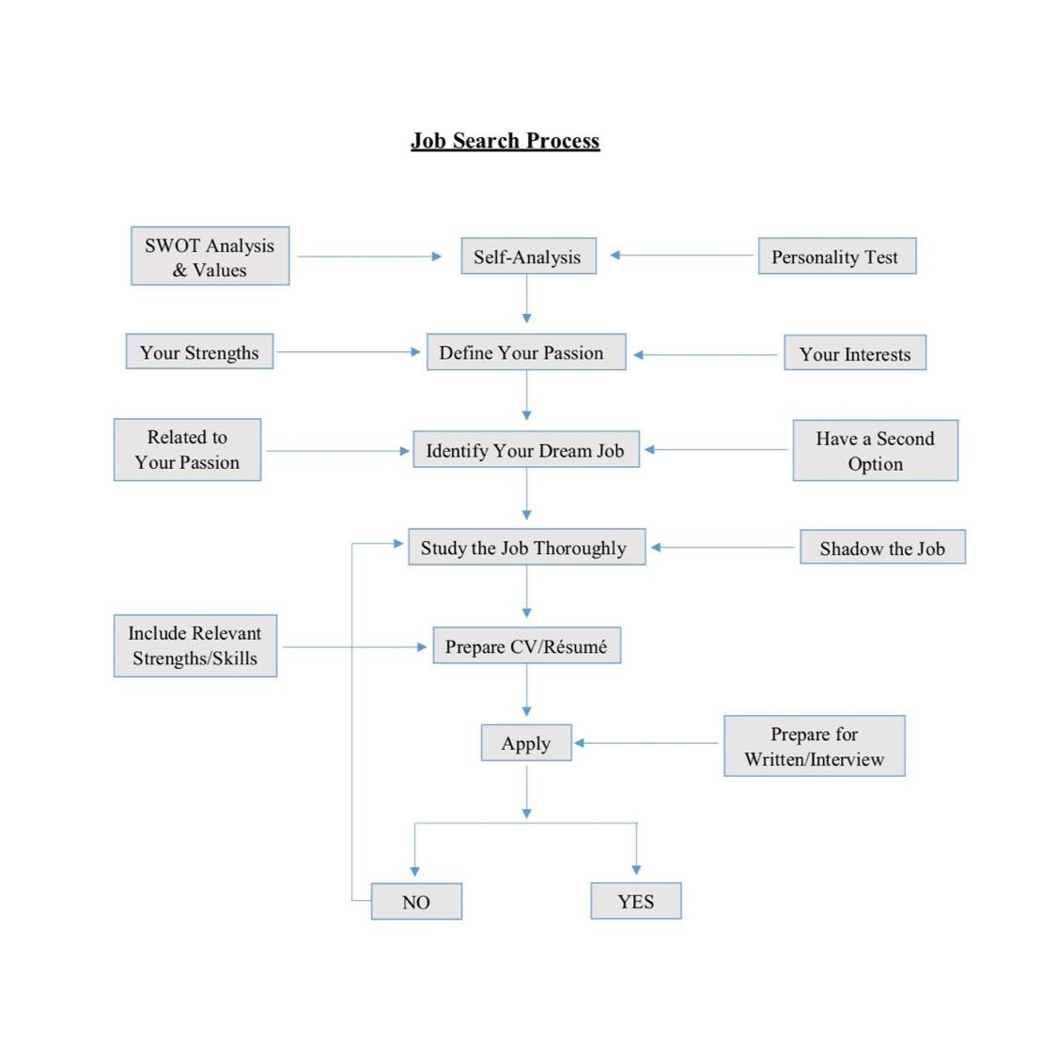

**Q2. How do I select my major?**

Before you select your major at your university you have to do a Market Need Analysis:

Before you can make a career choice you have to learn about yourself. Your values, interests, and skills, in combination with certain personality traits, () will make some careers especially suitable for you and some particularly inappropriate. (Which)

**Self-Assessment:** Self-assessment is the process of analyzing one-self to mine out information about themselves. If you want to plan your career effectively, this should be the first thing you do. A self- assessment should include your interests, values, expertise, personality, skills, and abilities. It should also include your weaknesses. Write them all on a paper so that it can be easier for you to analyse. Here’s an overview of the tools you can use to do your self-assessment.

**Your values:** Values are certain factors that satisfy you in your work and personal life. Examples of these values are higher salary, prestige, work environment, flexible work schedule, helping others, honesty, relationship etc. Find out your values, things that you care about the most. Now align those values with your potential careers.

**Interests:** To find out your interests, you have to list your likes and dislikes. There are certain things that you like and some you hate. Define them properly so that you can you don’t end up choosing a career where you have to do stuff that you don’t like. Examples of interests are reading, swimming, singing, sports, running etc.

**Personality:** Personality is your traits. Things that motivate you to do something. You need and attitudes also fall in your personality. Define your personality properly which will definitely come in handy while doing your self-assessment.

**Skills:** In this section of self-assessment, you have to identify the things that you are good at. There are certain skills that will help you to soar the growth of your career. This will also help you identify things that you enjoy doing. Skills are the most crucial part of your self-assessment.

### Exploring options

After gathering information about yourself you will have some options to start with. It may include different employment outlook, salary or job duties. Explore those options and choose the suitable one.

1. Explore your desired occupations
2. Define related industries and analyze them.
3. Analyze the labor market

### Matching with options

1. Identify feasible occupations
2. Evaluate them
3. Research those alternatives
4. Choose a short-term and a term option

**Q3. What one quality that needs to be present for a good leader?**

**Answer:** Emotional Intelligence (the ability to understand and manage your own emotions, and those of the people around you. People with a high degree of emotional intelligence know what they're feeling, what their emotions mean, and how these emotions can affect other people) is the sine qua non (an essential condition; a thing that is absolutely necessary) of leadership. Without it, a person can have the best training in the world, an incisive, analytical mind, and an endless supply of smart ideas, but he still won’t make a great leader

**Q4. How can I stay focused?**

**Answer:** According to Stephen R. Covey’s ‘7 Habits of Highly Effective People’, habit 3 explains on ‘Put First Things First’. In order to manage ourselves effectively, we must put first things first. We must have the discipline to prioritize our day-to-day actions based on what is most important, not what is most urgent. To maintain the discipline and the focus to stay on track toward our goals, we need to have the willpower to do something when we don't want to do it. We need to act according to our values rather than our desires or impulses at any given moment.

All activities can be categorized based on two factors: Urgent and important. Take a look at this time management matrix:

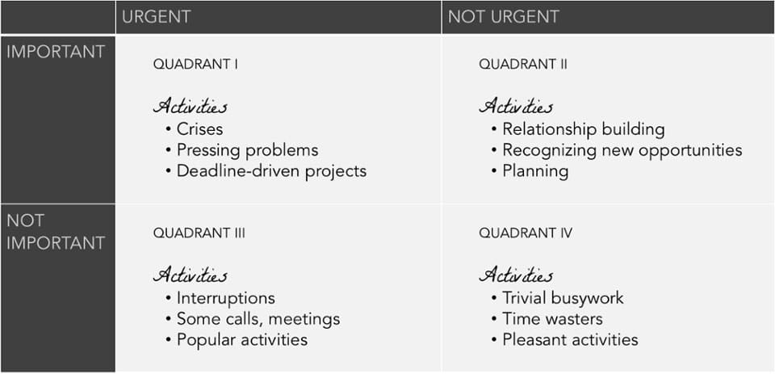

We react to urgent matters. We spend our time doing things that are not important. That means that we neglect Quadrant II, which is the actually most crucial of them all.

**If we focus on Quadrant I** and spend our time managing crises and problems, it keeps getting bigger and bigger until it consumes us. This leads to stress, burnout, and constantly putting out fires.

**If we focus on Quadrant III**, we spend most of our time reacting to matters that seem urgent, when the reality is their perceived urgency is based on the priorities and expectations of others. This leads to short-term focus, feeling out of control, and shallow or broken relationships.

**If we focus on Quadrant IV,** we are basically leading an irresponsible life. This often leads to getting fired from jobs and being highly dependent on others.

**Quadrant II** is at the heart of effective personal management. It deals with things like building relationships, long-term planning, exercising, and preparation -- all things we know we need to do but somehow seldom get around to actually doing because they don't feel urgent.

In order to focus our time in Quadrant II, we have to learn how to say "no" to other activities, sometimes ones that seem urgent. We also need to be able to delegate effectively.

Plus, when we focus on Quadrant II, it means we're thinking ahead, working on the roots, and preventing crises from happening in the first place! This helps us implement the [**Pareto Principle**](https://betterexplained.com/articles/understanding-the-pareto-principle-the-8020-rule/) -- 80% of your results come from 20% of your time.

We should always maintain a primary focus on relationships and results, and a secondary focus on time.

**Q5. How do I set my goal?**

**Answer:** Before setting GOAL, we have to understand the term GOAL (Goal setting involves the development of an action [plan](https://en.wikipedia.org/wiki/Plan) designed to [motivate](https://en.wikipedia.org/wiki/Motivate) and [guide](https://en.wikipedia.org/wiki/Guide) a person or group toward a [goal](https://en.wikipedia.org/wiki/Goal). Goal setting can be guided by goal-setting criteria (or rules) such as [SMART criteria](https://en.wikipedia.org/wiki/SMART_criteria))

What is SMART Goal?

Goals are part of every aspect of business/life and provide a sense of direction, motivation, a clear focus, and clarify importance. By setting goals for yourself, you are providing yourself with a target to aim for. A SMART goal is used to help guide goal setting. SMART is an acronym that stands for Specific, Measurable, Achievable, Realistic, and Timely. Therefore, a SMART goal incorporates all of these criteria to help focus your efforts and increase the chances of achieving that goal.

SMART goals are:

* Specific: Well defined, clear, and unambiguous
* Measurable: With specific criteria that measure your progress towards the accomplishment of the goal
* Achievable: Attainable and not impossible to achieve
* Realistic: Within reach, realistic, and relevant to your life purpose
* Timely: With a clearly defined timeline, including a starting date and a target date. The purpose is to create urgency.

**Q6. What are the skills needed for the 21st Century job market?**

**Answer:** Foundations skills are the basic skills that are required to show high performance in the workplace. In the age of globalization, competitions are soaring high. Everything is changing. To cope up with the change you have to stay updated. Soft skills are taking over the hard/physical skills. Here are few of the foundation skills that will help you to keep moving forward.

There are four groups of Foundation Skills:

* Basic skills
* Thinking skills
* People skills
* Personal qualities

# Basic skills

Reading: Reading is the best way to gain knowledge. This is a skill that not many people have. Most of the successful people have the habit of reading a lot. You must build that habit too. Reading will provide you with materials and knowledge about the unknown.

Writing: Writing is another basic skill that is a must. You have to write reports, emails, journals, and drafts every once in a while, in your career and personal life. Practice writing properly without any grammatical and spelling mistakes. Proper writing skills are values across the world.

Mathematics: Numeric skill gives you a dynamic look. If you are good at numbers, you will have lots of opportunities coming for you. So, be skilled in mathematics.

Speaking: Speaking is a way of communication. Learning it properly can enable you to go far just my speaking. There are people around this world who is making their living out of just speaking in front of people. Focus on your language, tone, expressions, clarity, and accent. Organize events and speak before the audience.

Listening: Listening is as powerful as speaking. If you cannot listen properly, you cannot speak the right thing. Be patient while listening. Practice, so that you can listen attentively.

# Thinking skills

Creative Thinking: The future employment will rely completely on creativity. If you are not a creative thinker then must try to be one from today.

Problem-Solving Skills: Employers across the world are looking for people with problem-solving skills. Every organization faces some level of complications while operating. You must have the ability to identify those problems and bring a proper solution for that.

Decision-Making Skills: Making decisions effectively and efficiently is the best managerial skill. You must focus on developing decision-making skills if you want to prosper in your career.

Visualization: Visualizing the future or being proactive is a special skill. Observing the past and present concisely can enable you to foresee the future.

# People skills

Social: Social skills are the abilities that people use to get along nicely with other people in the society. Being friendly, helping others and acting gently is few the behaviours.

Negotiation: Managing people through negotiation is the key skill for every managerial position. Negotiation skills can help you to soar your career growth.

Leadership: Leaders can create an impact on people’s lives. You have to have the ability to lead people. Act politely, be on the frontline and be proactive.

Teamwork: Getting along with a team is probably the most wanted skill by the employers. Teamwork is very effective in the workplace. Be supportive, act cooperatively, share your knowledge and help others. A team-player is always valued higher than an individual performer.

Cultural Diversity: Since the rapid growth of technology the world is becoming small. There is no scope of thinking locally. To face the global competition you must understand the cultural diversity and act in favour of it. You have to face the cultural adverse situation and keep the situation under control.

# Personal qualities

Self-Esteem: You are your greatest asset. If you cannot believe in yourself, it is Impossible for you to ace in your life. Develop your self-esteem so that you don’t lose against your own self.

Self-Management: If you have the ability to manage yourself means you can manage anybody in this world. Self-management is the first step of leadership and self-discipline.

Responsibility: Responsibility means being accountable for what you do. It can be the responsibility of your own self or your family or the organization your work for.

**Q7. How can I establish my own personal brand?**

**Answer:** Personal Branding is an ongoing process of creating a unique name, image or impression for an individual, group or organization. It will help one to control how people should look at them. We tend to relate branding with business products only, but in the modern world, every person should have their own brand. Some may think that personal branding is only for celebrities which are not correct. Technology has allowed everyone to create their own brand through content, engagement and hard work.

Social media is becoming the most popular medium for creating personal branding. You will find rarely any celebrity who does not have a social media profile. Social media can create a positive branding as well as a negative branding. So one should always think before what they are posting online as it impacts largely on personal branding.

For students who are about to enter into job market should have a strong personal branding because employers will not see you in action they will judge you by your personal brand. It is possible to develop and spread personal brand just like a normal business product. Let’s look at the process of business product branding and relate it to personal branding-

An e-portfolio can be very useful to spread your brand to everyone. It allows everyone to know what you have done and what you are up to. You can create a website for you as a portfolio.

**Q8. How can I be a better presenter?**

# **Answer:** To become a better presenter4Ts of Presentation can help you become a better presenter

If you want to give your presentation to an audience. It is important that you know the formula for a proper presentation. There are 4 Ts of presentation that will help you render a quality presentation next time.

# Tell them what you are going to tell them

At the beginning of your presentation, you need to brief the audience about what they will get from you. You can utter the topic of your presentation and describe what it is. Tell them why this topic is important. At this point, the audience will have a clear understanding of what to expect from the rest of the presentation.

# Tell them

This is the main body of the presentation where you will talk about the detail of the topic.

# Tell them what you have told them

This is the part where you conclude your presentation. Provide an overview of the presentation. Remind them what you have already told them.

# Test them

At the end of your presentation, you should allow them to ask questions or you can ask them queries related to your presentation.

# A to F method of sudden speech:

Sudden or impromptu speech is a kind speech that you will not be aware of until the very moment of the speech. In this kind of situations, A to F method works nicely. It’s a step by step method that will help you to excel in your next extempore speech.

# A – Appreciation:

At the beginning of your speech appreciate the organizer and the audience for attending there. Be humble and thank the organizer for inviting you.

# B – Best:

Now, appreciate the topic that is being discussed there as best suited and timely. This will make the organizer happy.

# C – Care:

Show that you care about the topic of the discussion. Try to share a story from your life related to that discussion.

# D – Danger:

The first three letters created a positive emotion among the audience. Now, it is time to give them a shock by changing the direction. Explain some of the demerits about the discussion in a positive manner. Explain further how you and the audience can help to solve the problem.

# E – Empathy:

At this point in time, you have reached the end of your speech. It is the best time to open the floor for questions. You can ask questions as well. This will create a two-way communication between you and the audience.

# F – Finally:

Now is the best time to wrap your speech in the form of finally. Give your concluding remarks. Appreciate the audience again, thank them and finish your speech

**Q9. How can I identify my strengths and weaknesses?**

# **Answer:** Personal SWOT analysis is popular for brands, products, and organizations. But it can be done for individuals as well. Personal SWOT analysis can help a person to identify his/her competitive advantages. What makes SWOT analysis more powerful is that it uncovers your weakness and potential threats. You can be aware of the threats and manage your weaknesses that otherwise could hurt your career.

If you look at yourself through the SWOT framework you will be able to distinguish yourself from your peers. It will provide a clear view of your future opportunities and the tools to grab them. Knowing the strengths will open the door for improvements.

**Internal Factors:** In SWOT framework Strengths and Weaknesses are the internal factors that we have direct control on.

**Strengths:** Strengths can be your unique abilities, competitive advantages, and achievements. To identify your strengths you need to picture yourself as a competitive product in the marketplace.

* What experiences, academic qualifications, and skills do you have that separates you from the crowd?
* What advantages do you get while working that others don’t?
* For which quality your boss or friends praise you?
* What extra recourses do have access to?
* What are your positive values that you exhibit?
* Do you have a good networking pool that most people don’t have?

**Weaknesses:** Weaknesses are just the opposite of strengths.

* What are the things you feel afraid of doing?
* In which task you feel less confident?
* What type of negative criticism are you getting from the people around you?
* What are your bad habits? (for example, being late at class/office, rising late from bed)
* What are your negative personality traits that hold you back from doing what you like?

**External Factors:** Opportunities and Threats are two external factors of the SWOT analysis framework.

**Opportunities:** Opportunities are potential benefits of that may come in alignment with your strengths.

* What benefits can you take from the technological advancement?
* The industry that you are working for, is it growing? If so, how can you take advantage of it?
* Do you have a good network?
* What trends do you see coming and how can you be benefited from it?
* Can you take some extra responsibilities?
* What type of skills you potentially may acquire in future?

**Threats:** Threats are the potential damage or danger. The world is changing rapidly every day some skills are becoming obsolete. Analysing the potential threats will help you to stay aware of the change.

* What type of obstacles do you face?
* How many competitors do you have?
* Remember your weakness? See if they can turn into threats.
* Do you have any skills that may become obsolete in coming future?

**Q10.** How to improve English Speaking skills

**Answer:** There are many ways you can improve your English Speak Skills. Below are few ways you can practice on your own and build your confidence.

1. Find An English-Speaking Conversation Partner.
2. Make Sure To Listen As Well As Speak.
3. Record Your Conversation Practice.
4. Surround Yourself With The English Language.
5. Practice with Music and Movies.
6. Read Aloud.
7. Talk To Yourself.

**Q11. Do I need a good CGPA for a good job?**

**Answer:** A good CGPA plays an important role both in your education and job life. Good CGPA means you are punctual and dedicated, no matter what you will complete your task. Good CGPA gives the employer an assurance that you will add value to the company. Apart from good CGPA extra-curricular activities also have great impacts and it will help your to impress your interviewer.

**Q12. How can I write a good CV?**

**Answer:** Résumé/CV are what people use to get jobs, right? Wrong! A Résumé/CV consists the summary of your educational qualifications, experiences, skills and personal information that will only get you to the door of the interview board. The job of a Résumé/CV is done if you get called for an interview. A Résumé/CV is your ticket to an interview where you get the opportunity to sell yourself!

Your Résumé/CV is your personal advertisement. And, just as with any other advertisement, it is largely focused on your ability to “market”, your qualification and position yourself competitively against the competition. Studies reveal that at least a million candidate is competing for one single job position worldwide. How can you distinguish yourself from these one million people in the job search game? You will not be the one to get the job if you cannot market yourself, despite having all the qualifications. A proper Résumé will help you with that. Your Résumé should be sharp, focused, visionary and aggressive. And, remember to be honest and bold

|  |  |
| --- | --- |
| **What Employers Want** | **Top 10 Qualities Employers Seek** |
| Employers say that they want people with good communication skills. They also demand people with quick learning and adaptability skills. People who can work without the need to get instructed in every step are more likely to get picked by the employers. Employers highly value good communication skill and creativity. | 1. Communication skills (especially speaking and witting skills) 2. Adaptability/flexibility 3. Honesty/integrity 4. Teamwork skills 5. Interpersonal skills 6. Analytical & problem-solving skills 7. IT skills 8. Creativity 9. Proactive 10. Quick learner |

**Q14. Is it necessary to have a good communication skill for a computer programmer?**

**Answer:** Yes. Because if you look at the current scenario, a good communicator can survive in the future. Having said that, being an engineer communication is not necessary but it is completely wrong. Most big companies look for both good communication and programming skills.