**Jannatul Ferdowsi Disha**

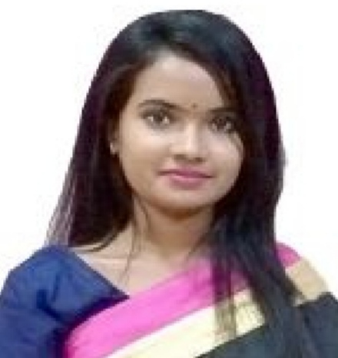

**Cell: (+88) 01517001481**

**E-mail: jannatulferdowseedisha@gmail.com**

**Or jfdisha1@gmail.com**

Career Objective

To work in a field where I can show strong sense of responsibility and devotion for building a bright career and contribute my best by sincerely accomplishing the duties and responsibilities assigned to me.

Personal Details

Date of Birth: 12-11-1998

Nationality: Bangladeshi (by birth)

Marital Status: Unmarried

Religion: Islam

Blood group: A (+)

Present Address: Room no. 316, 7 March Bhaban, Ruqayyah Hall, University of Dhaka

Permanent Address: DB Road, palashpara, Gaibandha Sadar, Gaibandha

Academic Information

* **Master of Social Sciences (MSS)**

CGPA- 3.28 (out of 4) [passing year- 2020]

Department of Development Studies, **(Major in Development Economics)**

University of Dhaka

* **Bachelor of Social Sciences (BSS)**

CGPA- 3.56 (out of 4) [passing year: 2019]

Department of Development Studies, University of Dhaka

* **Higher Secondary School Certificate (HSC)**

GPA 5.0(out of 5) [passing year: 2015]

Group: Humanities

Gaibandha Government College, Gaibandha [Dinajpur Board]

* **Secondary School Certificate (SSC)**

GPA 4.88 (out of 5) [passing year: 2013]

Group: Humanities

Gaibandha Govt. Girls' High School, Gaibandha. [Dinajpur Board]

Language and skills

* Fluent in **“Bengali”** and full working knowledge in **“English”.**
* Good at MSWord, Excel, Power Point, STATA, Project Professional, Browsing and Email.
* Experienced in quantitative and qualitative research analysis.

Working experiences

* Worked at **UNDP**, Bangladesh country office as a research intern
* Gained experience in Rural Development at Rural Development Academy (RDA), Bogra taking part in a study tour.
* Survey data Analysis, **PKSF**

Others

* Published article in Daily Observer (Editorial) --- *"Development: Investment in Human Capital"*
* Second prize winner - "Youth Thoughts on Economics, Part 1", South Asian Network on Economic Modeling **(SANEM)**