**Lead salt:**

The soluble lead nitrate (formed by the reaction between PbS and 50% Conc. HNO3) reacts with potassium iodide to form yellow precipitate of lead iodide.

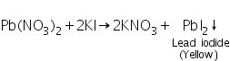

**Ammonium salt**: An ammonium salt on reaction with an alkali liberates ammonia. The other products are the respective salt of the metal and water.

NaOH + NH4Cl = NaCl + NH3 + H2O

**Calcium salt:** Calcium salt reacts with sulfuric acid to form calcium sulphate white ppt.

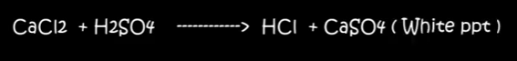

**Zinc:** Zinc reacts with ammonia to **form zinc hydroxide** and upon the addition of extra ammonia, the zinc hydroxide dissolves. When excess ammonia is added, it sets up an equilibrium which provides hydroxide ions; the formation of hydroxide **ions causes** a similar reaction as sodium hydroxide and creates a +2 charged complex with a co-ordination number of 4 with the ammonia ligands - this makes the complex soluble so that it dissolves.

**Iron (II):** Add 5 drops of 0.1 M potassium ferricyanide solution. A deep-blue precipitate will form with the iron(III) sulfate. In this reaction, the ferricyanide ions, [Fe(CN)6]3–, oxidize iron(II) to iron(III) forming ferrocyanide ions, [Fe(CN)6]4–  
  
Fe2+ + [Fe(CN)6]3– → Fe3+ + [Fe(CN)6]4–

**Iron (III):** Add 5 drops of 0.1 M potassium thiocyanate solution. A deep-red complex will form with the iron(III) sample. This is a positive indicator test for the iron(III) ion.  
Fe3+ + 3SCN– → Fe(SCN)3 Blood-red complex

**Copper salt:**

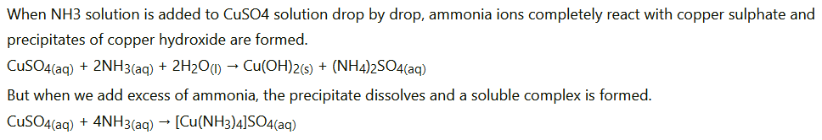

**Aluminum** **salt:** When aluminium salt reacts with ammonia, **aluminum hydroxide (Al(OH)3)** is formed as a product of the reaction. Aluminum hydroxide does not dissolve in water and forms cloudy white globs. As the globs settle, they form a solid gel at the bottom of the jar.

**How does the flame method work?**

The colors observed during the flame test result from the **excitement of the electrons** caused by the increased temperature. The electrons "jump" from their ground state to a higher energy level. As they return to their ground state, they emit visible light.

**Why can't we use glass rod instead of platinum wire for performing flame test ?**

Ans. This is because glass contains sodium silicate which imparts its own golden yellow colour to the flame.

**Why hydrochloric acid is used for flame test?**

The purpose of using conc. HCl is to convert the compounds into their metallic chlorides. Because **the metallic chlorides are very much volatile**. Thus, the flame color is caused by the metal alone.