**Elasticity of Demand**

**Elastic Demand**

Elasticity of demand is an important variation on the concept of demand. Demand can be classified as elastic, inelastic or unitary.

An elastic demand is one which the change in quantity demanded due to a change in price is large. An inelastic demand is one in which the change in quantity demanded due to a change in price is small.

The formula for computing elasticity of demand is:

(Q1-Q2) / (Q1+Q2)  
(P1-P2) / (P1+P2)

If the formula creates a number greater than 1, the demand is elastic. In other words, quantity changes faster than price. If the number is less than 1, demand is inelastic. In other words, quantity changes slower than price. If the number is equal to 1, elasticity of demand is unitary. In other words, quantity changes at the same rate as price.

**Elastic Demand:**Elasticity of demand is illustrated in Figure 1. Note that a change in price results in a large change in quantity demanded. An example of products with an elastic demand is consumer durables. These are items that are purchased infrequently, like a washing machine or an automobile, and can be postponed if price rises. For example, automobile rebates have been very successful in increasing automobile sales by reducing price.

Close substitutes for a product affect the elasticity of demand. If another product can easily be substituted for your product, consumers will quickly switch to the other product if the price of your product rises or the price of the other product declines. For example, beef, pork, poultry are all meat products. The declining price of poultry in recent years has been caused the consumption if poultry to increase, at the expense of beef and pork. So products with close substitutes tend to have elastic demand.  
Figure 1. Elastic demand

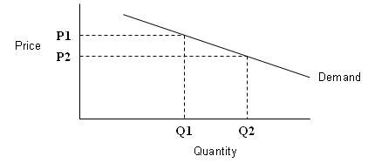

An example of computing elasticity of demand using the formula above is shown below. When the price decreases from $10 per unit to $8 per unit, the quantity sold increases from 30 units to 50 units. The elasticity coefficient is 2.25.

Elasticity example  
P1 = $10  
P2 = $8  
Q1 = 30  
Q2 = 50  
(Q1-Q2) / (Q1+Q2) _ (50-30) / (50+30) _ 20/80  
(P1-P2) / (P1+P2) ($10-$8) / ($10+$8) $2/$18

1/4 _ 1x9 _ 9 _ 2.25  
1/9 1x4 4

**Inelastic Demand:**  
Inelastic demand is shown in Figure 2. Note that a change in price results in only a small change in quantity demanded. In other words, the quantity demanded is not very responsive to changes in price.Examples of this are necessities like food and fuel. Consumers will not reduce their food purchases if food prices rise, although there may be shifts in the types of food they purchase. Also, consumers will not greatly change their driving behavior if gasoline prices rise.

Figure 2. Inelastic demand

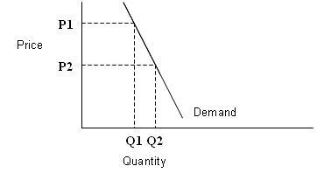

An example of computing inelasticity of demand using the formula above is shown below. When the price decreases from $12 to $6 (50%), the quantity of demand increases from 40 to only 50 (25%). The elasticity coefficient is .33.

Inelasticity example  
P1 = $12  
P2 = $6  
Q1 = 40  
Q2 = 50

(Q1-Q2) / (Q1+Q2) _ (50-40) / (50+40) _ 10/90  
(P1-P2) / (P1+P2) ($12-$6) / ($12+$6) $6/$18

1/9 _ 1x3 _ 3 _ .33  
1/3 1x9 9

This does not mean that the demand for an individual producer is inelastic. For example, a rise in the price of gasoline at all stations may not reduce gasoline sales significantly. However, a rise of an individual station’s price will significantly affect that station’s sales.

**Unitary Elasticity:**  
If the elasticity coefficient is equal to one, demand is unitarily elastic as shown in Figure 3. For example, a 10% quantity change divided by 10% price change is one. This means that a one percent change in quantity occurs for every one percent change in price.

