Gross Domestic Product (GDP)

**Definition:** Gross domestic product (GDP) is the monetary value of all the finished goods and services produced within a country's borders in a specific time period. Though GDP is usually calculated on an annual basis, it can be calculated on a quarterly basis as well.

GDP includes all private and public consumption, government outlays, investments, private inventories, paid-in construction costs and the foreign balance of trade (exports are added, imports are subtracted). Put simply, GDP is a broad measurement of a nation’s overall economic activity.

Textile sector contributes more than 12% in GDP of Bangladesh.

**How to Determine GDP**

There are three primary methods by which GDP can be determined. All, when correctly calculated, should yield the same figure.

These three approaches are often termed

A. the expenditure approach,

B. the output (or production) approach and

C. the income approach

**A. the expenditure approach:**

The **expenditure approach** or spending approach,which is the most common method, calculates **the monies spent by the different groups that participate in the economy**. For instance, consumers spend money to buy various goods and services and businesses spend money as they invest in their business activities (buying machinery, for instance). And governments also spend money. All these activities contribute to the GDP of a country. In addition, some of the goods and services that an economy makes are exported overseas, their **net export**. And some of the products and services that are consumed within the country are imports from overseas. The GDP calculation also accounts for spending on exports and imports.

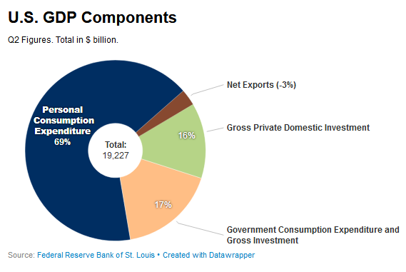

* A country's gross domestic product can be calculated using the following formula: **GDP = C + G + I + NX.**
* C is equal to all private consumption, or consumer spending, in a nation's economy,
* G is the sum of government spending,
* I is the sum of all the country's investment, including businesses capital expenditure and
* NX is the nation's total net exports, calculated as total exports minus total imports (NX = Exports - Imports).

**B. the output (or production) approach:**

The **production approach** is something like the reverse of the expenditure approach. Instead of exclusively measuring input costs that feed economic activity, the production approach estimates the **total value of economic output and deducts costs of** [**intermediate goods**](https://www.investopedia.com/terms/i/intermediate-good.asp) that are consumed in the process, like those of materials and services.

**C. the income approach:**

Income earned by all the [factors of production](https://www.investopedia.com/terms/f/factors-production.asp) in an economy includes the wages paid to labor, the rent earned by land, the return on capital in the form of interest, as well as an entrepreneur’s profits. An entrepreneur’s profits could be invested in his own business or it could be an investment in any outside business. All this constitutes national income, which is used both as an indicator of implied productivity and of implied expenditure.

In addition, the **income approach** factors in some adjustments for some items that don’t show up in these payments made to factors of production. For one, there are some taxes – such as [sales taxes](https://www.investopedia.com/terms/s/salestax.asp) and [property taxes](https://www.investopedia.com/terms/p/propertytax.asp) – that are classified as indirect business taxes. In addition, [depreciation](https://www.investopedia.com/terms/d/depreciation.asp), which is a reserve that businesses set aside to account for the replacement of equipment that tends to wear down with use, is also added to the national income.

GDP of south Asian Countries

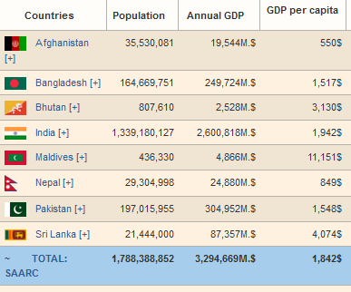

GDP growth of Bangladesh

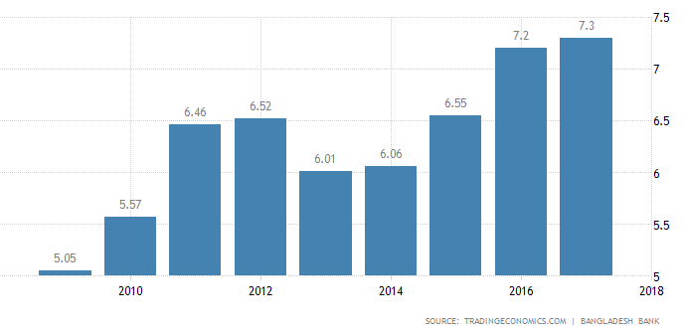

Top 10 GDP in the world

|  |  |  |  |
| --- | --- | --- | --- |
| **Rank** | **Country** | **Wealth ($ Trillions)** | **Change (2007-2017, %)** |
| **#1** | United States | $62.6 | 20% |
| **#2** | China | $24.8 | 198% |
| **#3** | Japan | $19.5 | 22% |
| **#4** | United Kingdom | $9.9 | -2% |
| **#5** | Germany | $9.7 | 0% |
| **#6** | India | $8.2 | 160% |
| **#7** | France | $6.6 | -11% |
| **#8** | Canada | $6.4 | 25% |
| **#9** | Australia | $6.1 | 83% |
| **#10** | Italy | $4.3 | -19% |