Warping

**Warping:**The parallel winding of warp ends from many winding package(cone or cheese, spool) on to a common package( warp beam )is called warping.

Object of Warping:

* Warping cannot improve weaving process but it can deteriorate the weaving process a lot.

1. To wound up fixed (required) length of yarn on to a warp beam. Because in weaver’s beam may have to many ends (ex: 10,000),if this were produced directly it would be necessary to have up to 10,000 creel package, that would be difficult to accommodate  
 2. To increase the weavability of yarn.  
 3. To make dynamic next process.  
 4. To increase production.  
 5. To increase quality of fabric.  
 6. To make re-useable small packages.  
 7. To make convenient yarn sheet for sizing process.

**Warping process involves:**

**Creel**

**↓**

**Control system**

**↓**

**Reed**

**↓**

**Measuring roller**

**↓**

**Winding on a drum /roller**

**↓ ↓**

**Direct warping indirect warping**

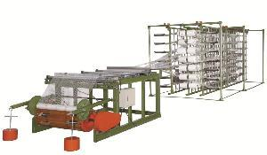

**Importance of Warping:** 1. Construction of a beam of warp yarn.  
 2. Constructing parallel yarn sheet.  
 3. Winding the predetermined length of yarn.  
 4. Combination of small packages.  
 5. Finding long length of warp.  
 6. Accelerating next process.  
 7. Minimize the yarn faults.  
   
**Requirements of warping:  
Warping should meet the following requirement-**1. The tension of all wound ends must be uniform & possibly constant during the withdrawal.  
2. Warping should not impair the physical properties of yarn.  
3. The surface of the warping package should be cylindrical.  
4. A predetermined length of yarn should be wound.  
5. The production rate of warping should be as high as possible.

* **Types of warping**:Normally two types of warping are used-  
  **1. Sectional warping or pattern warping/indirect warping  
  2. High speed warping or direct warping**.  
   Besides these there are some special types of warping such as-

**Components of warping machine**

**1. Creel**

**i) Single end creel ii) multiple creel package**

**a) Duplicated creel a) magazine creel**

**b) Truck creel b) travelling creel**

**2. Headstock –i) Fixed**

**Ii) Movable**

**3. Control device**

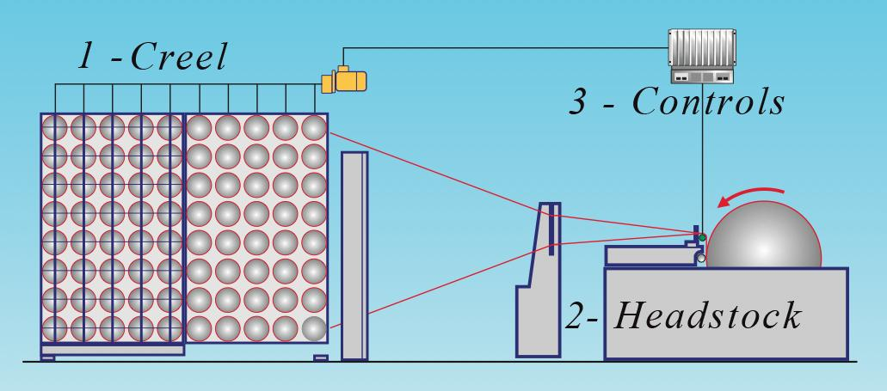

**1- Creels**

They are the metallic frames, where the yarn cones are fitted / organized to be fed to the intermediate carrier.  The creels are usually fitted with sensors for yarn tension and yarn breakage.

**The creel capacity** is an indication of the number of the cone fitted on it; it is parameter that determines the number of section of beams. The capacity usually between 800 – 1200 cones.

Different designs of creels are available to overcome the problems of consuming time and space. Different types of creels with their advantages are shown below.

**Mobile creel:**

This creel is formed by trolleys that can be fitted in the creels, which save time and space.

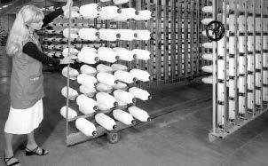

Figure (3): Mobile creel, adapted from Weaving Reference Books of Textile Technology, 2000.

Magazine creel

It is multiple creel packages. This type of creels is used when similar types of warps are needed to be prepared.  Two cones are used, one operating and one as reserve.

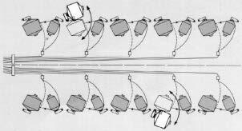

Figure (4): Magazine creel, adapted from Weaving Reference Books of Textile Technology, 2000.

Disadvantage:

1. About 1 percent of the ends break at the time of transfer from one package to another.

2. There cannot be as many ends per creel because of the space taken by the reverse packages.

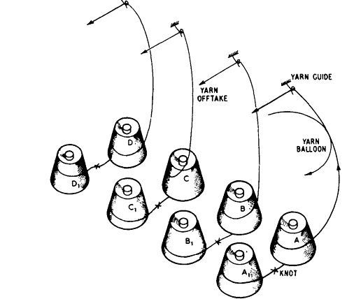

**Truck creel:**

Here the head stock is fixed, but creel is movable.

Only two creels are used but an extra space is required into which the exhausted creel can be moved before the full one can be brought into action.

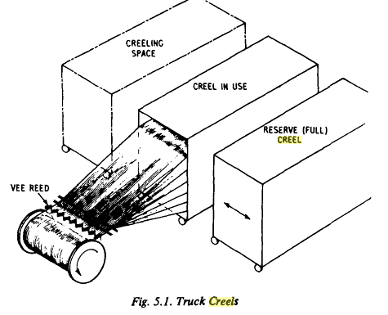

**Travelling package:** With the travelling package system,the package carriers move in loops so that while the yarn is being withdrawn from the outside of the loops, the inside carriers may be creeled.At change time the full packages are moved as a body to the outside of the loop and newly exhausted packages are moved to the inside ready for replacement.

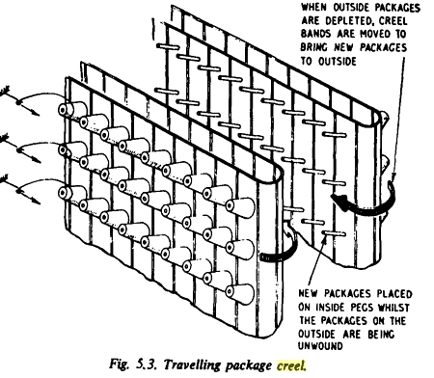

**V Shaped Creel**

Used for high speed warping because it allows high speed productivity.

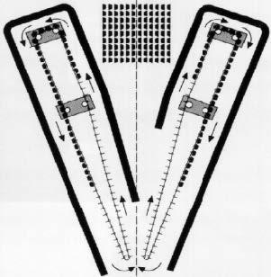

**Rectangular Creel ( H Shaped Creel)**

Used for indirect warping

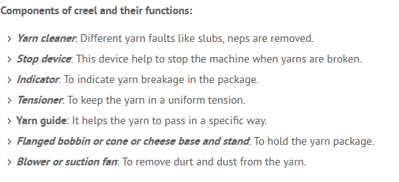

***Headstock***

*The winding process requires extra attention to tension of the yarns and the headstock is equipped with precision direct drive, advanced electronics, smooth doffing and programmable breaks.  Also measuring roller connected to control devices.*

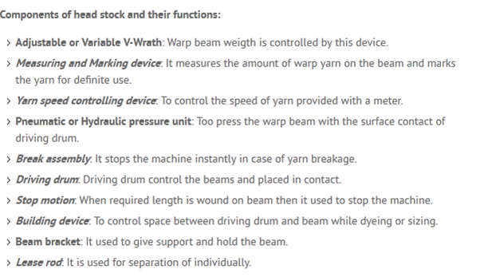

n the below fig (for sectional warping) 1.=drum 2=leasing device 3=carriage bearing,3a)expandable comb 3b)guide &metering roller 3c)leveling roller

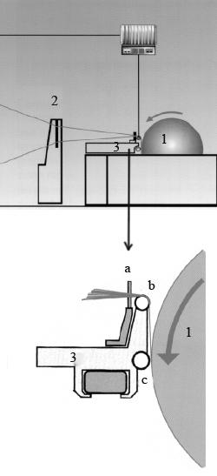

Figure (7): The head in the sectional warping machine, adapted from Weaving Reference Books of Textile Technology, 2000.

The headstock for the direct warping is simpler than the previous one, figure 8.  It consists of expanding comb, pressure roll and beam. .

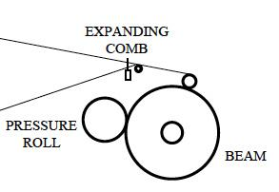

Figure (8): The head on the direct warping machine, adapted from Weaving Reference Books of Textile Technology, 2000.

***3- Controls***

As mentioned earlier the tension should be applied equally and fully controlled during the warping process.  The control devices are to ensure this.

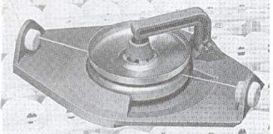

Figure (10): Yarn disc tensioner, Handbook of Weaving, 2001.

Also the yarn break sensors, figure 11, to stop the machine when there is a yarn break.

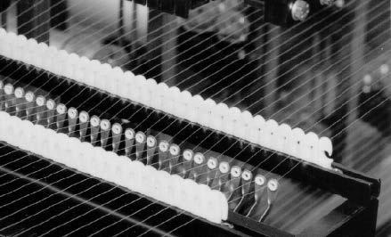

Figure (11): Yarn break sensors, adapted from Weaving Reference Books of Textile Technology, 2000

**Sectional warping or pattern warping:**A process of preparing warp beam over two stages, first winding the yarn in tapered drum as separate sheet or sections of equal length and then rewinding the warp yarn on to the weaver’s beam, this is called sectional warping.  
**Features of Sectional warping or pattern warping:**1. To produce fancy fabric (stripe or check).  
2. A tapered beam or drum is used for section wise different colored yarn wound.  
3. Two stage involved.   
4. Production is less.  
5. Costly process

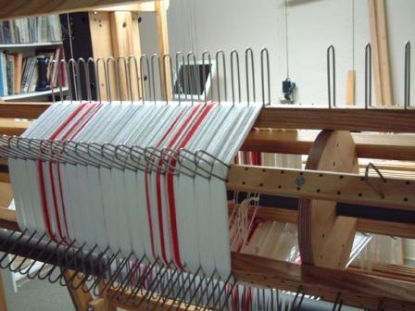

Sectional warping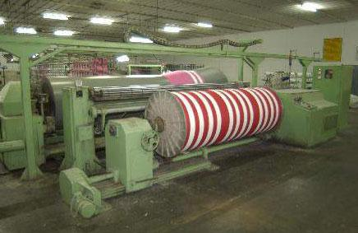

**Sections of Modern Warping Machine**

 There are two main sections of warping machines.

* Creel Section.
* Headstock Section.

**Creel Section**

  There are different parts of creel of high speed warping machine.

* ***Cone spindle rods****- Just used to hold the cones i.e. cones are mounted on it.*
* ***Balloon separator rods -*** *These are vertical rods through which yarn is passed and the balloon is avoided as high speed unwinding is done.*
* **Fixed rods and pre tensioner rods**
  + *These are vertical rods used to give the pre-defined tension to the yarn.*
  + *These rods are moveable when machine stops he pre- tensioner changes its position just to hold the warp and to avoid the twisting and slack of the yarn.*
  + *When machine stops due inertia an extra warp is unwound and pre tensioner rods movement is made to keep the yarn tense.*
  + *A motor at each side give drive to the pre tensioner.*
  + *When machine starts again the rods are brought to the original positions****.***
* **Yarn brake system**
  + There is a thin metal rod on which tensioner are mounted equal to no of yarn passing usually 9.
  + There is a photo sensor through which the warp passes.
  + When warp breaks this sensor gives signal to the plc through a case attached at the top of creel the plc immediately gives signal to all the motors at warping machine and machine is stopped.
  + At the same time the hoping cup is engaged for the brake force on the yarn.
* **Blow off system**
  + An air pressure is opened after every 2-3 seconds in order to avoid the fly and fluff at the photo sensor.
  + The pneumatic valve at the top delivers the required pressure for the certain intervals the pneumatic valve is controlled by the plc.
* **Creel moving system**
  + The cones are mounted on the creel side where as other side is being used.
  + When loading is completed the loaded side of the creel is brought to the other side and mean while the side replaces the first one.
  + The motor that has a again drive rotates the creel and a metal detector detects or counts the no of moving rods when 60 rods passes in front of it.
  + It gives signal to plc and plc stops the motor.
  + In this way whole creel is moved.
* **Light systems**
  + When machine stops due to yarn brake, the PLC displays tin rods no and the yarn no. at the front of warper.
  + Just for at the creel a see light shows the indication of broken yarn and small see light shows the warp no.
  + A big light is also lighted showing machine stop.
* **Yarn cutters**
  + *When cones are emptied & machine stops, a cutter operated manually by the warper cuts all the yarns.*

**Head Stock**

It is an assembly where warp sheet is wound on beam.

**Parts of Head stock**

* Traversing expandable comb
* Air below pipe(ABP)
* Guide roller
* Pressing drum
* Warper’s beam
* Motors
* Hydraulic breaks and oil pumping system
* Wind sheet

**Traversing expandable comb**

* Comb position at warping head stock is adjusted by using a motor and a chain gear.
* Comb up/down and lateral positions are adjusted according to the requirement.

**Beam Loading and Unloading System**

When beam is brought in front of the adapter, switch is turned ‘on’ and the inclined adapter moves towards the beam and plays into the beam, the beam are also lifted.

i. Limit Switch: -

  A limit switch is there, when beam is clamped, it gives signal to the hydraulic system and the pressing drum comes into the contact with the beam surface.

ii. Limit Switch: - Limit switches are installed at the right and 2 at left. 2 are used to control the extreme forward movement of the adapter and  are used to control the extreme backward movement of the adapter.

**Hydraulic Pressing Drum**

* The press drums moves only after when the metal detector senses the beam presence.
* The PLC is given a pressing force value, normally 250daN.
* When beam is installed, the hydraulic cylinder gives pressure to the jeck and ultimately the drum is forced to move towards the beam for the application of pressure at the beam to acquire the required density of warp beam.
* As diameter of the beam increases the pressing force remains same but the brake caliper moves backward gradually according to the increase in the diameter of the warper beam.

**Hydraulic System**

* The hydraulic pump along with the pneumatic control valve controls the break system at  creel , drum , beam , guide roller.
* When a yarn is broken the photo sensor at the creel checks its absence and immediately passes signal to PLC and PLC gives signal to all the concerned parts involved in the movement and their movement is immediately stopped by using the hydraulic brakes at the above parts.
* Also the motors are stopped.
* In this way all the machine is stopped immediately.

**Air Blow Pipe**

* When yarn passes through dents of comb ,  fluff produces due to friction of yarn with comb.
* In order to remove that fluff from the comb , there is air blow pipe that blows short fibers from the surface of comb.
* In this way , fibers do not mix with warp sheet.

**Guide Roller & Wind Sheet**

* When the warp sheet passes through zig-zag comb , it passes over guide roller.
* The main purpose of guide roller is to guide the warp yarns to warp in a proper sequence on warper beam.
* Wind sheet is used for the safety purpose.
* When the warping machine is in running position, fluff removes due to friction of warp yarns with comb and direction of flow is towards warper.
* Wind screen/sheet prevents a warper from fluff.

**Warper Beam**

* Warper beam is a place on which warp yarn is combined in form of a sheet.
* Its width is not adjustable like weaver beam.
* Its length and diameter is fixed.
* Warper beam is loaded and unloaded with the help of adopter on the headstoc

**Advantage:**

1. Reduction of wastage

2. Possibility of obtaining a ready weaver’s beam

3. Section warping makes it possible to obtain a warp with a great no of ends on the weaver’s beam without the use of many warping beam.

**Disadvantage:**

1. An additional operation of beaming off

2. Sectional warping is less efficient than beam warping.

3. Yarn tension is less uniform than beam warping.

**Uses:**

1) Silk weaving

Ii} synthetic yarn processing

iii) Check or stripe fabric

**Direct warping/High speed warping**

In beam warping the yarn is parallel wound on a warping beam. The ends from all warping beams are put together & wound on the weaver’s beam during sizing. The no of ends on the warping beam is 400 to 600 or more. The no of beams in the set may be from 2 to 16, depending on the no of ends in the warp & on the capacity of the warping creel.

**Advantage**

1. Yarn tension is more uniform

2. More efficient

3. High production

**Disadvantage:**

1. Number of beams is more

**Uses:**

Widely used in cotton,linen,wool weaving

**Draw backs of beam warping with a warping drum**:

1. *The yarn on the warping beam is subject to sharp mechanical action specially at starting & stopping the m/c.*
2. *During m/c operation a certain vibration of the warping beam is unavoidable, which might have a negative influence on the shape of the winding on beam.*
3. *A synchronous & rapid stoppage of the warping drum & beam when the m/c stops is not possible.*

***Control system in warping:***

*1. It is necessary to control tension such that all ends are as nearly as possible.*

*2. Ballooning off the yarn coming from the creel package must be controlled.*

*3. To arrange all packages to unwind in the same direction.*

*4. It is necessary to have stop motion.*

*5. Stop motion must be sited in such away as to allow sufficient time for any step to occur before the broken end reaches the head stock.*

*6. M/c is always fitted with powerful brakes.*

*7. Must have measuring roller &speed measuring control device*

*8. The density of the warp on the beam has to be controlled.*

**Differences Between Sectional and High Speed Warping**

|  |  |
| --- | --- |
| **High Speed Warping** | **Sectional Warping** |
| 1. Beam [**warping**](http://textilelearner.blogspot.com/2011/06/warping-types-o-warping-sectional-or_8427.html) is used for long runs of grey fabrics & simple pattern. | 1. Sectional warping is used for short runs especially for fancy pattern fabrics. |
| 2. The amount of colored yarn is less than 15% of the total. | 2. Greater amount of colored yarn is used. |
| 3. High production. | 3. Low production. |
| 4. Large amount of yarn required. | 4. Small amount of yarn required. |
| 5. Single yarn is used. | 5. Twisted yarn is used. |
| 6. Less expensive. | 6. More expensive. |
| 7. It is most widely used for cotton, linen, woolen & worsted yarn. | 7. It is most widely used for silk & synthetic yarn. |
| 8. Uniform tension of yarn. | 8. Less uniform tension of yarn. |
| 9. Weavers beam is produced after sizing. | 9. Weavers beam is produced after warping. |
| 10. Creel capacity is more. | 10. Creel capacity is less. |
| 11. Beam warping is more widely used. | 11. Sectional warping is not widely used. |

**Ball warping machine:**

Ball Warping: Ball warping is an intermediate process for storing yarn for transport, dyeing or reserve. It involves creeling multiple ends of yarn (Between 350-500 ends) and collecting them into an untwisted rope for dyeing. The rope is wound onto a long cylinder called a log on a machine called as a ball warper/Ball package It does not produce a beam. The usual form is a cross wound cheese in which multiple ends are wound at the same time in a ribbon which contains 350 to 500 ends.

It is used in Modern Denim Manufacturing Plant for its enormous advantages.

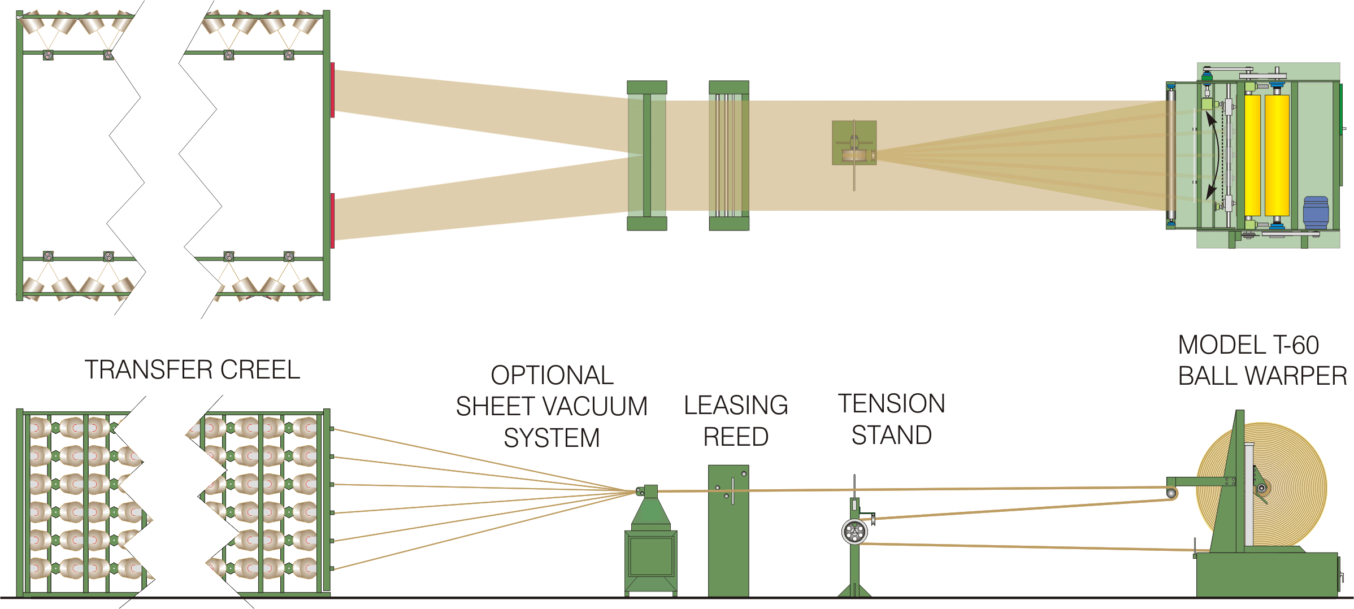

**Some note:**

1. Packages of yarn are preconditioned before ball warping

2. Packages are loaded into the creel (larger lots- magazine transfer creel 0 and smaller lots-swing gate or truck creel

3. Packages are placed on adapters. An adapter support the package of yarn and ensure that the package remains aligned to the tensioning devices. Wooden plug type adapter are most effectives they require least amount of exertion to remove the empty package.

**Faults & remedies in warping:  
1. Warp off centre of the beam:**   
 If the creel wraith & flanged beam is not carefully placed this type of fault may occur .So it should be placed properly.  
**2. Ridgy or Uneven surface of the warp beam:**   
  **This defect due to: -**  
 a) Winding of small no. of ends on longer beam.  
 b) When yarn of mixed count wound.  
 c) When the dents are bent.  
To overcome this types of faults use large no. of ends & uniform count the dents should be uniformly spaced.  
**3. Cross ends:** During creeling if yarn is broken then the cross ends is formed. To minimize there should be in proper tension.  
**4. Snarl in the warp:** It forms for over tension & twisting. So it should be given proper tension & twist.  
**5. End missing:** After breaking yarn if stop motion does not work during warping often two or more yarns are missed.   
**6. End broken down:** During warping if yarn is broken down then this fault is occurred.   
 To minimize this fault yarn to be joined carefully.  
**7. Hard beam:** Hard beam is formed if contact between drum & beam is not in moderate pressure. So pressure should be moderate.

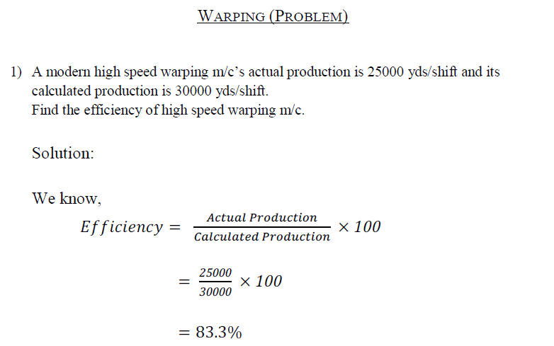

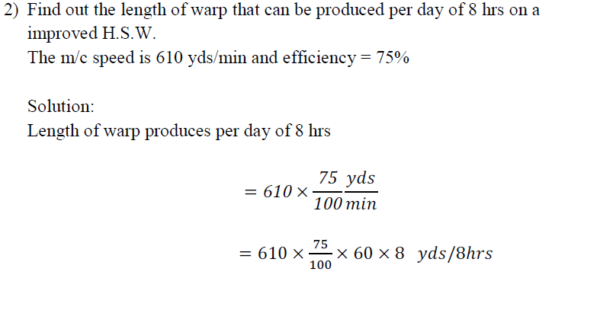

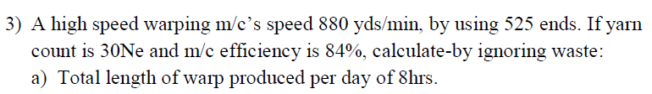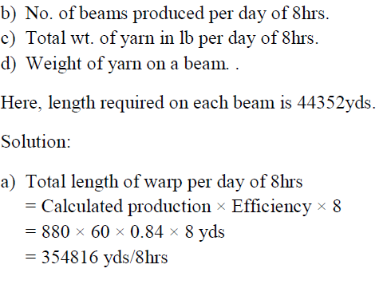

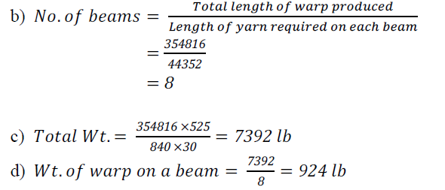

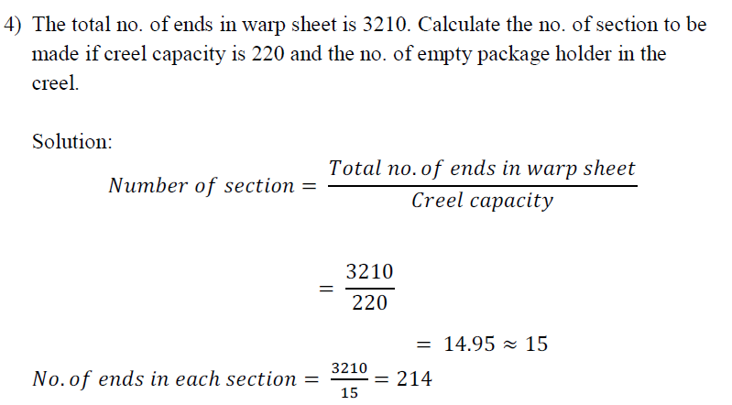

**So, creel capacity utilization = 214**

**No. of empty package holder in creel**

**= Creel capacity – Creel capacity utilization**

* **220 – 214**
* **6**

**Ans: No. of section = 15**

**No. of empty package holder = 6**