**Object Oriented Programming: Quiz Contest**

BY

**Nafisur Rahman**

**ID: 182-40-522**

Supervised by

**Md Salah Uddin**

Lecturer

Department of MCT

Daffodil International University



**DAFFODIL INTERNATIONAL UNIVERSITY**

**DHAKA, BANGLADESH**

**DATE OF SUBMISSION: 27-08-2019**

**Table of Contents**

CHAPTER 1

INTRODUCTION 3

CHAPTER 2

2.1AIM AND SCOPE 4

2.2PROBLEM STATEMENT 4

2.3TARGET AUDIENCE 4

CHAPTER 3

3.1REQUIRED SOFTWARE 5

3.1FLOW CHART 5

3.1DEVELOPMENT PROCESS 6

CHAPTER 4

EXPERIMENTAL RESULTS

FIGURE4.1 7

FIGURE4.2 7

FIGURE4.3 8

FIGURE4.4 8

CHAPTER 5

CONCLUSION 9

REFERANCE 9

**CHAPTER 1**

**INTRODUCTION**

This quiz contest is about console programming. It’s made to play between two players. Here players have to answer 10 mini questions out of four options. For every correct answer they get one point each. At the end of answering all the questions they can see their points & the game will declare the winner. The player can see the game instruction. After finishing the game the player can also see the game result so that they can compare their answers. This kind of mini quiz game can create interest among student learning programming. This can be an interesting way to learn.

**CHAPTER 2**

**2.1AIM AND SCOPE**

The aim is to make learning fun through contest. It’s a combination of game and study together.

**2.2PROBLEM STATEMENT**

The problem is that it’s very difficult to add more questions as the program gets lengthier and it’s become more complicated if we want to add more players.

**2.3TARGET AUDIENCE**

Students are the main target audience. As they can play this game and learn about console programming. It’s a good way to increase their interest in console programming.

**CHAPTER 3**

**3.1REQUIRED SOFTWARE**

Microsoft Visual Studio 2010

.

**3.2FLOW CAHRT**

Point2>point1

Game has drawn

Player2 has won

Display point2

Display point2

Display point1

Point2++

Ans1=a

Ans2=a

Input ans1

Input ans2

question

Point2=1

Point1=1

Input player 2

Input player 1

Display point1

Point1++

Point1>point2

Player1 has won

**3.3DEVELOPMENT PROCESS**

Specification:

1. Option to enter two players name
2. Players can choose right answer out of 4 options
3. Player can see the right answer after answering all of the questions & can compare their answers
4. Players can see their points
5. Finally it will show who has won or the game has drawn

Design:

Main

Player name entry

Quiz

String player_name1

String player_name2

String option

Int point 1

Int point 2

**CHAPTER 4**

**EXPERIMENTAL RESULT**

After building the code, there comes no errors & I can see the ‘console window’.

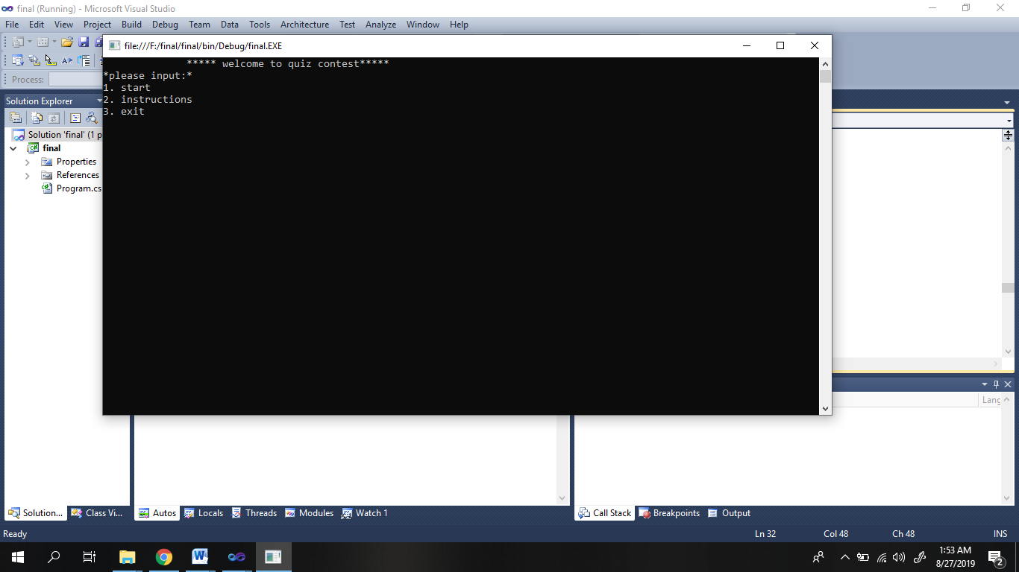

**Figure4.1: quiz contest**

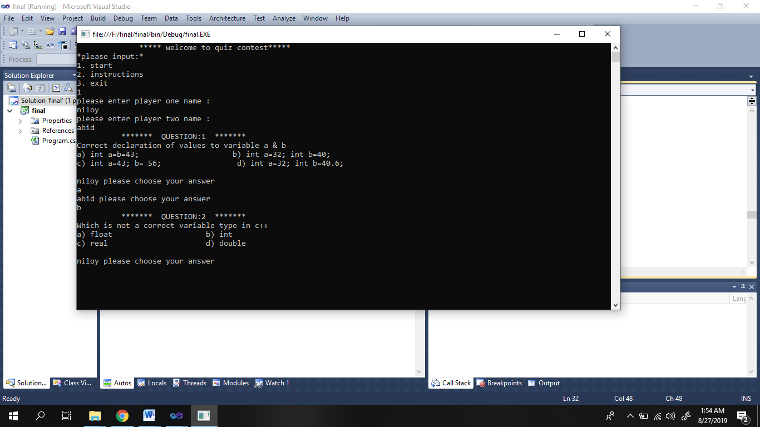

**Figure4.2: quiz contest**

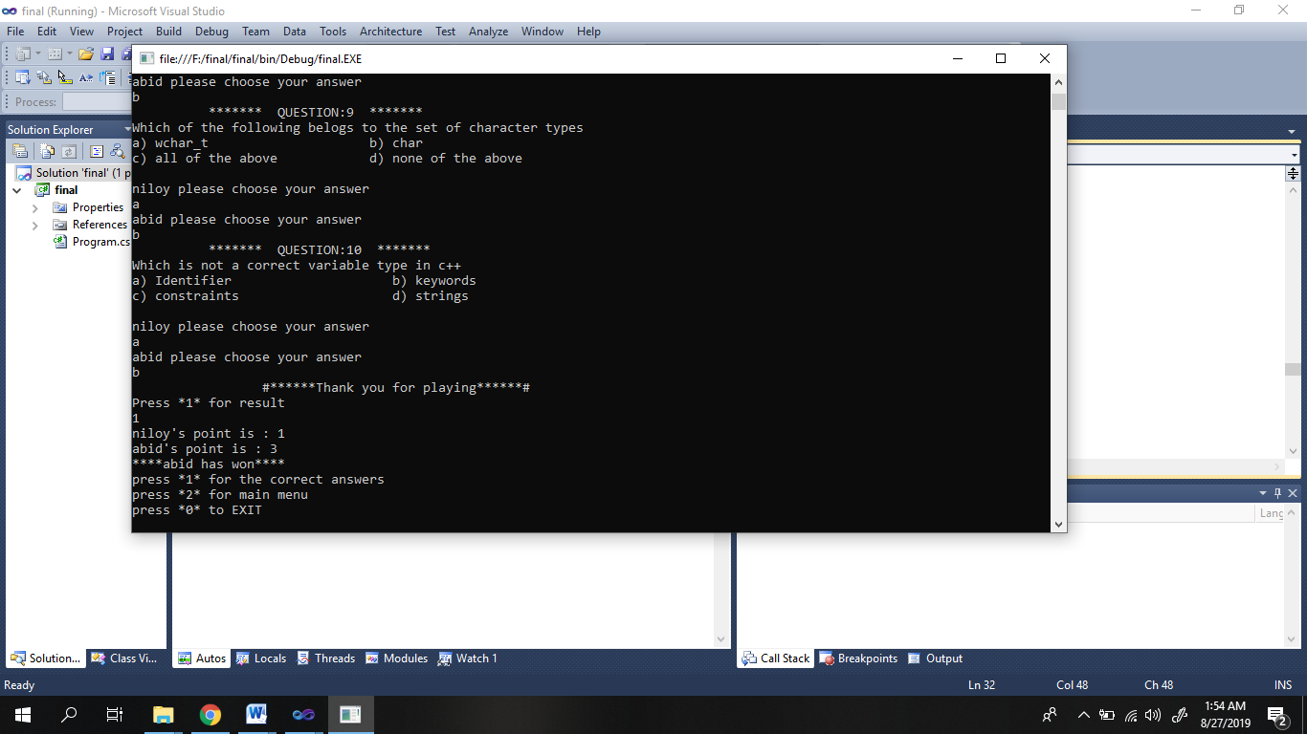

**Figure4.3: quiz contest**

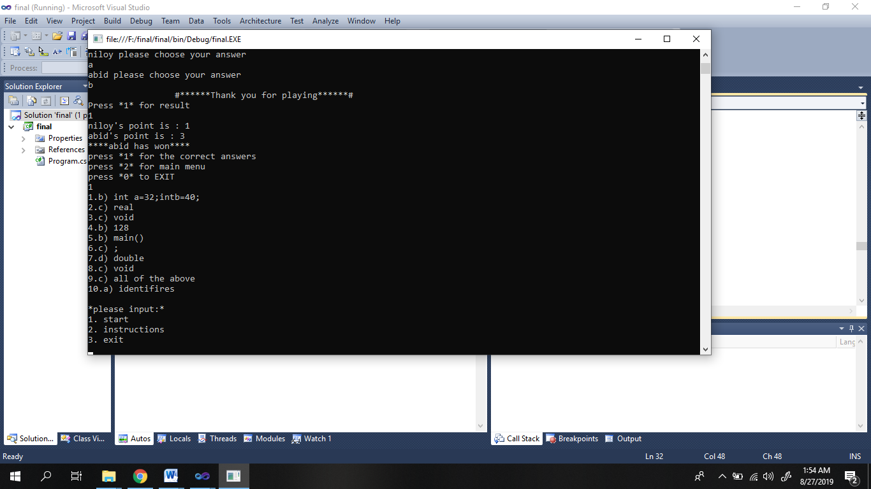

**Figure4.4: quiz contest**

**CHAPTER 5**

**CONCLUSION**

I hope this game will help to develop interest in programming among students.

**Reference**

Date: 4.43 pm ,20.08.2019

dotnetperls.com/string