**ASSIGNMENT CASE STUDY-1**

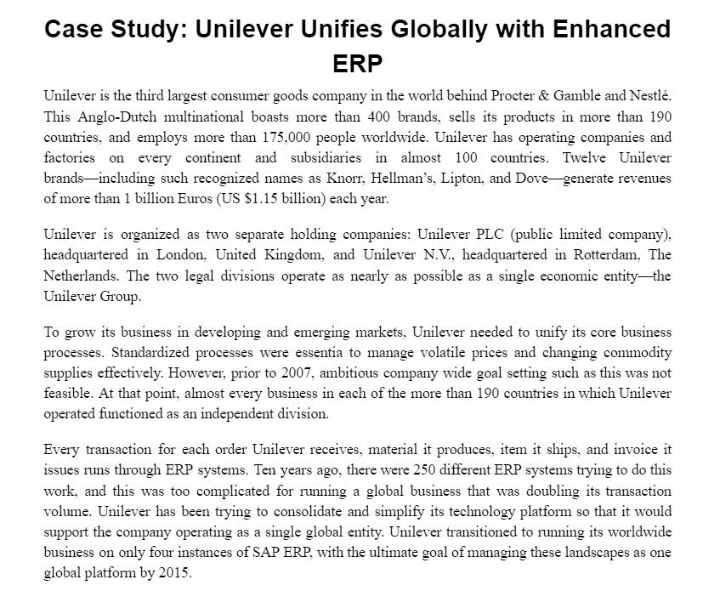

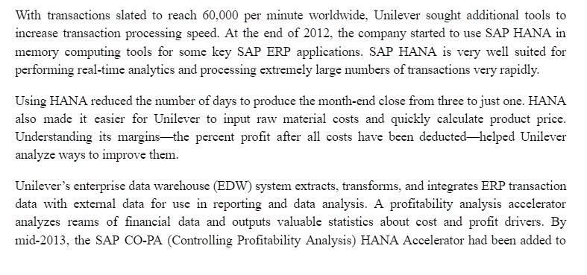

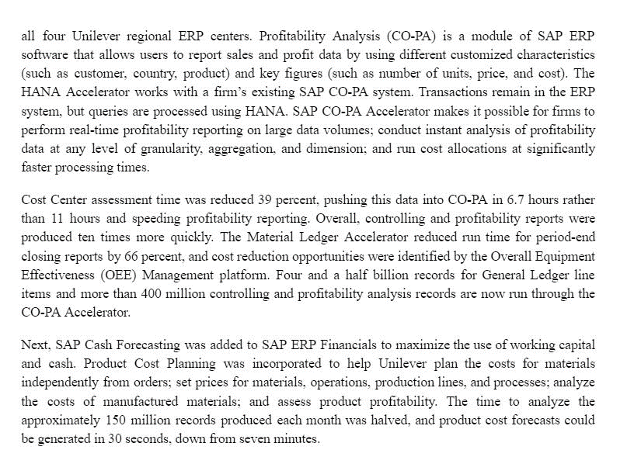

---- REST PART IS ON NEXT PAGE----

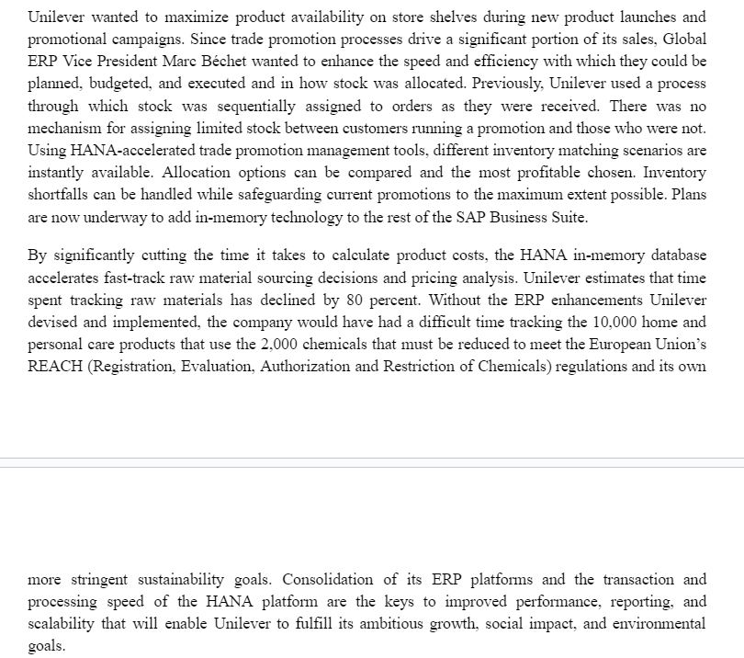

**QUESTIONS**

1. How is enterprise resource planning related to Unilever’s business strategy? How did consolidating ERP systems support Unilever’s business strategy? 1**.5 marks**
2. How did Unilever’s new systems improve operations and management decision making? Give two examples? **1 mark**