What is Alternative dispute resolution (ADR?)

Alternative dispute resolution (ADR) includes dispute resolution processes and techniques that act as a means for disagreeing parties to come to an agreement short of litigation. Despite historic resistance to ADR by many popular parties and their advocates, ADR has gained widespread acceptance among both the general public and the legal profession in recent years. In fact, some courts now require some parties to resort to ADR of some type, usually Arbitration, before permitting the parties’ cases to be tried. The rising popularity of ADR can be explained by the increasing caseload of traditional courts, the perception that ADR imposes fewer costs than litigation, a preference for confidentiality, and the desire of some parties to have greater control over the selection of the individual or individuals who will decide their dispute. Alternative” dispute resolution is usually considered to be alternative to litigation. It also can be used as a colloquialism for allowing a dispute to drop or as an alternative to violence.

Types and features of alternative dispute resolution

ADR is generally classified into at least four types: arbitration, negotiation, mediation, and conciliation.

ADR or Alternative Dispute Resolution traditions vary somewhat by country and culture. There are significant common elements which justify the main topic, and each country or region’s difference should be delegated to sub-pages. ADR is of two historic types. First, methods for resolving disputes outside of the official judicial mechanisms. Second, informal methods attached to or pendant to official judicial mechanisms. It is important to realize that conflict resolution is one major goal of all the ADR processes. If a process leads to resolution, it is a dispute resolution process.

The salient features of each type are as follows:

In negotiation, participation is voluntary and there is no third party who facilitates the resolution process or imposes a resolution. In mediation, there is a third party, a mediator, who facilitates the resolution process (and may even suggest a resolution, typically known as a “mediator’s proposal”), but does not impose a resolution on the parties.

In collaborative law or conciliation, each party has an attorney who facilitates the resolution process within specifically contracted terms. The parties reach agreement with support of the attorneys (who are trained in the process) and mutually-agreed experts. No one imposes a resolution on the parties. However, the process is a formalized process that is part of the litigation and court system. Rather than being an Alternative Resolution methodology, it is a litigation variant that happens to rely on ADR like attitudes and processes.

In arbitration, participation is typically voluntary, and there is a third party who, as a private judge, imposes a resolution. Arbitrations often occur because parties to contracts agree that any future dispute concerning the agreement will be resolved by arbitration. In recent years, the enforceability of arbitration clauses, particularly in the context of agreements has drawn scrutiny from courts. Although parties may appeal arbitration outcomes to courts, such appeals face an exacting standard of review.

Benefits of ADR

ADR has been both; increasingly used alongside, and integrated formally, into legal systems internationally in order to capitalize on the typical advantages of ADR over litigation:

* Suitability for multi-party disputes;
* The flexibility of procedure – the process is determined and controlled by the parties the dispute;
* Lower costs and less complexity;
* Parties choice of neutral third party (and therefore expertise in area of dispute) to direct negotiations/adjudicate;
* Likelihood and speed of settlements;
* Practical solutions tailored to parties’ needs;
* The durability of agreements;
* Confidentiality;
* The preservation of relationships.

Traditional people’s mediation has always involved the parties remaining in contact for most or all of the mediation session. The innovation of separating the parties after (or sometimes before) a joint session and conducting the rest of the process without the parties in the same area was a major innovation and one that dramatically improved mediation’s success rate.

Traditional arbitration involved heads of trade guilds or other dominant authorities settling disputes. The modern innovation was to have commercial vendors of arbitrators, often ones with little or no social or political dominance over the parties. The advantage was that such persons are much more readily available.

Alternative dispute resolution in Bangladesh is not new and it was in existence even under the previous Arbitration Act, 1940. The Arbitration Act, 2001 has been enacted to accommodate the harmonization mandates of UNCITRAL Model. To streamline the Bangladesh legal system the traditional civil law known as Code of Civil Procedure, (CPC) 1908 has also been amended and section 89A & 89B has been introduced which provides options for the settlement of disputes outside the court. It provides that where it appears to the court that there exist elements, which may be acceptable to the parties, the court may formulate the terms of a possible settlement and refer the same for arbitration, conciliation, mediation or judicial settlement. Due to the very slow judicial process, there has been a big thrust on Alternate Dispute Resolution mechanisms in our country.

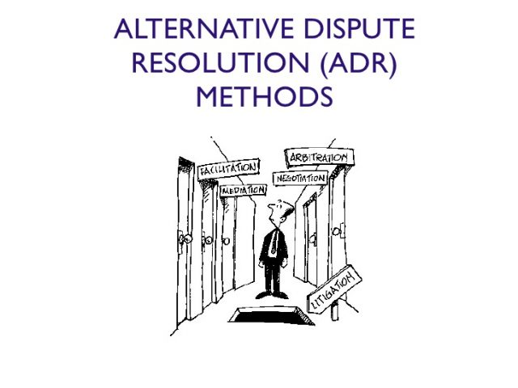

Arbitration

The process of arbitration can start only if there exists a valid Arbitration Agreement between the parties prior to the emergence of the dispute. As per Section 7, such an agreement must be in writing. The contract, regarding which the dispute exists, must either contain an arbitration clause or must refer to a separate document signed by the parties containing the arbitration agreement. An exchange of statement of claim and defense in which the existence of an arbitration agreement is alleged by one party and not denied by other is also considered as a valid written arbitration agreement.

Any party to the dispute can start the process of appointing an arbitrator and if the other party does not cooperate, the party can approach for the sole arbitration if any Arbitration Agreement exists between them. There are only two grounds upon which a party can challenge the appointment of an arbitrator – reasonable doubt in the impartiality of the arbitrator and the lack of proper qualification of the arbitrator as required by the arbitration agreement. A sole arbitrator or a panel of arbitrators so appointed constitutes the Arbitration Tribunal. Once the period for filing an appeal for setting aside an award is over, or if such an appeal is rejected, the award is binding on the parties and is considered as a decree of the court.

Conciliation

Conciliation is a less formal form of arbitration. This process does not require the existence of any prior agreement. Any party can request the other party to appoint a conciliator. One conciliator is preferred but two or three are also allowed. In the case of multiple conciliators, all must act jointly. If a party rejects an offer to conciliate, there can be no conciliation.

Parties may submit statements to the conciliator describing the general nature of the dispute and the points at issue. Each party sends a copy of the statement to the other. The conciliator may request further details, may ask to meet the parties, or communicate with the parties orally or in writing. Parties may even submit suggestions for the settlement of the dispute to the conciliator. When it appears to the conciliator that elements of settlement exist, he may draw up the terms of settlement and send it to the parties for their acceptance. If both the parties sign the settlement document, it shall be final and binding on both.