Daffodil International University
Faculty of Business and Entrepreneurship
Department of Real Estate
Program: Bachelor of Real Estate (BRE)

Semester: Spring 2024 | Examination: Final
Time: 2:00 Hours | Full Marks: 40
Course Code: 0731-121 | Course Title: Principles of Urban Planning
Section: A & B | Faculty: NFM

Answer all the following questions:
SL | Question | Marks
1 | a) Differentiate the concepts of “Land Cover” and “Land Use” with examples.  b) What do you understand by “Smart City”? Explain with relevant examples. | 2+ 3=5  [CLO 1]
2 | Describe the three land use values. What do understand by compatibility among land uses? | 5  [CLO 1]
3 | Write short note on the following two:  a) Urban Fringe  b) Transit Oriented Development (TOD) | 2.5+2.5=5  [CLO 1]
4 | Discuss the pros and cons of “mixed” and “segregated” land use patterns. Which one do you think is better suited for Dhaka? | 5  [CLO 2, 3]
5 | Describe five principles of designing a Residential Neighbourhood Unit by Clarence Perry. | 5  [CLO 2]
6 | Identify the five zones of the Concentric Zone Model and briefly describe their activities | 5  [CLO 2]
7 | The following model shows the “Multiple Nuclei Model”. Identify the zones (as shown in numbers) and write down at least two principles that the model follows.  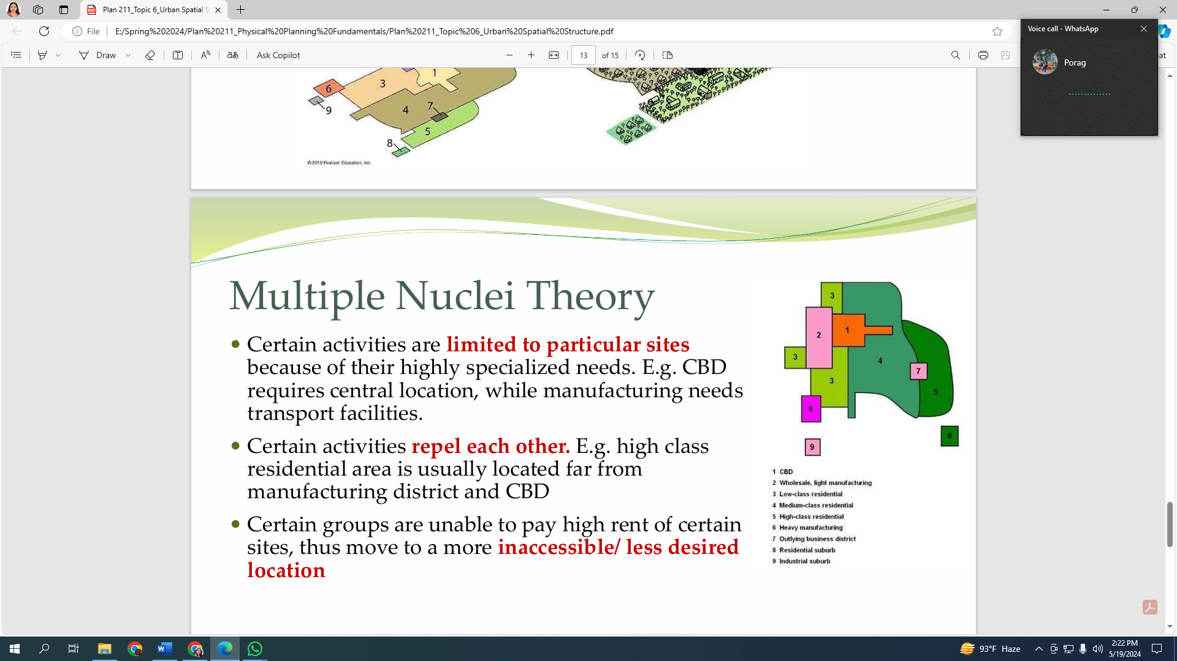 | 5  [CLO 2]
8 | Mention one function of the following authorities (any five):  a) Public Works Department (PWD)  b) National Housing Authority (NHA)  c) Urban Development Directorate (UDD)  d) Bangladesh Bridge Authority (BBA)  e) Bangladesh Road Transport Authority (BRTA)  f) Bangladesh Road Transport Corporation (BRTC) | 5  [CLO 3]

