**Chapter-05: Long Staple Spinning (Jute Spinning Process)**

* **Chapter Objectives:**

1. To know the basic process involves in jute spinning
2. To learn the operating procedure of jute
3. To distinguish the different machines
4. To know the different actions are involve in jute spinning process
5. To evaluate the production calculation

* **Chapter outcomes:**

After completing this chapter, students will able

1. To know the process flow chart of jute spinning system
2. To learn the operating procedure of different machines
3. To know the different actions, involve in jute spinning process
4. To evaluate the production calculation

**Composition of Jute Fibre:**

1. Cellulose → 65.2%
2. Hemi-cellulose → 22.2%
3. Lignin → 12.5%
4. Water Soluble matter → 1.5%
5. Fat and Wax → 0.6%

**Grading of Jute:**

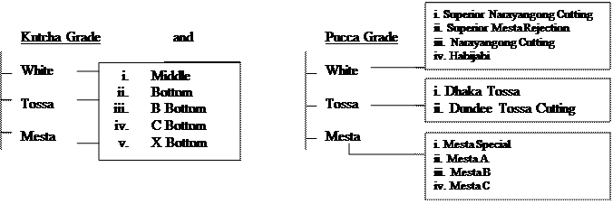

**Defects in Jute:**

1. **Rooty Jute**: in these jute the lower parts of jute fires contain barks.
2. **Specky jute**: this defects occur because of insufficient washing which causes the outer barks to adhere in some places
3. **Croppy Jute**: this is a defect where the top end of the fibre become rough and hard. It is usually caused by careless steeping.
4. **Knotty jute**: the jute fibres contain knots in places and it is caused by insect bite or punctures.
5. **Dezed or Dead fibres**: due to over retting in moist condition, the fibre becomes dull, lose strength and becomes inferior for spinning.
6. **Runners**: this is a defect where long and hard barky ribbon of fibres remains in jute fibre.
7. **Hunka**: defects caused by non-removal of dried up base and hard bark from the fibres.
8. **Mossy jute**: fibres from short plants that cannot be properly stripped and cleaned contain broken piece of jute sticks etc.
9. **Flabby or Fluffy jute**: due to careless stripping, fibre loses firmness and becomes flabby and hairy
10. **Heart damage**: These defects occur when jute fibre contains excess moisture when baled. The centre of the bale becomes badly tendered and in some cases fibres are reduced to powder.

**Flowchart of Jute Yarn Manufacturing:**

**Text Box: Jute Bale
↓
Selection of jute for a batch
↓
Piecing up
↓
Softening and Lubricating
↓
Pilling and Conditioning
↓
Carding
i. Breaker Card
ii. Finisher Card
↓
Drawing and Doubling
1st Drawing
2nd Drawing
3rd Drawing
↓
Spinning
**

**Different forms of jute purchased by Mills:**

Jute is purchased by mills in two forms.

1. Jute may be purchased in the form of bundles of 1 to 2 mounds or 3 to 4 mounds of kutcha jute or in loose forms. In these forms the fibres are uncut and require selection, grading, and piecing-up before processing.
2. Jute fires used for export are bought in the form of pucca bales each weighing 400 lbs including 6 lbs binding ropes. The dimension of the bales is

**4 feet 1 inches by 1 feet 6.5 inches by 1 feet 6 inches = 9.5 cubic feet**

And the bales are under pressure of 6000 to 7000 lbs per square inch.

**Batch:**

A blend of different types of jute is made up to suit the particular class of yarns being spun. This blend is known as ‘the batch’.

**Batching:**

All the processes starting from batch selection up to carding of jute is called batching.

**Objects of Batching:**

1. To help fibre move freely during processing
2. To get expected dampness and flexibility
3. To remove hardness and stiffness of jute fibres
4. To intermix the batch component effectively
5. To reduce loss due to wastage
6. To control and reduce yarn cost

**Factors considered for batch selection:**

1. Cost of raw material
2. Availability and duration of stock jute
3. Physical properties and quality of jute fibres
4. Quality of yarn being spun
5. Cost of production
6. Machine used during processing
7. Demand of the customer

**Batch Selection technique/ Composition of jute yarns/ Types of jute yarn****:**

1. **Hassian warp**: to make this type of yarn clean and defect free jute is required. Hassian warp yarn is good quality, clean and free from speck with high lustre.

Batch selection: Hard jute →→→ 70%

Soft jute →→→ 30%

Example: for 8 lbs/spyndlehassian warp

White C →→→ 40%

White X →→→ 40%

Tossa →→→ 20%

2. **Hassian weft**: Hassian weft yarn is cleaner and softer than hassian warp yarn. So for hassian weft clean fibre is required, but fibre of strength can be used to hassian weft yarn.

Batch selection: For heavy yarn

Hard jute →→→ 30%

Soft jute →→→ 70%

For light yarn

Hard jute →→→ 50%

Soft jute →→→ 50%

Example: for 8.5 lbs/spyndlehassian weft

White C →→→ 20%

White X →→→ 50%

Tossa →→→ 30%

3. **Sacking warp**: Sacking warp jute yarn is good and strong. Specks and colour is not important when manufacturing this type of yarn.

Batch selection: Hard jute →→→ 60%

Soft jute →→→ 40%

Example: for 8 lbs/spyndle sacking warp

X bottom →→→ 67%

S M R →→→ 33%

4. **Sacking weft**: Sacking weft yarns are low quality yarn. It is coarse and is made from low grade jute fibre. It may contain line cuttings, bale cuttings, soft and hard waste, rope waste, jute dust, habijabi and entangled jute.

Example: for sacking weft

NC →→→ 70%

S M R →→→ 15%

Caddis →→→ 5%

Thread waste and gunny cuttings → 10%

5. **C.B.C (carpet breaking cloth)**:

Batch selection: Hard jute →→→ 100%

Example: for 8 lbs/spyndle C.B.C *warp*

B.W.B →→→ 40%

B.W.C →→→ 60%

Example: for 8 lbs/spyndle C.B.C *weft*

B.W.B →→→ 30%

B.W.C →→→ 70%

**Pucca bales**: The ropes are first cut using an axe and are kept aside for treatment separately. As the jute is packed very tightly, they are loosened by beating with a hammer. Then the bulky layers are split into handfuls by batchers. Each handful is 2 to 3 lbs.

**Kutch jute, jute bundles and loose jutes**: in this condition the jute of various qualities and colour are mixed together. The fibres are more or less in loose form and so beating is not required. The batchers separate the defected jute and keep it aside to make low grade jute yarn. The pieced-out jute is later carried in the form of small bundle to the next process.

**Bale cuttings**: as the bale cuttings are baled when the roots are wet, they are very hard and are difficult to separate cuttings from the bale. Bale ropes are cut down, bales broken by hammering and the cuttings separated by hand.

**Softening and Lubrication:**  Softening and lubrication is the process of treating the jute with an emulsion in order to make it suitable for further processing.

**Emulsion**: It is a mixture of lubricating agents which is applied on jute fibres to make it soft and flexible.

**Characteristics of a good quality emulsion**:

1. It should not damage the fibre
2. The emulsion should be colourless
3. It should be stable for a certain period of time
4. Its softening quality should be high
5. The emulsion droplets should be very small

**The reasons why emulsion is used**:

1. To make the jute fibre soft
2. To increase cohesiveness of fibre
3. To increase flexibility
4. To make it move easily through different parts of the machines
5. To reduce fibre stiffness and brittleness

**Recipe for Emulsion:**

**General emulsion**:

Water →→ 73%

Mineral oil →→ 25.4%

Emulsifier →→ 1.6%

**Emulsion for Carpet breaking cloth (CBC):**

Water →→ 89-91%

Oil →→ 8-10%

Emulsifier →→ 0.5-1%

**High standard effective and modified emulsion:**

Water →→ 72.85%

Jute Batch (J.B.) oil →→ 26.45%

Urea →→ 0.3%

Nonident →→ 0.4%

**Functions of emulsion Ingredients:**

**Function of oil:**

* It lubricates the fibre
* It helps fibre to move freely during processing
* It makes the fibre soft and gives more spinning property
* It cleans the pins and rollers of the machine

**Function of water:**

* It increases extensibility of fibre which resists fibre breakage
* It gives sufficient dampness and flexibility to the fibre

**Function of emulsifier:**

* It removes temporary hardness of water
* It helps emulsifier to remain in stable form
* It reduces surface tension
* It makes droplet formation easier
* It stabilizes the emulsion

**Function of urea:**

* It helps in emulsion penetration into the fibre
* It helps fibre to soften quickly
* It reduces maturity time to half

**fish oil and vegetable oil are not use in making emulsion:**

**Drawbacks of fish oil:**

* It is very costly
* It has a very bad smell
* If the percentage of fish oil is more then it will lead to combustion of fire

**Drawbacks of vegetable oil:**

* In comparison to mineral oil, it is very costly
* It allows dirt and bust to lap around the rollers and thus it jams the rollers
* It causes build-up of static electricity between the fibres and rollers which causes the fibres to stick to the rollers

**Faults of emulsion:**

**Creaming:** When an emulsion is prepared it is not possible to make all drops exactly same size. The larger droplets move to the surface because they have less density than water. These droplets cause uneven distribution of water and form a layer on the surface and causes uneven distribution of emulsion. This defect is called creaming. This defect increase yarn breakage during spinning.

*Causes of creaming*

·         Improper oil selection

·         Not accurate mixing ratio of oil, water and emulsifier

·         Bad agitation of the mixture

*Remedy to avoid creaming*

·         Using slow running paddles to stir the mixture, thus the droplet size can bekept small

·         Using oil of high specific gravity

·         Emulsion should not be stored for long time

**Breaking:** Sometimes the mixture is not uniform and so in some places it is dense and in others it is light. The defect is called breaking.

*It is caused by faulty stirring equipment.*

*It can be avoided by high speed agitation.*

**Making of Emulsions: (O.D Batch Mixture)**

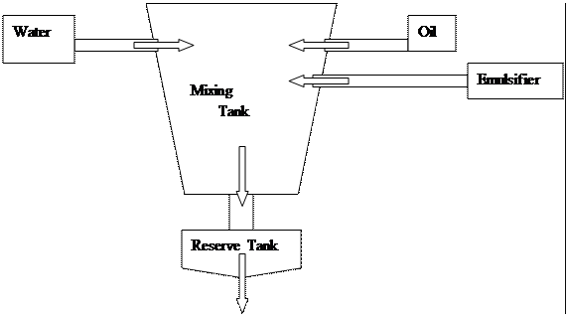

**Procedure of emulsion preparation**:

* First emulsifier and equal quantity of mineral oil are place in the mixing tank and mixed until a jelly like substance is formed.
* Then the remaining oil is added and slowly heated and mixed for 35 minutes
* Then required amount of water is add and mixed for about 20 minutes until required form is achieved.
* After that the emulsion is transferred to the reserve tank and kept there for 20 minutes.
* Then it is transferred to the softener or spreader machines.

**Softener Machine:**

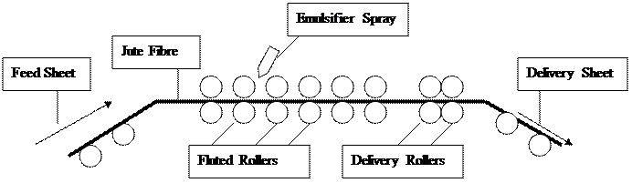These machines consist of 24 to 64 pairs of rollers and these are spirally fluted and jute goes through them. When the jute passes one third of the rollers then the emulsion is added with the spray. Then through the delivery rollers the jute is passed on to the delivery sheet.

**Machine specification:**

1. Length: 16 feet
2. Motor rpm: 715 revolutions per minute
3. Surface speed of feed roller: 83.84 inch per minute
4. Surface speed of fluted roller: 93.86 inch per minute
5. Surface speed of delivery roller: 103.4 inch per minute

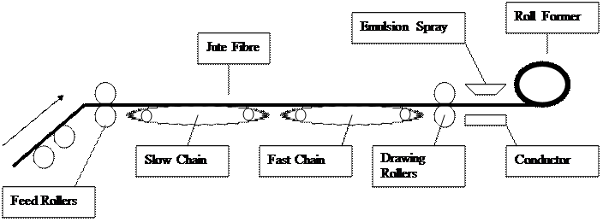**Spreader Machine**

The jute fibres first enter through the feed rollers on to the slow chain. This contains pins or grill bars which have a combing action on the jute. Then the jute moves to the fast chain which moves 10 to 12 times faster than the slow chain. Here combing action occurs and also due to the speed variations the fibres get a draft of 10. Then the jute moves to the conductor plate where it is sprayed with emulsion and at last it is rolled up by the roll former.

**Carding:**

Carding is the process by which long strikes of jute fibres, while passing through high speed pinned rollers, are broken down into an entangled mass and delivered in ribbon form of uniform weight per unit length.

**Objects of Carding:**

* To break down the long strikes of jute and split up
* To individualize the fibre
* To reduce the fibres weight per unit length
* To make sliver of uniform weight per unit length
* To mix the quantities of jute fibres

**Types of Carding Machines:**

1. **Mono Carding**: the breaker and finisher card are to separate machines but the jute is directly delivered from the delivery of the breaker to the feed of the finisher card.

http://jute21texwiz101.zxq.net/Pictures/clip_image006.gif

2. **Dual carding:** the breaker card and finisher card work separately and are not joind together.

http://jute21texwiz101.zxq.net/Pictures/clip_image007.gif

3. **Tandem Carding**: the breaker and the finisher card are combined together to form one carding machine. The two machines have common parts. The jute passes from doffer of the breaker card to the taker in of the finisher card.

Text Box: Breaker + Finisher card

**Types of carding machines according to cylinder direction:**

1. **Up striking**: In this card the material moves over the cylinder

2. **Down striking**: In this card the material moves under the cylinder

**Types of carding machines according to path of jute:**

1. **Half Circular**: Here the jute travels half the circle of the cylinder.

2. **Full Circular**: Here the jute travels the entire circle of the cylinder.

**Breaker Card:**

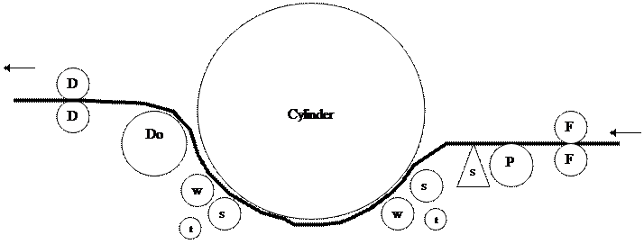

D = Delivery roller

Do = Doffer

W = Worker roller

S = Stripper roller

T = Tin cylinder

S = Shell

P = Pin roller

F = Feed roller

**Principle of Breaker Card:** It is a down striking and half circular carding machine. Its feed is at one side of the machine and delivery is on the opposite side.

**Working regions:**

* Combing action occurs between stripper and worker roller.
* Carding action occurs between cylinder and worker roller.
* Opening spreading ocurrs between shell and pin feed roller.

**Speed of rollers:**

Cylinder: 2400 – 2700 feet per minute

Feed roller: 9 – 14 feet per minutes

Worker: 35 – 50 feet per minutes

Stripper: 300 – 500 feet per minutes

Doffer: 75 – 95 feet per minutes

Delivery roller: 150 – 200 feet per minutes

**Finisher Card:**

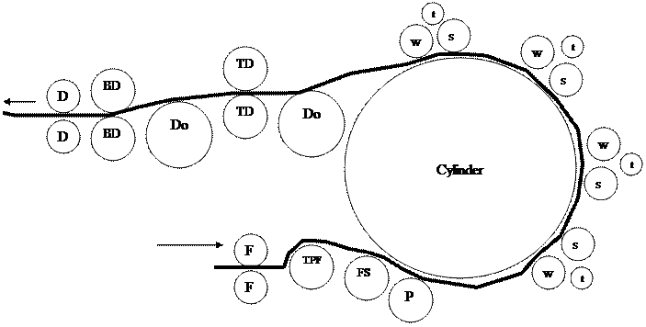

D = Delivery roller

Do = Doffer

W = Worker roller

S = Stripper roller

T = Tin cylinder

S = Shell

P = Pin roller

F = Feed roller

TPF = Top Feed Roller

FS = Feed Striper

TD = Top Drawing Roller

BD = Bottom Drawing Roller

**Principle of Breaker Card:** It is a down striking and full circular carding machine. Its feed and delivery are on the same side of the machine.

**Working regions:**

* Combing action occurs between stripper and worker roller.
* Carding action occurs between cylinder and worker roller.
* Opening spreading occurs between cylinder and pin feed roller.

**Speed of rollers:**

Cylinder: 2400 – 2800 feet per minute

Feed roller: 10 – 15 feet per minutes

Worker: 30 – 40 feet per minutes

Stripper: 300 – 500 feet per minutes

Doffer: 75 – 100 feet per minutes

Delivery roller: 150 – 200 feet per minutes

**Cause of excessive droppings in Jute Breaker Card:**

1. Hard and specky jute fibre.
2. improper emulsion application
3. improper speed ratio of different rollers
4. faulty roller pins
5. more work load on pin
6. high or low moisture regain
7. if any roller is eccentric

**Cause of excessive Sliver wastage in Jute Breaker Card:**

1. more moisture regain
2. faulty roller setting
3. faulty pin
4. jam or lapping due to faulty drawing
5. faulty auto stop motion
6. frequent quality change
7. operation negligence

**Some Definitions:**

**Carding ratio:** It is ratio between the surface speed of cylinder and surface speed of worker roller.

**Carding efficiency:**

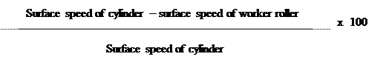

**Card pinning:** the process by which pins are set on different rollers in the card.

**Clock length:** the length of the feed material which is fed per one revolution of clock pointer is called clock length.

**Dollop weight:** the weight of the feed that is fed per one revolution of the clock pointer is called dollop weight.

References:

* 1. Manual of Textile Institute (UK)

Principles of short Staple Spinning: Volume-1 – 6

By: W. Klein

* 1. Principles of short Staple Spinning: Volume-1

By: Prof. Dr. Engr. Ayub Nabi Khan

* 1. Lecture series of Prof. Dr. Mohammad Ali