Technology of Printing

Textile Printing:

Textile printing is the process of localized application of dyes or pigments and chemicals by any method which can produce particular effect of color on the fabric according to the design.

Methods of Textile Printing:

Method of printing means the method of producing printed pattern. Followings are the important textile printing methods-

- Block printing
- Screen printing
  - Flat screen printing
  - Rotary screen printing
- Stencil printing
- Roller printing
- Transfer printing
- Flock printing
- Burn-out printing
- Duplex printing
- Batik printing
- Air brush painting
- Spray Printing
- Digital ink-jet printing

Block printing:

It is the oldest and most artistic printing method. It is an easy manual process for printing single color. The block used has a general size of 3”x4”–9”x12”.

Block preparation:

A suitable piece of wood, free from all defects is cut to size. The next step is ‘putting on’ of the pattern. A careful outline tracing of the design is transferred by on it and the ground between the color parts are removed.

Process of printing:

The fabric is stretched on a flat table covered with resilient substance, back grey and gunny cloth. The print paste is kept on a color pad. The color pad is kept in a color tray. The block is carefully placed on the color pad. Then it’s raised and the impression of the design is obtained by stamping the block smartly by hand on cloths. After each transfer of print paste the color pad is resupplied evenly with color by means of tie ring brush.

Advantages:
1. Any design can be done.
2. No need of elaborate and extensive equipment.
3. Low initial cost.
4. Simple to operate.

Disadvantages:
1. Slow method and low output.
2. Time consuming.
3. Skilled operator and great care needed.
4. Difficult to join up each repeat perfectly.
5. Difficult to produce multicolor design. (No of blocks = no of color)
Screen printing:

Screen printing is an easy process to produce multicolor design. This system requires the use of screen and squeegee. With the help of this squeegee, color is moved on to the fabric. The screens, used are mainly rotary screen and flat screen.

Classification of screen printing machines:

There are four types of screen printing machines. These are –

- Hand screen printing machine (flat)
- Semiautomatic screen printing machine.
- Automatic (fully) flat screen printing machine.
- Rotary screen printing machine.

1. Hand screen printing:

This type of printing is fully manual process and is now confide normally for high fashion designs. This process is carried out on a flat table covered with resilient support (flat) and a washable blanket over which back grey is placed. The fabric to be printed is adhered on the blanket with clips / brackets and screens are pressed on fabric one for each color. Heat for drying the printed fabric may be provided either under the blanker or by hot air fans. Fabric movement or shrinkage must be avoided during printing in order to maintain the required outline of the design. So some water soluble adhesive is placed on the back grey before fabric is laid down on it. Before commencing to print a design, it must be reproduced on the screen. One screen is required for every color. The process sequence is as follows:

- Fabric preparation – cotton / polyester / blended etc.
- Print paste preparation – various types according to requirement.
- Printing by using screen.

The printing process consists of forcing a viscous print paste through the open areas of the screen with a flexible synthetic rubber blade known as a squeegee. The rubber blade which is contained in a wooden or metal support is drawn steadily across the screen at a constant angle and pressure. If the screen is too wide to allow one operator to reach all the way across it, two operators may work together, one on either side of the table. The pressure exerted by each of the two must be as similar as possible.

For multicolor printing, first one color is printed. Then that screen is picked up and another screen is placed on the same area. Next another color is printed. In case of hand printing, curing process is not carried out. After printing, the screen is washed properly. The initial amount of print paste is very important, otherwise shade variation may result.

Advantages of hand screen printing:
1. Low initial cost.
2. Machinery problem not present.
3. Drying system not necessary.
4. Suitable for small scale production.
5. Multicolor produce possible.

Disadvantages of hand screen printing:
1. Fastness is poor because after treatment cannot be carried out properly.
2. Not suitable for large scale of production.
3. Skilled operator required.
4. Slow process rate.
5. More labour required.

2. Semi-automatic screen (flat) printing machine:

This is almost same as hand screen printing, but the manual process has been semi-automated by mounting the screen on a carriage and driving the squeegee mechanically across the screen. Long tables, typically 20 – 60 m long, are used and some provisions are usually made for drying the printed fabric.

It is still popular when high productivity is not required. In both hand and semi automatic flat screen printing, the colors are printed one after another with time for drying between printing one color and the next. That means the situation approaches “wet on dry” printing and but sharp results can’t be achieved by printing the colors in more rapid succession (“wet on wet”).

3. Fully automatic screen printing machine (flat bed):

In fully automatic screen printing machine, all the screens for the design (one screen for each color) are positioned accurately along the top of a long endless blanket. This is the most used process and 8 – 12 colors can be used & no. of screen is more (from 7 to 12).

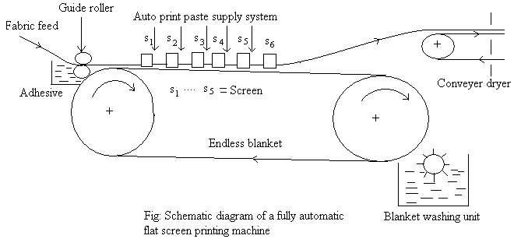

Process description:

The fabric is gummed to the blanket at the entry end and moves along with the blanket in an intermittent fashion, one screen repeat distance at a time. There is a water soluble adhesive unit at the entry zone; adhesive helps the fabric to be firmly attached and smooth with the blanket. All the colors in the design are printed simultaneously while the fabric is stationery. Then the screens are lifted and the fabric & blanket move on. When the screen is on the fabric, fabric can’t pass because it can be torn. So, screen must be moved upward to assist in the passing of fabric. When the fabric approaches the turning point of the blanket, it is pulled off and passed into a dryer in a little slack state, then into the steaming chambers.

The soiled blanket is washed and dried during its return passage on the underside of the machine. As the adhesive is water soluble, it is easily washed off. The width of the gap between the area printed by one screen and the area printed by adjacent screen must be a whole no. of length ways designs repeats.

4. Rotary screen printing machine:

It is a continuous printing method; the continuous rotation of the cylindrical screen in contact with fabric ensures continuous printing. It is also one kind of roller printing and is very advantageous. So, now days, it is replacing flat screen. The design of the most machines follows the pattern established for fully automatic flat screen machines.

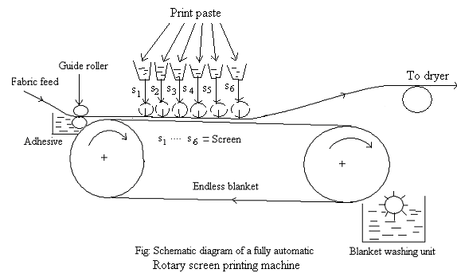
Process description:

The print paste is pumped from a container into the screen through a flexible pipe. During printing, the paste is forced out through the design areas with the aid of stationery squeegee. The fabric to be printed runs in contact with the screen on an endless blanket. An adhesive unit applies adhesive to the cloth and washing unit helps in washing.

The screen is adjusted at its two ends but it can rotate. The driving can be done at either side. Its driving mechanism is very complex as screen, fabric and blanket- all are rotating simultaneously. So, each must be maintained individually. The main controlling/maintaining points are:-
- Regulation of speed.
- Squeegee system.
- Driving mechanism.

After a certain time, it must be checked that all colors are being uniformly printed on fabric. The fabric speed ranges from 30 – 50 m/min. standard international circumference of the cylindrical screen is 64 – 65 cm.

Difference between Rotary Screen Printing and Flat Screen Printing:

Rotary screen printing | Flat screen printing
1. It is truly a continuous process. | 1. It is not a true continuous process because the printing is done when the fabric is stationary.
2. Rod, blade and air flow squeegee systems are used. | 2. Double blade and magnetic rod squeeze systems are used.
3. The repeat area is subjected to limitation i.e. 64 cm. | 3. Repeat area can be higher than that of rotary screen.
4. Production is high. | 4. Production is low.
5. Not very economical for small runs because the preparation of screen is more costly. | 5. Economical for shorter runs as the screen preparation is relatively cheap.
6. Rotary screen gives rotation. | 6. Flat screen does not give rotation.
7. Higher speed. | 7. Lower speed.
8. Less pressure is needed. | 8. More pressure is needed.

Roller printing:

Roller printing or M/C printing is the most economical and fastest way of printing. The output of this M/C cannot be surpassed by any other method of printing. Designs with up to 16 colors present no problem in Roller printing.

Construction:
- This M/C consists of a central pressure bowl (1) suitably wrapped with layers of cloth called lapping (2) around which an endless woolen blanket (3) ,a back grey (4) and the cloth (5) to be printed circulate in contact with each other.
- An engraved printing roller of shell (6) mounted on a steel shaft or mandrel (7) revolves in contact with the pressure bowl above and a furnisher roller (8) below which partly dips in the printing paste kept in the color box (9).
- A sharp edged steel blade called color doctor (10) rests on the engraved roller on one side and a brass blade lint doctor(11) rests on the other by suitable weights and levers.

Working procedure:
- The fabric to be printed is placed on the impression cylinder. The pressure cylinder comes to the contact of engraved roller by rotating forwards.
- The engraved roller is first supplied with the printing paste by the furnisher roller. This paste is deposited in the engravings as well as applied on the smooth surface.

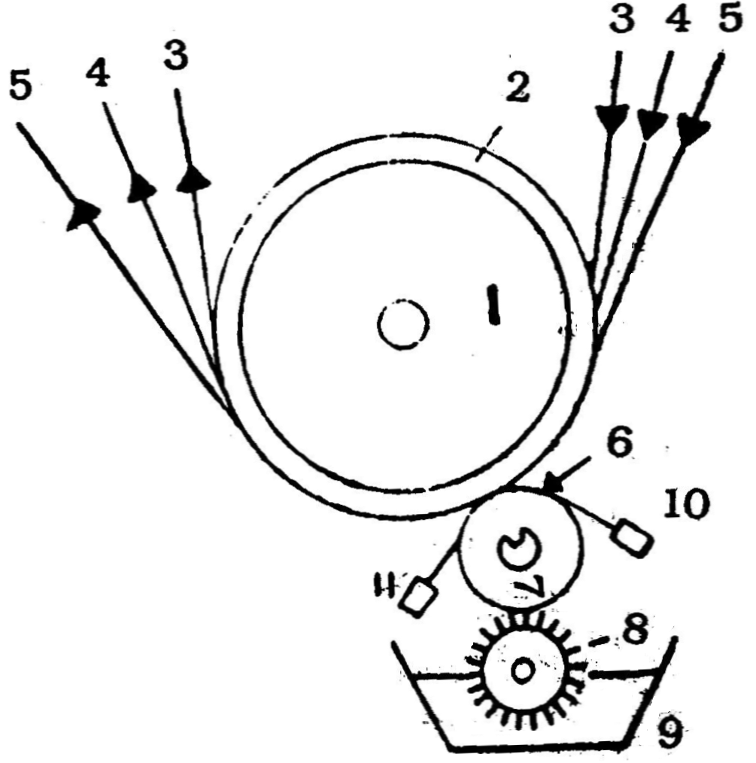

Fig: Roller printing m/c

- When the engraved roller rotates, it comes into contact with the color doctor which scrapes the excess color (paste) from the smooth surface and allows the paste deposited in the engravings to remain there. Subsequently, it makes an impression on the fabric by depositing the paste contained in the engraving.
- During the further rotation of the engraved roller, it meets the lint doctor which is placed at an angle against the rotation of the roller. It cleans the engraving rollers by removing fibres, faulty matters.
- A no. of engraved rollers provided with separate furnishers, color boxes and color doctor and lint doctors are placed around the central pressure bowl so that by a single passage of the cloth through the M/C all the colors required in the design are printed, each roller supplying a part of the design.

Advantages:
- Suitable for large scale production.
- High speed M/C and hence more production.
- Can be used for fine printing.
- Can be made/prepared high quality design due to not joint mark.
- Possible to print in complex weave design.

Disadvantages:
- Changing time high. So, not suitable in small scale production.
- Engraving the printing roller is an expensive operation.
- May be light printing shade.
- Crush effect produce.

Difference between Rotary Screen and Roller Printing:

Rotary Screen Printing | Roller Printing
1. Printing is done by specially made perforated cylindrical or spherical screen. | 1. Printing is done by specially engraved roller.
2. Paste is pumped to the screen and distributed lengthwise by pumps. | 2. Paste is transferred to the engraved roller by color furnishing roller.
3. Up to 24 colors can be printed but, 8-10 are printed easily. | 3. Even 16 engraved rollers can be used for different colors of pattern.
4. Can be printed woven and knitted fabric. | 4. Can be printed woven and tricot fabric.
5. The main equipment of printing is rotary screen. | 5. The main equipment of printing is Engraved roller.
6. Design can be changed quickly | 6. More time required for changing of pattern.
7. Engraving cost is slightly lower than copper roller. | 7. Engraving costs is higher.
8. Setting up time is lower. | 8. Setting up time is higher.
9. Production rate is high. | 9. Production rate is medium.
10. Pressure of fabric is low. | 10. Pressure of fabric is high.
11. Skillness required by the operator is low. | 11. Skillness required by the operator is high.
12. Color applied is more flexible. | 12. Color applied is less flexible.

Defects in Roller Printing:
- When sand particles in the printing paste cut the smooth surface of the unengaged roller, the scratches produced will also transfer the paste to the cloth. By burnishing the roller as well as by straining/filtering the printing paste again this fault may be removed.
- Sometimes large double stripes of color called snappers appear along the length of the cloth due to solid coming under the color doctor edge. Washing, cleaning the doctor blade, roller and filtering the paste are to prevent this defects.
- Streaks appear as fine lines or series of lines running along the piece and parallel to selvedge due to scratches on the engraved roller and cut in the color doctor blade edge. Polishing the roller and sharpening the doctor blade edge can remedy this problem.
- Scrumming is the fault arising out of insufficient scraping of the printing paste from the unengraved portion of the printing roller by the doctor blade.
- Uneven printing is another fault due to the faulty of the cloth, the roller, the printing paste and working of the M/C.
- The printed cloth with deeper shades near one selvedge than near the other due to uneven pressure exerted by the engraved roller on the pressure bowl and faulty setting.
- If the fitting of the engraved roller on the mandrel is not perfect, it slips while rotating, this defect known as lobbing of the engraved roller.

Defects in Screen Printing:
- When uneven pressure is exerted by the squeegee during the stroke, the resulting print becomes lighter on one selvedge and becomes gradually deeper towards the other .Uneven steaming may also lead to this fault.
- The prints may come out lighter in the middle and deeper towards the selvedges. This occurs when too much cloth is steamed in one batch or when the cloth is very thick.
- Very small specks of color appear on the ground (unprinted portions) when the screen has tiny holes in the blocked areas. In this case, the screen should be inspected and lacquer applied at these places.
- When the printing has too much solids in it, especially in pigment printing, the screen may got choked (clogged) during working. This results in light prints after working for some time.
- When the screen is placed on a previously printed area with another color, which is not dried , the back of the screen picks up some paste and transfers it to the next area where it is placed, leading to smudging of the print.
- Deeper prints are obtained irregularly throughout the material. This may due to uneven table surface and hence the squeegee exerts different pressures at different places.
- Deeper prints appear throughout the cloth in the direction of the weft (direction of the squeegee stroke). Uneven edge of the squeegee leads to this fault. This may remedied by sharpening in the squeegee edge.
- If the squeegee vibrates while applying the pressure (stroking) deep stripes along the warp appear.
- When a paste containing a large amount of foam is printed, lighter prints are obtained throughout the cloth.
- If a soft squeegee is used on a hard table surface deeper prints are produced. On the other hand, if a hard squeegee is used on a soft table surface, fine lines of the designs are not obtained.

Styles of printing:

Styles of printing means the manner in which a printed effect is produced. Styles of printing are-
- Direct style
- Discharge style
- Resist style
- Azoic style
- Creep style
- Flock style
- Burn-out style

Direct style:
The dyes are printed directly at the required places on the fabric to produce multi colored design, leaving the other portions white. Thus a multi colored print on a white ground can be produced.

Discharge style:
Discharge style of printing means the process which can produce a white or color effect on a previously dyed ground. Discharge style of printing is carried out by the following steps-
1st step: Dyeing: Fabric is dyed firstly with an easily reducible dye.
2nd step: Printing:
- The fabric is printed with a thickened solution of discharging agent.
- This discharging agent destroys the color at the printed areas and leaves the dye of unprinted areas unaffected.
- If any dye is present in the solution of discharging agent which is not affected by its discharging action, can also be deposited and fixed on the ground.
- Reducing agent must be stronger than Dye.
3rd Step: Steaming
4th Step: Washing

Types of discharge style:
I) White discharge: After dyeing and printing, the discharge agents discharge the dye of printed areas and leave the dye present on the unprinted area unaffected. A while design is produced on color ground.
II) Color Discharge: The colored printing paste removes the initial value from the colored ground and at the same time deposits color on the original ground.

Resist style:
In this process, a substance is applied to the fabric that will prevent the fixation of any coloring agent employed afterwards on that area. Resist style of printing is carried out by the following steps-
Step-1: Printing-The fabric is printed with a resist salt solution which is sprayed on the fabric mechanically or manually.
Step-2: Dyeing-The fabric is dyed with a suitable dye as a result the areas covered by the resist salt will not be dyed and other portions would be dyed.
Types of resist style:
I) White Resist: No color is added to the print paste solution with resist salt and after dyeing the printed area remains white.
II) Color resist: Coloring matter is added to the print past with resist salt. The printed area contains the color added to print paste and the remaining areas will contain the color of dye solution.

Flock Style:

Flock is a branch of short fibre. In the electrostatic method of flocking, the fabric is printed with on adhesive and passes on a moving belt through an electric charge. The flock made from cotton, rayon, is filtered from the flock hopper on to the fabric and is attracted to the adhesive.

Creep Style:

In this style, printing is performed after alkali treatment or heat setting.

Difference between Discharge Style and Resist Style of Printing:

Discharge Style | Resist Style
1. It is always sharp in outline, bright in appearance. | 1. It is less sharp in outline and less bright.
2. Discharging agent is used. | 2. Resist salt is used.
3. Strong chemical reaction is required. | 3. No chemical reaction due to pre dyeing.
4. At first the fabric is dyed and then discharging printing. | 4. At first resisting salt printed and then fabric is dyed.
6. Discharging agent destroy pre fixed dye of fabric. | 6. Resisting salt resist to be fixed of color on the fabric.
7. The cost of discharging agent is high. | 7. Resist salt is cheap.
8. More wastages of dye. | 8. Less wastage of dye.

Textile Thickener

Thickener:

Thickener is a thick mass which imparts stickiness and plasticity to the print paste so that it may be applied on the fabric surface without color bleeding or spreading and be capable of maintaining the design outlines even under high pressure.

Functions of thickener in print paste:

- To give required viscosity to the print paste.
- To prevent premature reaction between the chemicals contained in the print paste.
- To hold the ingredients of the paste on the fabrics.
- To hold or adhere the dye particles in the desired place on the fabric.

Factors to be considered to select a suitable thickener:

- Should have certain physical and chemical properties.
- Type and quality of material to be printed.
- Compatibility with dyes and chemicals.
- Print paste stability.
- Styles and methods of printing.
- Properties of the dried thickener film.
- Effect on color yield, such as-diffusion, fixation.
- Easy preparation and removal of the thickener.
- Cost consideration and economically availability.

Classification of thickener:

1) Natural thickener
- Cereal starch (ex-maize starch, wheat starch)
- Plant exudates (ex-gum tragacanth, gum arabic, gum karaya)
- Roots and seeds (ex-guar gum, locust bean gum)
- Sea weeds (ex-sodium alginate)

2) Modified natural thickener
- Starch derivatives (ex-british gum)
- Cellulose derivatives (ex-carboxyl methyl cellulose , hydroxyl ethyl cellulose)
- Gum derivatives (ex-meypro gum)

3) Synthetic thickener
- Acrylic (ex-polyacrylic acid, polyacrylic amides)
- Vinyl (ex-polyvinyl alcohol, polyvinyl chloride, polyvinyl acetate)

