Textile Finishing

Finishing is the general term for a multitude of processes and treatments which a fabric may undergo after it has been made (woven or knitted) and colored (dyed or printed). It is the final processing of the cloth and its purpose is to make the fabric suitable for its intended end use. For example, making the fabric shrink proof, softer, stiffer, water repellent, crease resistant or a combination of these properties.

Classification of Textile Finishing:

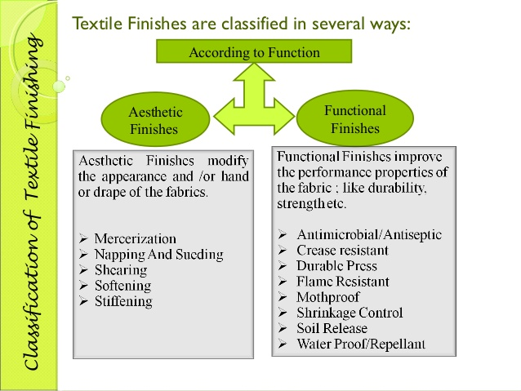

Textile Mercerization

Mercerization is a physio-chemical treatment of cellulosic textiles in yarn or fabric form, where the fabric or yarn is treated with highly concentrated caustic soda solution (20-25%) at lower temperature (15-18 ⁰C). Mercerization is one of the most important of all cotton finishes and is a permanent chemical finishing process. This finish imparts luster to the cotton, increases its tensile strength by nearly 25% and improves dye affinity, producing brighter shades than unmercerized cotton. It also enhances the handle as well as uses less dye to achieve the same depth of shade. Both the fabrics and yarns can be mercerized, but fibres cannot.

Importance of Textile Mercerization Process

- Improved luster of yarn or fabric
- Improved ability to absorb dye
- Improved reaction with a variety of chemicals
- Improved stability of form
- Improved strength and elongation
- Improved smoothness
- Improved handle

Conditions of Mercerization:

- Temperature (ideal temperature of mercerization is 15-18⁰C)
- Tension during mercerization (tension should be sufficient to achieve the desire effect)
- Caustic soda concentration (most commonly used concentration is 20-22%)
- Nature and mount of wetting agent (usually 0.5-1% of wetting agent is used)
- Time of mercerization (30-60 seconds time is enough to achieve the mercerizing effect)
- Washing condition (washing under stretched condition after mercerization is very important)

Reasons of Physio-chemical Changes of Cotton after Mercerization:

- Kidney shaped becomes almost circular (oval shape) in cross-section, so light reflection becomes more uniform and lustre is improved.
- NaOH acts as decrystallising agent which causes increasing amorphous region of cotton. As a result, no. of available –OH groups in the fibre are increased, which contribute in water absorbency and dye affinity.
- Molecular orientation of cotton is increased after mercerization and thus higher strength of fibre is obtained.
Shearing Process

Shearing is a mechanical permanent finishing process by which the fibres protrude from the surface of a fabric is cut to an even height. One important use of this technique is the production of pile fabrics from a looped terry and fleece fabric. When this type of fabric is sheared, the top of the loops of the fabric are cut off and velvet like appearance is produced. When knitted loops of fleece fabrics are sheared, knitted velour effect is produced that has great deal of use in upholstery fabric. Velour is used in dance wear, stage curtains and is also popular for warm, colorful casual clothing. When used as upholstery, velour often is substituted for velvet.

The shearing machine can process a wide range of fabrics. Knitted fabrics can be processed in open width form but these cannot be processed in tubular form. Shearing Process is very important to cut the pile of random lengths present on fabric surface at a constant level of height and hence produce a certain hand feel, pile and velour effect. The process can also improve the color and appearance of the fabric.

Importance of Shearing Process

- To clear out random lengths of fibers and produce a uniform pile
- To cut the pile present on a fabric surface at a constant level of height
- To prevent pill formation on the cloths
- To produce a certain hand feel onto the cloths
- To improve the color and appearance of the fabric

Crease Resistant Finishing

Crease resistant finishing is a special type of chemical finishing process by which resins are applied on textile materials so that resins can cross-link inside the amorphous region of fibre and thus improve the crease recovery angle of the textile material. Sometimes, resins are also known as cross-linking agents, which are used on cotton, rayon and linen, because these three fibres are wrinkled easily. The textile material is saturated with the crease resistant finishes or resin finishes and then the resin is cured at the temperature ranges from 180-190°C.

Importance of Resin Finishing

- Improved crease resistance and crease recovery property is achieved.
- Resin finishes improve resilience, handle and draping properties of cloths.
- It increases the strength of rayon in both dry and wet condition.
- It decreases the extension of rayon with freedom from distortion.
- Resin finishes decrease the shrinkage on laundering.
- By resin finish color fastness of dyed goods can be improved.
- Resin finish sometimes resists the degradation of textile material by light.
- Resin finish gives comfort to the wearer.
- It imparts adequate wear and tear resistance of fabrics.
- Good soil repellency and easy removal of soil by washing can be achieved by resin finish.

Types of Cross-linking Agent used in Crease Resistant Finishing

The most important synthetic resins or cross-linking agents can be used for surface coating are:

- Phenol formaldehyde
- Urea formaldehyde
- Tetra methylol acetylene di-urea
- Dimethylol ethylene urea (DMEU)
- Dimethylol dihydroxy ethylene urea (DMDHEU)*

Benefits of Using DMDHEU as Creases Resistance Finish on Cloths

- It is very effective resin at low concentration.
- Its durability is very high.
- It does not reduce the colorfastness properties of dyed materials.
- Suitable for both colored and white fabrics and extensively used for high quality suiting.
- It does affect the fabric handle.
- It has more ability to be post-cured for permanent creases.
- It does not cause strength loss in cloths.

Differences between Crease Resistance and Crease Recovery

Crease resistance | Crease recovery
1) It is a property of fabric that resists fabric from creasing. | 1) It is a fabric property that indicates the ability of fabric to go back to it’s original position after creasing.
2) Crease resistance comes into play before the fabric is creased. | 2) Crease resistance comes into play after the fabric has been creased.
3) It resists the stretching and compression of molecular chain of fibre polymer. | 3) By this property, stretched or compressed polymer chain comes back to normal position.

Water Repellent/Proof Finishing

Water repellency is a feature of textile material by which it prevents the spreading of a drop of water on its surface. Water repellency can be defined as the ability of the fabric to withstand wetting or penetration by water under the test conditions. Water repellent fabrics have open pores and, by finishing the interstices between warp and weft yarns remain unaltered or little affected. So, these are air permeable and also allow water vapor to pass through.

On the other hand, the term “water proof” is used to define a fabric coated with a solid surface film with no or little air permeability. When a uniform coating of suitable substances such as rubber, fats, wax etc. is produced on the surface of the fabric the interstices between the warp and weft yarns are blocked by the continuous film of the substance and the fabric becomes completely impervious to water. The treated fabric becomes impermeable to air also. This type of finish is called as water-proof finish.

The textile material is padded with the water repellent or water proof finishes and then is cured at the temperature ranges from 140-150°C.

Differences between Water Proof Fabric and Water Repellent Fabrics

Criteria | Water proof fabric | Water repellent fabric
1) Fabric pores | 1) Filled. | 1) Open.
2) Water vapor permeability | 2) None to very small permeability. | 2) Small to large permeability.
3) Air permeability | 3) None to small permeability. | 3) Usually large permeability
4) Resistance to water permeability | 4) Highly resistant even under external hydrostatic pressure. | 4) Resistant to wetting by rain drops. Permits water only under external hydrostatic pressure.

Name of Important Water Repellent Finishes:

There are two types of water repellent finishes, namely, durable finish and non-durable finish. Durable finish can withstand after washing many times whereas non-durable finish cannot withstand against washing for many times. Following finishing agents can be used to make the fabrics water repellent.

- Aluminium salts
- Aluminium salt and wax combination
- Zirconium salt and wax combination (Phobotex FT)
- Pyridinium chloride (Velan PF)
- Silicones (polysiloxanes)*
- Fluorochemicals (polyacrylates)

Silicone Water Repellent Finishes

Silicones are relatively new class of durable water repellents which are very popular and widely used for its high solubility and chemical inertness, more durability, relatively low flammability, and non-toxic nature.

The silicon polymer (-O-Si-O-) used as water repellent, is named as polysiloxane. There are three types of polysiloxane, namely, i) dimethyl polysiloxanes, ii) methyl hydrogen polysiloxanes and iii) hydrogen polysiloxanes. Among three polysiloxanes, methyl hydrogen polysiloxanes impart high water repellency.

