**4. Question of Midterm & Final Examination**

**Hard Copy Submitted to Mushfiq**

**5. Student Attendance Sheet**

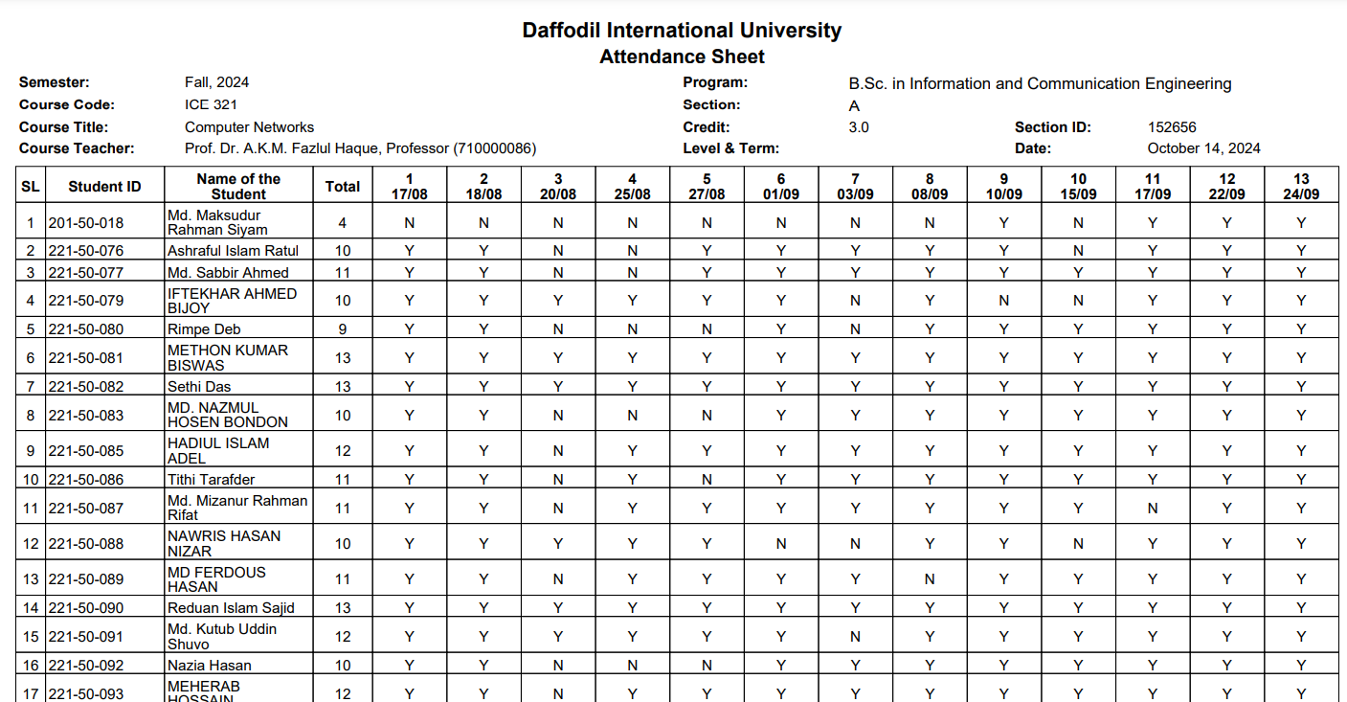

**6. Lesson Plan & Lecture Note https://elearn.daffodilvarsity.edu.bd/course/view.php?id=26763**

**7. Students Answer Scripts (Class Test-3 for each, Mid Term-3, Final-3), Assignment Copy with Rubrics**

**Photocopy available to Dept.**