**YEAST**

Yeast are single-celled fungi. As fungi, they are related to the other fungi that people are more familiar with, including: edible mushrooms available at the supermarket, common baker’s yeast used to leaven bread, molds that ripen blue cheese, and the molds that produce antibiotics for medical and veterinary use. Yeast cells are egg-shaped and can only be seen with a microscope. It takes 20,000,000,000 (twenty billion) yeast cells to weigh one gram, or 1/28 of an ounce, of cake yeast.

**A tiny organism with a long name**

The scientific name for the yeast that baker’s use is *Saccharomyces Cerevisiae*, or “sugar-eating fungus”. A very long name for such a tiny organism! This species of yeast is very strong and capable of fermentation, the process that causes bread dough to rise.

**A fungus with a sweet tooth**

Yeast cells digest food to obtain energy for growth. Their favorite food is sugar in its various forms: sucrose (beet or cane sugar), fructose and glucose (found in honey, molasses, maple syrup and fruit), and maltose (derived from starch in flour).

The process, alcoholic fermentation, produces useful end products, carbon dioxide (gas) and ethyl alcohol. These end products are released by the yeast cells into the surrounding liquid in the dough. The ethyl alcohol (and other compounds) produced during fermentation produce the typical flavor and aroma of yeast-leavened breads. Growing yeast love to eat sugar and starches, like the ones in bread flour. When they eat these starches, some of the proteins in the flour, called glutens, swell up. Yeast eating starch make a gas called carbon dioxide that forms lots of tiny bubbles in the bread dough. The history of **yeast** took a decisive turn in 1857 when Louis Pasteur **discovered** the fermentation process. Relive this small nineteenth century revolution! Type of metabolism allowing the cell to acquire energy by transforming glucose into ethanol and carbon dioxide.

**Reproduction of Yeast**

1. 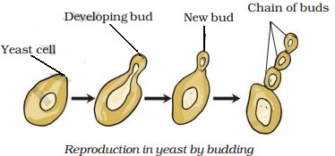**Vegetative reproduction:**

The vegetative reproduction takes place by means of ‘budding’. This method of reproduction takes place in favourable conditions when the yeast cells grow in sugar solution. From each yeast cell one or more small outgrowths are given out, which gradually enlarge in size, detached from the mother cells and act as independent individuals. The nucleus of the mother cells divides amitotically and transfers to the daughter cell. Several other outgrowths develop from the newly formed outgrowths, and sometimes the chains of the cells are seen. Very soon the yeast cells are detached from each other and act as new independent individuals.

**2. Asexual reproduction:**

This type of reproduction probably takes place in adverse conditions, especially when there is scarcity of nutrients and abundance of oxygen. The yeast cell enlarges in size and called the ‘ascus.’ The nuclues of the ascus divides twice producing four nuclei. Now around each nucleus the cytoplasm deposits and the four ascospores are formed. Sometimes eight ascospores may also be produced.

Each ascospore is surrounded by a thick wall. These spores are perennating bodies. They remain dormant in adverse conditions. On the approach of favourable conditions they germinate. The ascus wall bursts and the ascospores liberate « in the atmosphere. They are dispersed by wind from one place to another. On getting suitable media and appropriate weather conditions the ascospores 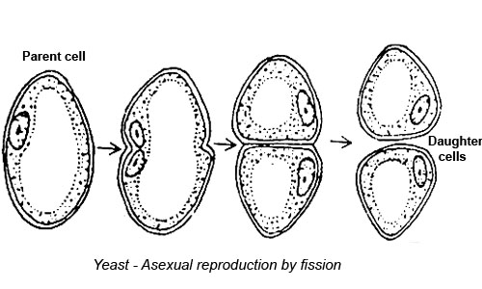germinate and the new individuals are formed by budding.

**3. Sexual reproduction:**

The sexual reproduction takes place very rarely in some of the species of yeasts. This takes place by conjugation. Two individuals come close to each other and the beak-like outgrowths are given out from them. These outgrowths fuse with each other. The nuclei of both individuals come in these beaks, the wall of contact dissolves and ultimately the nuclei fuse with each other giving rise to a zygote, which soon converts into an ascus. The diploid nucleus (2n) of asucs divides thrice producing eight nuclei. The first division is reductional to bring haploid (n) condition again.

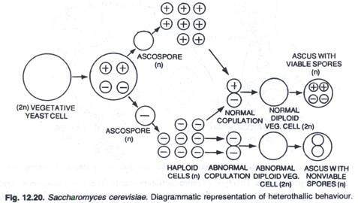

Around each nucleus the cytoplasm is deposited, they become walled and called the ascospores. On bursting the wall of ascus the ascospores are liberated. On getting suitable conditions they germinate and the new individuals are produced by budding.

**Culinary Uses for Yeast**

* Beer: Yeast is added to malted grains and allowed to ferment in order to produce alcohol. The type of yeast used will affect the type and flavor of beer produced. S. cerevisiae, also known as a “top fermenting” or “top cropping” yeast, ferments at a higher temperature and produces sweet or fruity beers. Bottom croppers, such as *Saccharomyces pastorianus*, ferment at lower temperatures and are used to make lagers.​
* Wine: Yeast is naturally present on the skins of grapes and can be used to naturally ferment grape juice into wine. Despite the naturally present yeast, most wines today have pure culture (usually S. cerevisiae) added to them to produce a more consistent and controllable result. There are many different strains of S. cerevisiae and each will produce a unique flavor characteristic in a finished wine.​
* Bread: Records of using yeast as a leavening agent date back to the ancient Egyptians, though the form of yeast used has changed over time. Many varieties are available for [use in bread making,](https://www.thespruce.com/bread-making-yeast-faq-1447197) such as fresh yeast cakes, bakers yeast, active dry, instant, or yeast starter.​
* Nutrition: Raw yeast is not recommended for consumption in quantity as it can proliferate within your body, but once pasteurized, yeast offers a host of nutritional benefits. Yeast is a good source of protein, B vitamins, and minerals. Yeast intended as a nutritional supplement is often sold as “[nutritional yeast](https://www.thespruce.com/what-is-nutritional-yeast-3376833)”
* Use in Medicine: Lowering high cholesterol. Research showed that taking a specific red yeast product for two to three months could significantly lower total and “bad cholesterol” (low-density lipoprotein (LDL) They are also utilized in medicine as a source of enzymes

Medical Science

* Medical Use: Yeast causes Lowering of high cholesterol and triglyceride levels caused by human immunodeficiency virus (HIV) disease (AIDS).
* Genetically engineered bio-factories: Various yeast species have been genetically engineered to efficiently produce various drugs, a technique called metabolic engineering. S. cerevisiae is easy to genetically engineer; its physiology, metabolism and genetics are well known, and it is amenable for use in harsh industrial conditions. A wide variety of chemical in different classes can be produced by engineered yeast, including phenolics, isoprenoids, alkaloids, and polyketides.

**Disadvantages:**

* Yeast infections can range in severity from minor discomfort to a life-threatening ailment, depending on your immune system, the type of yeast, the location of the yeast and the way you combat it
* Yeast rice is a culture of the yeast, grown onrice and consumed as food, may cause hair loss
* Food spoilage: During their growth, yeasts metabolize some food components (sucrose, ethanol, acetic acid) and produce metabolic end products. This causes the physical, chemical, and sensible properties of a food to change, and the food is spoiled
* Intoxication: Yeasts cause Intoxication of food and imbibed drinks
* Resistant: Yeasts can tolerate very high temperature, hence difficult to check their reproduction
* Plant Pathogens: Certain species of Yeast are plant pathogens and decrease crop production Animal Diseases: Some species cause skin, hair and nail infections in humans e.g. Candida Albicans. Yeasts cause respiratory diseases in human’s e.g.Aspergilus

**Yeast Infection**

Candida is the scientific name for yeast. It is a fungus that lives almost everywhere, including in your body. Usually, your immune system keeps yeast under control. If you are sick or taking antibiotics, it can multiply and cause an infection. Yeast infections affect different parts of the body in different ways:

* Thrush is a yeast infection that causes white patches in your mouth
* Candida esophagitis is thrush that spreads to your esophagus, the tube that takes food from your mouth to your stomach. It can make it hard or painful to swallow.
* Women can get vaginal yeast infections, causing [vaginitis](https://medlineplus.gov/vaginitis.html)
* Yeast infections of the skin cause itching and rashes
* Yeast infections in your bloodstream can be life-threatening

Antifungal medicines get rid of yeast infections in most people. If you have a weak immune system, treatment might be more difficult.