**Rickettsiae**

The rickettsiae are a diverse collection of obligately intracellular Gram-negative bacteria found in ticks, lice, fleas, mites, chiggers, and mammals. Howard Ricketts discovered that the bacterium Rickettsia rickettsii was the organism that caused Rocky Mountain spotted fever. Within his research he found out that Rickettsia rickettsii has a very complex life cycle that includes two different hosts (tick and mammals).

**Structure, Classification, and Antigenic Types**

Rickettsia species are small, Gram-negative bacilli that are obligate intracellular parasites of eukaryotic cells. This genus consists of two antigenically defined groups: spotted fever group and typhus group.Five genera in this class cause human diseases:

* Rickettsia
* Bartonella
* Coxiella (does NOT cause skin rash)
* Ehrlichia
* Orientia

There are many rickettsial species, but 3 cause most human rickettsial infections:

* *R. rickettsii*
* *R. prowazekii*
* *R. typhi*

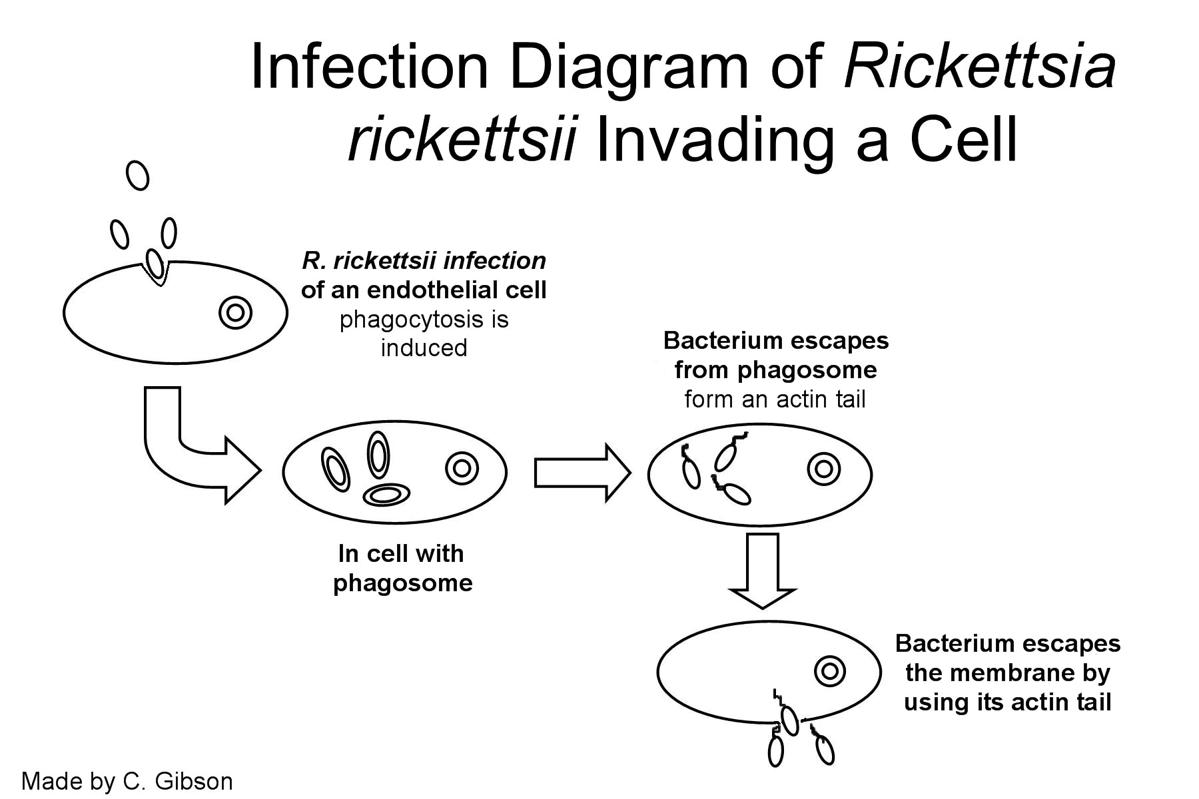

**Clinical Manifestations**

*Rickettsia* species cause Rocky Mountain spotted fever, rickettsialpox, other spotted fevers, epidemic typhus, and murine typhus. *Orientia* (formerly *Rickettsia*) *tsutsugamushi* causes scrub typhus. Patients present with febrile exanthems and visceral involvement; symptoms may include nausea, vomiting, abdominal pain, encephalitis, hypotension, acute renal failure, and respiratory distress.

**Differentiating among rickettsial diseases**

Rickettsial diseases must also be differentiated from each other. Clinical features allow some differentiation, but overlap is considerable:

* [**Rocky Mountain spotted fever**](http://www.merckmanuals.com/professional/infectious-diseases/rickettsiae-and-related-organisms/rocky-mountain-spotted-fever-rmsf) **(RMSF):** The rash usually appears on about the 4th febrile day as blanching macules on the extremities and gradually becomes petechial as it spreads to the trunk, palms, and soles over several days. Some patients with RMSF never develop a rash. Vasculitis often develops; it may affect the skin, subcutaneous tissues, CNS, lungs, heart, kidneys, liver, or spleen.
* [**Epidemic typhus**](http://www.merckmanuals.com/professional/infectious-diseases/rickettsiae-and-related-organisms/epidemic-typhus)**:** The rash usually appears initially in the axillary folds and on the trunk. Later, it spreads peripherally, rarely involving the palms, soles, and face. Severe physiologic and pathologic abnormalities similar to those of RMSF occur.
* [**Murine typhus**](http://www.merckmanuals.com/professional/infectious-diseases/rickettsiae-and-related-organisms/murine-endemic-typhus)**:** The rash is nonpurpuric, nonconfluent, and less extensive, and renal and vascular complications are uncommon.
* [**Scrub typhus**](http://www.merckmanuals.com/professional/infectious-diseases/rickettsiae-and-related-organisms/scrub-typhus)**:** Manifestations are similar to those of RMSF and epidemic typhus. However, scrub typhus occurs in different geographic areas, and frequently, an eschar develops with satellite adenopathy.
* [**Rickettsialpox**](http://www.merckmanuals.com/professional/infectious-diseases/rickettsiae-and-related-organisms/rickettsialpox)**:** This disease is mild, and the rash, in the form of vesicles with surrounding erythema, is sparse and may resemble varicella.
* **African tick bite fever** (due to *R. africae*): Symptoms are similar to those of other rickettsial diseases. The rash is characterized by multiple black eschars on the distal extremities with regional adenopathy.

**Host Defenses**

T-lymphocyte-mediated immune mechanisms and cytokines, including gamma interferon and tumor necrosis factor alpha, play a more important role than antibodies.

**Diagnosis**

Rickettsioses are difficult to diagnose both clinically and in the laboratory. Cultivation requires viable eukaryotic host cells, such as antibiotic-free cell cultures, embryonated eggs, and susceptible animals. Confirmation of the diagnosis requires comparison of acute- and convalescent-phase serum antibody titers.

It is assumed that the observed clinical manifestations of a rickettsial infection are due to production of an endotoxin, although this endotoxin is quite different in physiological effects from that produced by members of the Enterobacteriaceae.

IV-injected rickettsia cause rapid death in experimental animals. UV-irradiation of rickettsia diminishes infectivity without reducing toxicity. anti-rickettsial drugs do not prevent rapid death in experimental animals.Antiserum specific for cell wall antigens of the rickettsia prevents the toxic effect.

**Control**

*Rickettsia* species are susceptible to the broad-spectrum antibiotics, doxycycline, tetracycline, and chloramphenicol. Prevention of exposure to infected arthropods offers some protection. A vaccine exists for epidemic typhus but is not readily available.

**Tetracyclines** are first-line treatment: doxycycline 200 mg once followed by 100 mg twice daily until the patient improves, IV preparations are used in patients too ill to take oral drugs. Although tetracyclines can cause tooth staining in children, experts think that a course of doxycycline is warranted.

**Chloramphenicol** 500 mg po or IV qid for 7 days is 2nd-line treatment.

Both drugs are rickettsiostatic, not rickettsicidal.

**Ciprofloxacin and other fluoroquinolones** are effective against certain rickettsiae, but extensive clinical experience is lacking.Because severely ill patients with RMSF or epidemic typhus may have a marked increase in capillary permeability in later stages, IV fluids should be given cautiously to maintain BP while avoiding worsening pulmonary and cerebral edema.