**Infection:** The invasion and multiplication of microorganisms such as bacteria, viruses, and parasites that are not normally present within the body. An infection may cause no symptoms and be subclinical, or it may cause symptoms and be clinically apparent. An infection may remain localized, or it may spread through the blood or lymphatic vessels to become systemic (bodywide). Microorganisms that live naturally in the body are not considered infections. For example, bacteria that normally live within the mouth and intestine are not infections.

**Pathogenicity:** Pathogenicity refers to the ability of an organism to cause disease (ie, harm the host). This ability represents a genetic component of the pathogen and the overt damage done to the host is a property of the host-pathogen interactions.

**Virulence:** The term “virulence” means the disease-producing (pathogenic) capabilities and mechanisms of a microorganism and also the inherent potential of an infection to cause harm. Virulence is a measure of the degree of disease that a pathogen causes.

**Immunity:** Immunity is derived from Latin word “immunis” which means free from burden. In this case burden refers to disease caused by microorganisms or their toxic products. So we can say, Immunity is the ability of the body to protect against all types of foreign bodies like bacteria, virus, toxic substances, etc. which enter the body. Immunity is also called disease resistance. The lack of immunity is known as susceptibility.

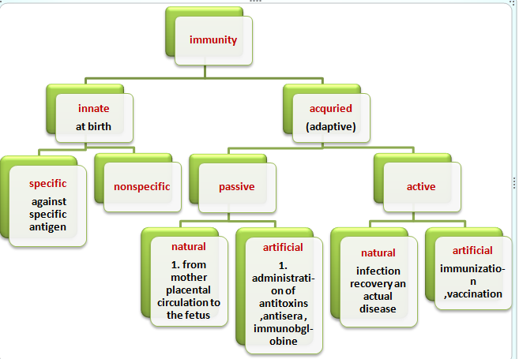

**Innate immunity -** innate immunity is a natural immunity which may be genetically passed on from one generation to other generation. Innate immunity is known as birth immunity. Innate immunity is our first defense against invaders. The epithelial and mucosal linings of our respiratory and GI tracts, as well as our skin are major components of the innate immune system. These act as physical and chemical barriers against pathogens. Cells known as macrophages also play a large role in innate immunity. Macrophages recognize bacterial or viral components such as lipopolysaccharide (LPS) or double-stranded RNA (dsRNA), via special receptors known as Toll-like receptors (TLRs). TLR activation cause macrophages to secrete cytokines (small molecules involved in cell signaling and attraction), as well as to phagocytose the infected cells. The innate immune system is required to activate our adaptive immune system.Innate immunity is commonly divided in to two types.

1. **specific immunity**
2. **nonspecific immunity**
3. **Specific immunity** - we know specific immunity is a type of innate immunity but it is not present from birth because this immunity develop in individual against specific antigen. Basically the immune system produced millions of lymphocyte and each lymphocytes has different antigen receptor. Specific immunity show difference between self-cell and foreign cell. It’s can recognize foreign cell and ignore self-cell. Example of specific immune system its remember pathogens encounter such as chicken pox. Chicken pox is an infection that does not occur once in humans once again.
4. **Nonspecific immunity** - nonspecific immunity is a safety system of our body which protect the human body from infectious diseases, mainly involves all the mechanisms  of our body such as skin  , gastrointestinal tract, genitourinary tract, respiratory tract, mucous membrane, eyes etc. the various nonspecific mechanisms are present they are following -

* Skin
* Mucus membrane
* Respiratory tract
* Gastrointestinal tract
* Genitourinary tract
* Eye

**Adaptive immunity**

Adaptive or acquired immunity is the protection mechanism from an infectious disease agent as a consequence of clinical or subclinical infection with that agent or by deliberate immunization against that agent with products from it. This type of immunity is mediated by B and T cells following exposure to a specific antigen. It is characterized by specificity, immunological memory, and self/nonself recognition.

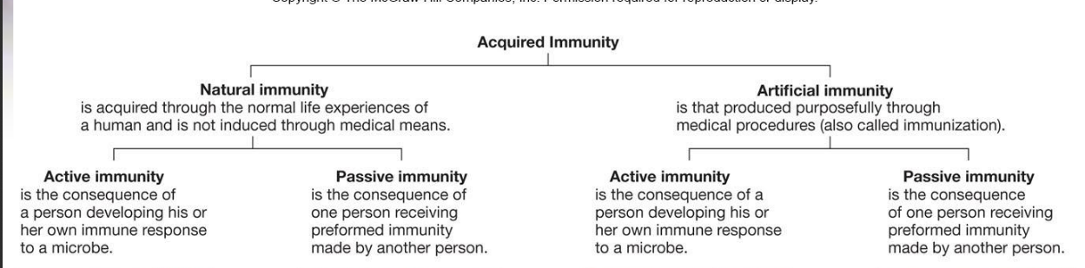

**Antigen:**

In immunology, an antigen is a molecule capable of inducing an immune response (to produce an antibody) in the host organism. Antigens can be classified according to their sources. Some of them are:

* **Exogenous antigens**: Exogenous antigens are antigens that have entered the body from the outside, for example by [inhalation](https://en.wikipedia.org/wiki/Inhalation), [ingestion](https://en.wikipedia.org/wiki/Ingestion) or [injection](https://en.wikipedia.org/wiki/Injection_(medicine)).
* **Endogenous antigens:** Endogenous antigens are generated within normal cells as a result of normal cell [metabolism](https://en.wikipedia.org/wiki/Metabolism), or because of viral or intracellular bacterial [infection](https://en.wikipedia.org/wiki/Infection).
* **Autoantigens:** An [autoantigen](https://en.wikipedia.org/wiki/Autoantigen) is usually a normal protein or protein complex (and sometimes DNA or RNA) that is recognized by the immune system of patients suffering from a specific [autoimmune disease](https://en.wikipedia.org/wiki/Autoimmune_disease). Under normal conditions, these antigens should not be the target of the immune system, but in autoimmune diseases, their associated T cells are not deleted and instead attack.

**Antibody:**

**Antibodies, also referred to as immunoglobulins, are glycoproteins naturally produced in response to invading foreign particles (antigens) such as microorganisms and viruses. As such, they play a critical role in the immune system’s defense against infection and disease.**

There are five immunoglobulin classes (isotypes) of antibody molecules found in serum: IgG, IgM, IgA, IgE and IgD.

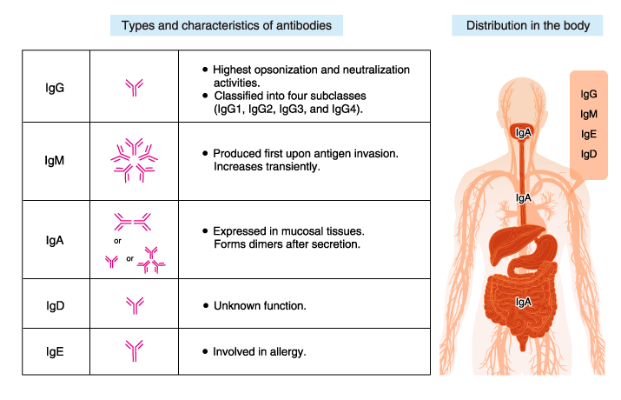

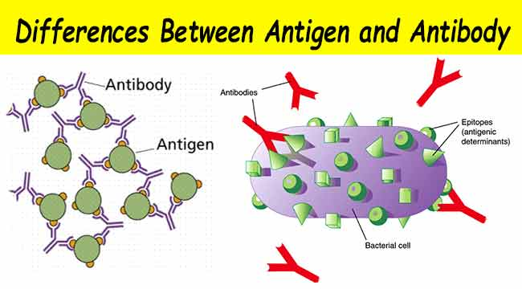

|  |  |  |
| --- | --- | --- |
| **Sl.N** | **Antigen** | **Antibody** |
| **1** | Generally proteins but can be lipids, carbohydrates or nucleic acids. | Antibodies are proteins. |
| **2** | Triggers the formation of antibodies. | Variable sites has the antigen binding domain. |
| **3** | There are three basic kinds of antigens. (Exogenous, Endogenous and Autoantigens) | There are five basic kinds of antibodies. (Immunoglobulins M, G, E, D and A) |
| **4** | The region of the antigen that interacts with the antibodies is called epitopes. | The variable region of the antibody that specially binds to an epitope is called paratope. |
| **5** | Cause disease or allergic reactions. | Protects the body by immobilization or lysis of antigenic material. |