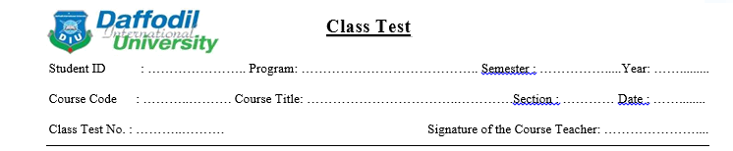

***Marks: 10***

***Time: 20 mins***

1. **Define Pseudo alkaloids with suitable example. 1**
2. **Mention only the examples of the following pharmacological activities.(0.5X6=3)**

**Analgesic and narcotic …….**

**Myotic…….**

**Antineoplastic…..**

**Emetic…..**

**Oxitocic…..**

**Skeletal muscle relaxant……**

1. **Classify alkaloid based on the structure or nucleus. Draw the basic structures of each group. 5**
2. **Draw the structure of hyoscine and coniine. 1**