**Course Code: CSE312**

**Course Title: Database Management System Lab**

**Project Name: Bus Management System**

**Course Teacher: Mr. Saif Mahmud Parvez**

**Group Member:**

**Name: Jacky Mong Marma ID: 182-15-2132**

**Name: Md. Mobarok Hossen ID: 182-15-2187**

**Name: Md. Ashraful Alam Akif ID: 182-15-2225**

Entities in Bus Management System:

* Bus_Table
* Employee_Table
* Passenger_Table
* Station_Table
* Route_Table
* Ticket_Table

Attributes in Bus Management Project

* Bus_Table:

BusID, BusName, BusNumber, Busmodel, BSeats, BType

* Employee_Table:

EmployeeID, Ename, BusID

* Passenger_Table:

Pname, PTicketID, PGender, PMobileNumber

* Station_Table:

SID, SName

* Route_table:

RID, RstationCode, RdepartTime, ArriveTime

* Ticket_table:

TID, TBusnumber, Source, Destination, Tcost

Description: We will design database for bus management system. Here our entities are Bus table, Employee table, Station table, Ticket table, Route table and Passenger table. Every table have many attributes. In the below we also design ER diagram And Schema diagram. From the Schema diagram we will develop SQL. From the SQL we get some result and we also find the many query from our SQL. I think this project is useful for mini bus company and also useful for our University.

**ER-Diagram**

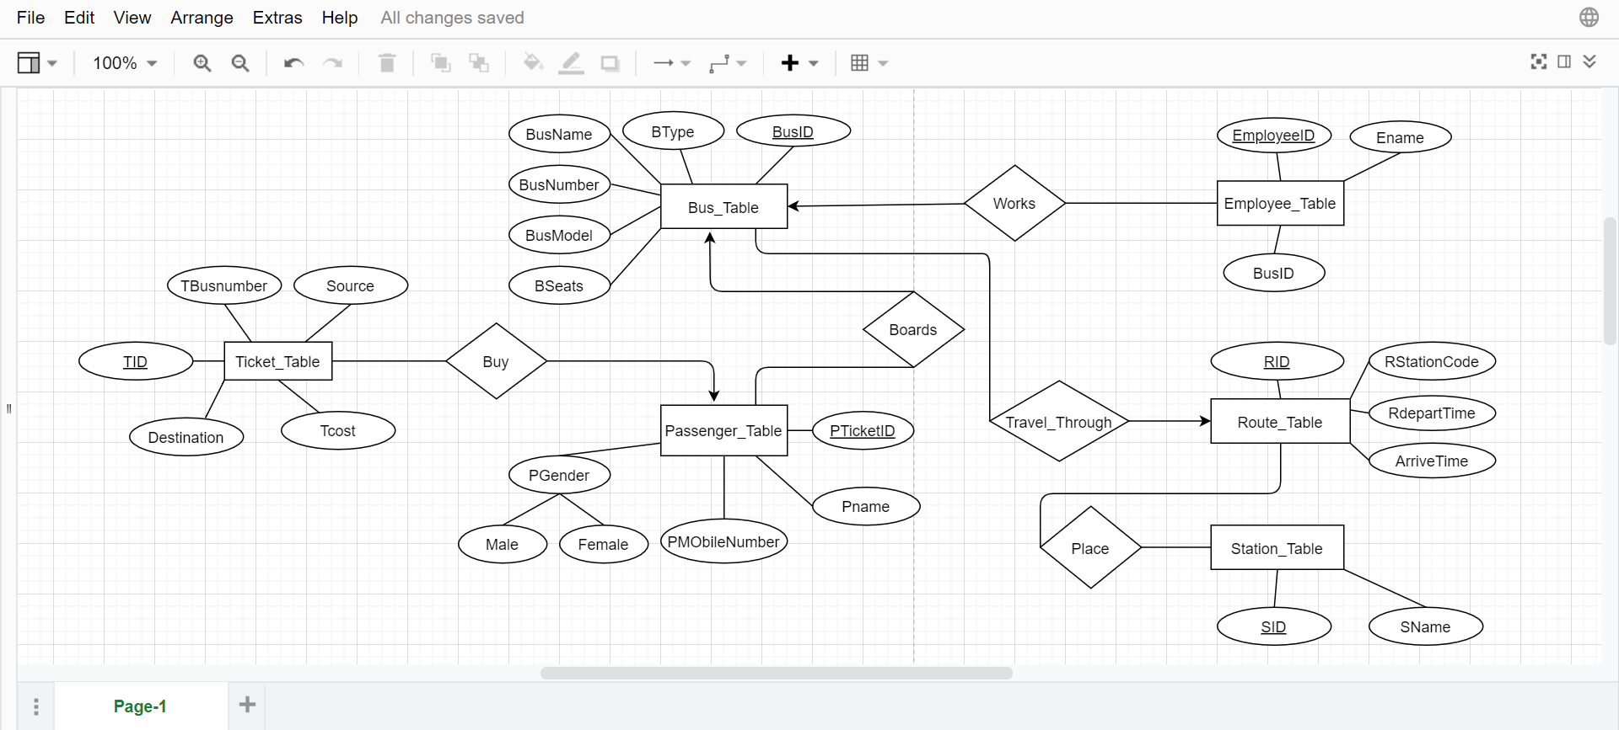

**Schema Diagram**

