**ID: 171-15-1367**

**What is computer graphics?**

**Answer:** Computer graphics is an art of drawing pictures on computer screens with the help of programming. It involves computations, creation, and manipulation of data.

**Why computer graphics used?**

**Answer:** Suppose a shoe manufacturing company want to show the sale of shoes for five years. For this vast amount of information is to store. So a lot of time and memory will be needed. This method will be tough to understand by a common man. In this situation graphics is a better alternative. Graphics tools are charts and graphs. Using graphs, data can be represented in pictorial form. A picture can be understood easily just with a single look.

Interactive computer graphics work using the concept of two-way communication between computer users. The computer will receive signals from the input device, and the picture is modified accordingly. Picture will be changed quickly when we apply command.

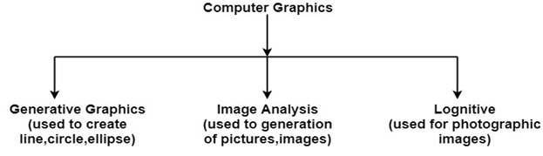

**How computer graphics used?**

**Answer:**

1. **Art** − Computers provide a new medium for artists.
2. **Business presentation graphics** − "A picture is worth a thousand words".
3. **Cartography** − Drawing maps.
4. **Weather Maps** − Real-time mapping, symbolic representations.
5. **Satellite Imaging** − Geodesic images.
6. **Photo Enhancement** − Sharpening blurred photos.
7. **Medical imaging** − MRIs, CAT scans, etc. - Non-invasive internal examination.
8. **Engineering drawings** − mechanical, electrical, civil, etc. - Replacing the blueprints of the past.
9. **Typography** − The use of character images in publishing - replacing the hard type of the past.
10. **Architecture** − Construction plans, exterior sketches - replacing the blueprints and hand drawings of the past.
11. **Training** − Flight simulators, computer aided instruction, etc.
12. **Entertainment** − Movies and games.
13. **Simulation and modeling** − Replacing physical modeling and enactments.

**Uses of Graphics Display Devices?**

**Answer:**

1. Random Scan and Raster Scan
2. Plasma Display
3. Refresh Cathode Ray Tube
4. Color CRT Monitors
5. Direct View Storage Tubes(DVST)
6. Flat Panel Display
7. 3D Display
8. Liquid Crystal Display(LCD)
9. Light Emitting Diode(LED)
10. Lookup Table