Exception Handling in Java

The Exception Handling in Java is one of the powerful mechanism to handle the runtime errors so that normal flow of the application can be maintained. Exception Handling is a mechanism to handle runtime errors such as ClassNotFoundException, IOException, SQLException, , etc.

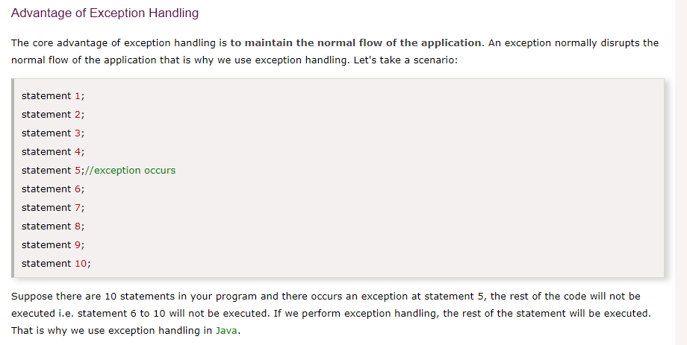

Hierarchy of Java Exception classes

The java.lang.Throwable class is the root class of Java Exception hierarchy which is inherited by two subclasses: Exception and Error. A hierarchy of Java Exception classes are given below:

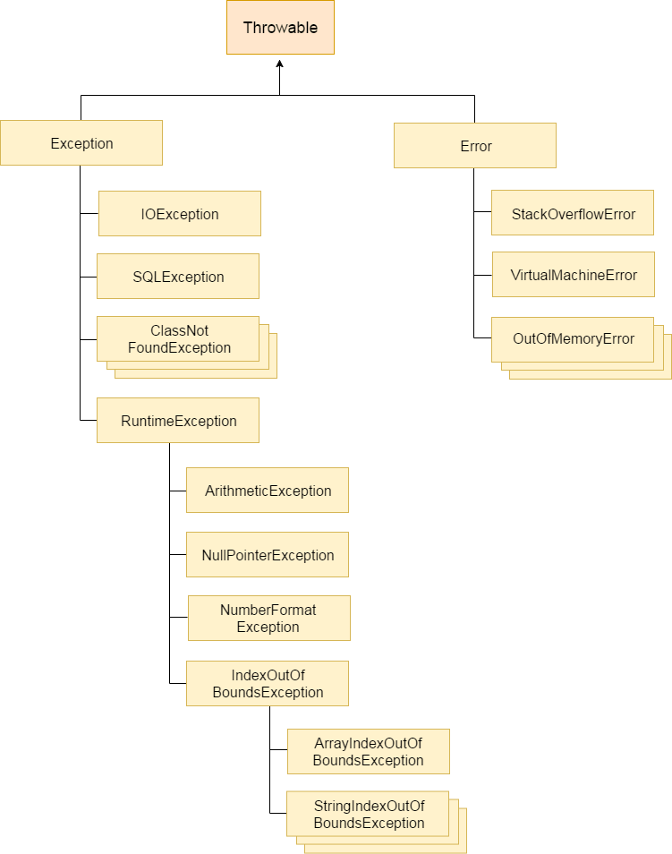

Types of Java Exceptions

There are mainly two types of exceptions: checked and unchecked. Here, an error is considered as the unchecked exception. According to Oracle, there are three types of exceptions:

Checked Exception

Unchecked Exception

Error

Difference between Checked and Unchecked Exceptions

1) Checked Exception

Checked exceptions − A checked exception is an exception that is checked (notified) by the compiler at compilation-time, these are also called as compile time exceptions. These exceptions cannot simply be ignored, the programmer should take care of (handle) these exceptions.

For example, if you use FileReader class in your program to read data from a file, if the file specified in its constructor doesn't exist, then a FileNotFoundException occurs, and the compiler prompts the programmer to handle the exception

The classes which directly inherit Throwable class except RuntimeException and Error are known as checked exceptions e.g. IOException, SQLException etc. Checked exceptions are checked at compile-time.

2) Unchecked Exception

The classes which inherit RuntimeException are known as unchecked exceptions e.g. ArithmeticException, NullPointerException, ArrayIndexOutOfBoundsException etc. Unchecked exceptions are not checked at compile-time, but they are checked at runtime.

Unchecked exceptions − An unchecked exception is an exception that occurs at the time of execution. These are also called as Runtime Exceptions. These include programming bugs, such as logic errors or improper use of an API. Runtime exceptions are ignored at the time of compilation.

For example, if you have declared an array of size 5 in your program, and trying to call the 6th element of the array then an ArrayIndexOutOfBoundsExceptionexception occurs.

3) Error

Errors − These are not exceptions at all, but problems that arise beyond the control of the user or the programmer. Errors are typically ignored in your code because you can rarely do anything about an error. For example, if a stack overflow occurs, an error will arise. They are also ignored at the time of compilation.

Error is irrecoverable e.g. OutOfMemoryError, VirtualMachineError, AssertionError etc.

Java Exception Keywords

There are 5 keywords which are used in handling exceptions in Java.

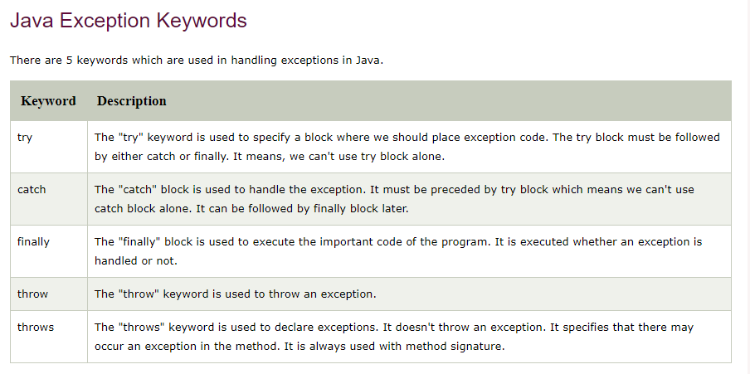

Java Exception Handling Example

Let's see an example of Java Exception Handling where we using a try-catch statement to handle the exception.

public class JavaExceptionExample{

public static void main(String args[]){

try{

//code that may raise exception

int data=100/0;

}catch(ArithmeticException e){System.out.println(e);}

//rest code of the program

System.out.println("rest of the code...");

}

Output:

Exception in thread main java.lang.ArithmeticException:/ by zero

rest of the code...

}

Common Scenarios of Java Exceptions

There are given some scenarios where unchecked exceptions may occur. They are as follows:

1) A scenario where ArithmeticException occurs

If we divide any number by zero, there occurs an ArithmeticException.

int a=50/0;//ArithmeticException

2) A scenario where NullPointerException occurs

If we have a null value in any variable, performing any operation on the variable throws a NullPointerException.

String s=null;

System.out.println(s.length());//NullPointerException

3) A scenario where NumberFormatException occurs

The wrong formatting of any value may occur NumberFormatException. Suppose I have a string variable that has characters, converting this variable into digit will occur NumberFormatException.

String s="abc";

int i=Integer.parseInt(s);//NumberFormatException

4) A scenario where ArrayIndexOutOfBoundsException occurs

If you are inserting any value in the wrong index, it would result in ArrayIndexOutOfBoundsException as shown below:

int a[]=new int[5];

a[10]=50; //ArrayIndexOutOfBoundsException