Reactive Dye & It’s Application

Reactive Dye:

The dye which contains reactive group and this reactive group makes covalent bond with the fibre and acts as an integral part of the fibre is called reactive dye.

Reactive dyes are so called because this is the only type of dye which has reactive group and that reactive group reacts chemically with fibre polymer molecule and forms covalent bond. This covalent bond is formed between the reactive group and terminal amino (-NH2) group of polyamide and wool fibre or between reactive group and terminal hydroxyl (-OH ) group of cellulosic fibre polymer. The strength of this covalent bond is more than the ionic bond, hydrogen bond and Vander Waals force of attraction. Thus, the reactive group becomes an integral part of the fibre. For these reasons the dyes are so called.

Properties of Reactive dyes:

The properties of reactive dyes are as follows-

- Reactive dyes are anionic dyes which can be used for dyeing of cellulosic (cotton, rayon, flax), protein (wool, silk) and polyamide (nylon) fibres.
- Reactive dyes are soluble in water.
- Reactive dyes are comparatively cheap.
- Fixation of reactive dyes occurs in alkaline condition.
- During dyeing the reactive group of this dye forms strong covalent bond with the fibre polymer and becomes an integral part of fibre.
- These dyes have very good light fastness with rating about 6.
- Textile materials dyed with reactive dyes have very good wash fastness with rating about 4–5.
- Reactive dyes give brighter shades and have moderate rubbing fastness.
- Reactive dyes have good perspiration fastness with rating 4–5.
- Dyeing method of reactive dye is easy and it requires less time and low temperature for dyeing.

Reasons for popularity of reactive dyes:

Reactive dyes are popular for the following reasons-

- The reactive dyes show good washing fastness property
- The dyes have good light fastness property
- Dye are cheap in price
- These dyes gives brighter shades
- The dyeing method is very simple
- These dyes have good reproducibility
- Less temperature dyeing

General structure of Reactive dye:

The general structure of reactive dye is W-D–B–R–X.

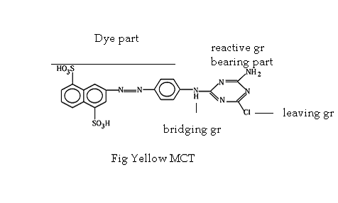
Here, W= Water solublising group
D = Dye part or Chromogen (colour producing part)
B = Bridging part
R = Reactive group bearing part.
X = Reactive group.

- Water solubilizing groups may be -NH₂, -NH-CH₃, -OH, - NO₃, -COOH, -SO₃Na.
- Bridging groups may be –NH-, -NH-CO-, -NH-CO-NH- .
- Reactive group bearing part may heterocyclic ring.
- Reactive group may be vinyl sulphone, monochlorotriazine, dichlorotriazyne, triazine etc.
Classification of reactive dyes:

A. On the basis of reactive group present in dye structure:

1) Halogen (commonly chlorine) derivatives of Nitrogen containing heterocyclic.

i) Triazine dyes.
ii) Pyrimidine dyes.
iii) Quinoxaline dyes.

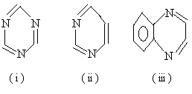

2) Activated vinyl compounds.

- Vinyl sulphone : (D – SO₂ – CH₂ – CH₂ –)
- Vinyl acrylamide : (D – NH – COO – CH₂ – CH₂ –)
- Vinyl sulphonamide : (D – SO₂ – NH – CH₂ – CH₂ –)

B. On the basis of Reactivity:
On the basis of reactivity reactive dyes are of three types

i) Lower reactive dyes: Reactivity of these dyes is very low. So, highly alkaline condition is required for the fixation of these dyes with the substrate. Here, pH is maintained between 12-12.5 by using NaOH in dye bath.

ii) Medium reactive dye: Reactivity of these dyes is better than the previous class. Here, pH is maintained between 11-12 by using Na₂CO₃ in the dye bath.

iii) Higher reactive dye: These dyes are highly reactive. So, fixation of these dyes are easy and lower alkaline medium is kept in where pH is maintained between 9-11 by using NaHCO₃ in the dye bath.

C. On the basis of dyeing temperature and method:

i) Cold brand: This type of dye contains reactive groups of high reactivity. So dyeing can be done in lower temperature (32⁰–60⁰C).

ii) Medium brand: This type of dye contains reactive groups of moderate reactivity. So, dyeing is done in higher temperature (60⁰–71⁰C) than that of cold brand dyes.

iii) Hot brand: This type of dye contains reactive groups of least reactivity. So, high temperature (72⁰–93⁰C) is required for dyeing.

Mechanism of dyeing of textile fibres with Reactive dyes:

When fibre is immersed into dye liquor, an electrolyte is added to assist the exhaustion of dye. Usually, NaCl or Na₂SO₄ is used as an electrolyte. This electrolyte neutralize the negative charge formed on fibre surface and puts extra energy to increase dye absorption. After the exhaustion process fixation of dye occurs due to formation of covalent bond between the reactive group and terminal amino (-NH2) group of polyamide and wool fibre or between reactive group and terminal hydroxyl (-OH) group of cellulosic fibre polymer. This is an important phase which is controlled by maintaining proper pH by adding alkali.

i) D – SO₂ – CH₂ – CH₂ – OSO₃Na + H₂N –Wool → D–SO₂–CH₂–CH₂–NH–Wool + NaHSO₃

ii) D – SO₂ – CH₂ – CH₂ – OSO₃Na + H₂N –Nylon → D–SO₂–CH₂–CH₂–NH–Nylon + NaHSO₃

iii) D – SO₂ – CH₂ – CH₂ – OSO₃Na + HO – Cell → D–SO₂–CH₂–CH₂–O–Cell + NaHSO3

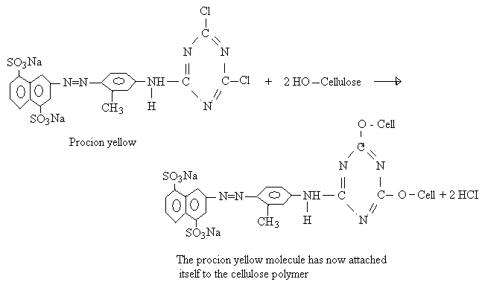

Assistants used for dyeing with reactive dye

1) Salt:
- Salt are used to increase affinity of the dye to fibre .
- To decrease the hydrolyzed of the dye.
- To add extra energy to push the dye in the fibre that increase the absorption
- To neutralize the electro negativity of fibre.

2) Alkali:
- Alkali is used to create optimum pH in the dye bath
- It is used as a fixing agent.
- Without it no dyeing will take place.
- The strength of alkali used depends on the reactivity of the dye.
- Strong alkali (pH 12-12.5) for lower reactive dye.
- Medium alkali (pH 11-12) for medium reactivity.
- Weak alkali (pH 9-11) for strong reactivity.

Hydrolysis of Reactive Dyes:

Under alkaline condition reactive group in reactive dye is supposed to be attached with the hydroxyl group (-OH) of cellulose through the reaction. But, the reactive group of such dyes may react with water as the increasing temperature which is simply referred as hydrolysis. Thus, hydrolysis increases the loss of dyes and about 35-40% dyes may go for wastage in this case.

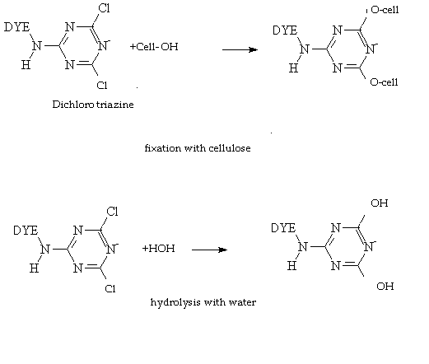
Factors affecting dye hydrolysis:

- Liquor ratio: longer liquor ratio increases hydrolysis and vice versa.
- Salt concentration: Higher salt concentration decrease hydrolysis up to a limit and vice-
versa.
- pH: Higher pH increases dye hydrolysis.
- Temperature: Higher temperature increases the hydrolysis of dyes.
- Dye reactivity: It increase both hydrolysis and fixation rate.
- Time: Higher dyeing time increases hydrolysis.
- Type and no of reactive dye: vinyl sulphone is more prone to hydrolysis than triazinyle
group.

Prevention of dye hydrolysis:

- As hydrolysis is increased with increasing the temperature during dye dissolving, its application temperature should not be above 40^{O}C.
- Relatively large amount of electrolytes are required for the exhaustion, otherwise dye hydrolysis will occur greatly in dye bath.
- Dye and alkali solution should be prepared separately and mixed just before using.
- Dye and alkali solution should not keep for long time after mixing.

Stripping of Reactive Dyes:

Stripping becomes necessary when there is uneven dyeing. The reactive dye cannot be satisfactory stripped from fibre due to covalent bond between dye molecules and fibre molecules. Stripping includes methods which remove azo (– N= N–) group from the dye.

For complete stripping the goods are first treated with sodium hydrosulphite (Na₂S₂O₄) at boil and then washed off and bleached with 1% sodium hypochlorite (NaOCl) at room temperature. This is carried out for 30 minutes. The recipe is at below:

Na- hypochlorite : 1% at room temperature.
Na- hydrosulphite : at boil
Time : 30 minutes

