Chapter 2
Basic Elements of Supply and Demand

Markets are like the weather—sometimes stormy, sometimes calm, but always changing. Yet a careful study of markets will reveal certain forces underlying the apparently random movements. To forecast prices and outputs in individual markets, you must first master the analysis of supply and demand. Economics has a very powerful tool for explaining such changes in the economic environment. It is called the theory of supply and demand. This theory shows how consumer preferences determine consumer demand for commodities, while business costs are the foundation of the supply of commodities. Using these basic tools, we will see how the market price is determined where these two curves intersect—where the forces of demand and supply are just in balance. It is the movement of prices—the price mechanism— which brings supply and demand into balance or equilibrium.

- THE DEMAND SCHEDULE

If you demand something, then you 1. Want it, 2. Can afford it, and 3. Plan to buy it. Scarcity guarantees that many—perhaps most—of our wants will never be satisfied. Demand reflects a decision about which wants to satisfy.
The quantity demanded of a good or service is the amount that consumers plan to buy during a given time period at a particular price. The quantity demanded is not necessarily the same as the quantity actually bought. Sometimes the quantity demanded exceeds the amount of goods available, so the quantity bought is less than the quantity demanded. The quantity demanded is measured as an amount per unit of time. For example, suppose that you buy one cup of coffee a day. The quantity of coffee that you demand can be expressed as 1 cup per day, 7 cups per week, or 365 cups per year.
There exists a definite relationship between the market price of a good and the quantity demanded of that good, other things held constant. This relationship between price and quantity bought is called the demand schedule, or the demand curve.

Let’s look at a simple example. Table 3-1 presents a hypothetical demand schedule for cornflakes. At each price, we can determine the quantity of cornflakes that consumers purchase. For example, at $5 per box, consumers will buy 9 million boxes per year.
At a lower price, more cornflakes are bought. Thus, at a price of $4, the quantity bought is 10 million boxes. At yet a lower price ( P ) equal to $3, the quantity demanded ( Q ) is still greater, at 12 million. And so forth. We can determine the quantity demanded at each listed price in Table3-1

THE DEMAND CURVE

The graphical representation of the demand schedule is the demand curve. We show the demand curve in Figure 3-2, which graphs the quantity of cornflakes demanded on the horizontal axis and the price of cornflakes on the vertical axis. Note that quantity and price are inversely related; that is, Q goes up when P goes down. The curve slopes downward, going from northwest to southeast. This important property is called the law of downward-sloping demand. It is based on common sense as well as economic theory and has been empirically tested and verified for practically all commodities—cornflakes, gasoline college education, and illegal drugs being a few examples.
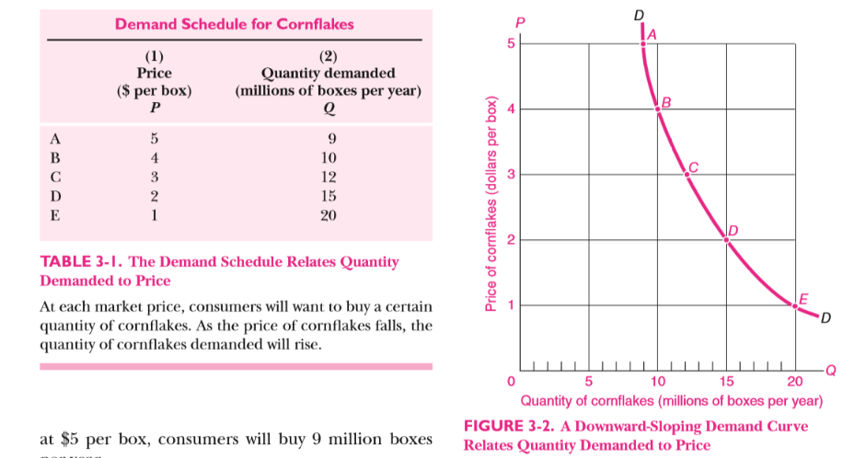

In the demand curve for cornflakes, price (P) is measured on the vertical axis while quantity demanded (Q) is measured on the horizontal axis. Each pair of (P, Q) numbers from Table 3-1 is plotted as a point, and then a smooth curve is passed through the points to give us a demand curve, DD. The negative slope of the demand curve illustrates the law of downward-sloping demand.

Law of downward-sloping demand

When the price of a commodity is raised (and other things are held constant), buyers tend to buy less of the commodity. Similarly, when the price is lowered, other things being constant, quantity demanded increases. Quantity demanded tends to fall as price rises for two reasons:

- First is the substitution effect, which occurs because a good becomes relatively more expensive when its price rises. When the price of good A rises, I will generally substitute goods B, C, D, . . .for it. For example, as the price of beef rises, I eat more chicken.

- A higher price generally also reduces quantity demanded through the income effect. This comes into play because when a price goes up, I find myself somewhat poorer than I was before. If gasoline prices double, I have in effect less real income, so I will naturally curb my consumption of gasoline and other goods.

Market Demand
Market demand represents the sum total of all individual demands. The market demand is what is observable in the real world.
The market demand curve is found by adding together the quantities demanded by all individuals at each price. Does the market demand curve obey the law of downward-sloping demand?
It certainly does. If prices drop, for example, the lower prices attract new customers through the substitution effect. In addition, a price reduction will induce extra purchases of goods by existing consumers through both the income and the substitution effects. Conversely, a rise in the price of a good will cause some of us to buy less.

Forces behind the Demand Curve
A whole array of factors influences how much will be demanded at a given price:

● The average income of consumers is a key determinant of demand. As people’s incomes rise, individuals tend to buy more of almost everything, even if prices don’t change. Automobile purchases tend to rise sharply with higher levels of income.
● The size of the market —measured, say, by the population—clearly affects the market demand curve. California’s 40 million people tend to buy 40 times more apples and cars than do Rhode Island’s 1 million people.
● The prices and availability of related goods influence the demand for a commodity. A particularly important connection exists among substitute goods—ones that tend to perform the same function, such as cornflakes and oatmeal, pens and pencils, small cars and large cars, or oil and natural gas. Demand for good A tends to be low if the price of substitute product B is low. (For example, as computer prices fell, what do you think happened to the demand for typewriters?)
● In addition to these objective elements, there is a set of subjective elements called tastes or preferences. Tastes represent a variety of cultural and historical influences. They may reflect genuine psychological or physiological needs (for liquids, love, or excitement). And they may include artificially contrived cravings (for cigarettes, drugs, or fancy sports cars). They may also contain a large element of tradition or religion (eating beef is popular in America but taboo in India, while curried jellyfish is a delicacy in Japan but would make many Americans gag).
● Finally, special influences will affect the demand for particular goods. The demand for umbrellas is high in rainy Seattle but low in sunny Phoenix; the demand for air conditioners will rise in hot weather; the demand for automobiles will be low in New York, where public transportation is plentiful and parking is a nightmare.

The determinants of demand are summarized in T able 3-2 , which uses automobiles as an example.
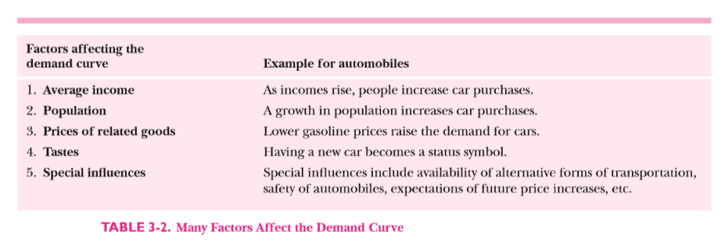
Shifts in Demand

Why does the demand curve shift?
Because influences other than the good’s price change. Let’s work through an example of how a change in a non price variable shifts the demand curve. We know that the average income of Americans rose sharply during the long economic boom of the 1990s. Because there is a powerful income effect on the demand for automobiles, this means that the quantity of automobiles demanded at each price will rise. For example, if average incomes rose by 10 percent, the quantity demanded at a price of $10,000 might rise from 10 million to 12 million units. This would be a shift in the demand curve because the increase in quantity demanded reflects factors other than the good’s own price. The net effect of the changes in underlying influences is what we call an increase in demand. An increase in the demand for automobiles is illustrated in Figure 3-4 as a rightward shift in the demand curve. Note that the shift means that more cars will be bought at every price.
When there are changes in factors other than a good’s own price which affect the quantity purchased, we call these changes shifts in demand. Demand increases (or decreases) when the quantity demanded at each price increases (or decreases).
You can test yourself by answering the following questions: Will a warm winter shift the demand curve for heating oil leftward or rightward? Why? What will happen to the demand for baseball tickets if young people lose interest in baseball and watch basketball instead?

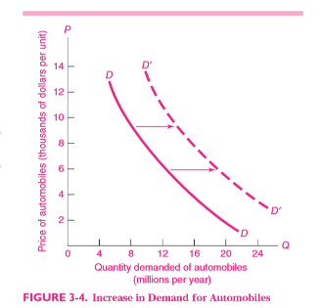

As elements underlying demand change, the demand for automobiles is affected. Here we see the effect of rising average income, increased population, and lower gasoline prices on the demand for automobiles. We call this shift of the demand curve an increase in demand.

- THE SUPPLY SCHEDULE

The supply side of a market typically involves the terms on which businesses produce and sell their products. The supply of tomatoes tells us the quantity of tomatoes that will be sold at each tomato price. More precisely, the supply schedule relates the quantity supplied of a good to its market price, other things constant. In considering supply, the other things that are held constant include input prices, prices of related goods, and government policies. The supply schedule (or supply curve) for a commodity shows the relationship between its market price and the amount of that commodity that producers are willing to produce and sell, other things held constant.

THE SUPPLY CURVE
Table 3-3 shows a hypothetical supply schedule for cornflakes, and Figure 3-5 plots the data from the table in the form of a supply curve. These data show that at a cornflakes price of $1 per box, no cornflakes at all will be produced. At such a low price, breakfast cereal manufacturers might want to devote their factories to producing other types of cereal, like bran flakes, that earn them more profit than cornflakes. As the price of cornflakes increases, ever more cornflakes will be produced. At ever-higher cornflakes prices, cereal makers will find it profitable to add more workers and to buy more automated cornflakes-stuffing machines and even more cornflakes factories. All these will increase the output of cornflakes at the higher market prices.
Figure 3-5 shows the typical case of an upward- sloping supply curve for an individual commodity. One important reason for the upward slope is “the law of diminishing returns.”

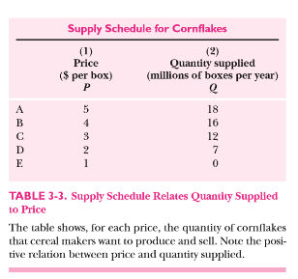
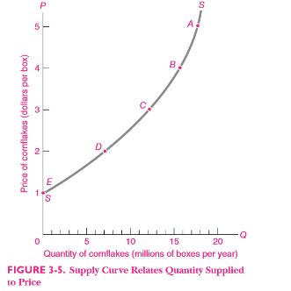
The supply curve plots the price and quantity pairs from Table 3-3. A smooth curve is passed through these points to give the upward-sloping supply curve, SS.

Forces behind the Supply Curve

In examining the forces determining the supply curve, the fundamental point to grasp is that producers supply commodities for profit and not for fun or charity. One major element underlying the supply curve is the cost of production.
When production costs for a good are low relative to the market price, it is profitable for producers to supply a great deal. When production costs are high relative to price, firms produce little, switch to the production of other products, or may simply go out of business. Production costs are primarily determined by the prices of inputs and technological advances.
The prices of inputs such as labor, energy, or machinery obviously have a very important influence on the cost of producing a given level of output. For example, when oil prices rose sharply in 2007, the increase raised the price of energy for manufacturers, increased their production costs, and lowered their supply. By contrast, as computer prices fell over the last three decades, businesses increasingly substituted computerized processes for other inputs, as for example in payroll or accounting operations; this increased supply.
An equally important determinant of production costs is technological advances, which consist of changes that lower the quantity of inputs needed to produce the same quantity of output. Such advances include everything from scientific breakthroughs to better application of existing technology or simply reorganization of the flow of work. For example, manufacturers have become much more efficient in recent years. It takes far fewer hours of labor to produce an automobile today than it did just 10 years ago. This advance enables car makers to produce more automobiles at the same cost. To give another example, if Internet commerce allows firms to compare more easily the prices of necessary inputs, that will lower the cost of production.
But production costs are not the only ingredient that goes into the supply curve. Supply is also influenced by the prices of related goods, particularly goods that are alternative outputs of the production process. If the price of one production substitute rises, the supply of another substitute will decrease. An interesting example occurred in U.S. farming. The government has raised the subsidy on automotive ethanol to reduce imports of foreign oil. Ethanol is today primarily made from corn. The increased demand for corn (a shift in the demand curve for corn) increased the corn price. As a result, farmers planted corn instead of soybeans. The net result was that the supply of soybeans declined and soybean prices rose. All of this occurred because of a subsidy to reduce oil imports.
Government policy also has an important impact on the supply curve. We just discussed the case of ethanol subsidies and corn production. Environmental and health considerations determine what technologies can be used, while taxes and minimum-wage laws can significantly affect input prices. Government trade policies have a major impact upon supply. For instance, when a free-trade agreement opens up the U.S. market to Mexican footwear, the total supply of footwear in the United States increases.
Finally, special influences affect the supply curve. The weather exerts an important influence on farming and on the ski industry. The computer industry has been marked by a keen spirit of innovation, which has led to a continuous flow of new products. Market structure will affect supply, and expectations about future prices often have an important impact upon supply decisions.

Table 3-4 highlights the important determinants of supply, using automobiles as an example.

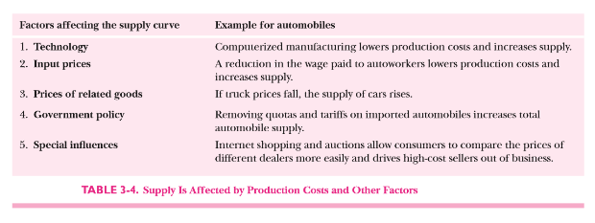

Shifts in Supply

When changes in factors other than a good’s own price affect the quantity supplied, we call these changes shifts in supply. Supply increases (or decreases) when the amount supplied increases (or decreases) at each market price.
When automobile prices change, producers change their production and quantity supplied, but the supply and the supply curve do not shift. By contrast, when other influences affecting supply change, supply changes and the supply curve shifts.
We can illustrate a shift in supply for the automobile market. Supply would increase if the introduction of cost-saving computerized design and manufacturing reduced the labor required to produce cars, if autoworkers took a pay cut, if there were lower production costs in Japan, or if the government repealed environmental regulations on the industry. Any of these elements would increase the supply of automobiles in the United States at each price.
Figure 3-6 illustrates an increase in the supply of automobiles.
As production costs fall, the supply of automobiles increases. At each price, producers will supply more automobiles, and the supply curve therefore shifts to the right. (What would happen to the supply curve if Congress were to put a restrictive quota on automobile imports?)
To test your understanding of supply shifts, think about the following: What would happen to the world supply curve for oil if a revolution in Saudi Arabia led to declining oil production? What happens to the supply curve for computers if Intel introduces a new computer chip that dramatically increases computing speeds?

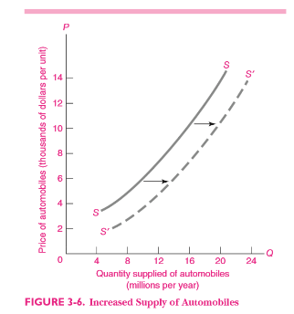

- EQUILIBRIUM OF SUPPLY AND DEMAND

The market equilibrium comes at that price and quantity where the forces of supply and demand are in balance. At the equilibrium price, the amount that buyers want to buy is just equal to the amount that sellers want to sell. The reason we call this an equilibrium is that, when the forces of supply and demand are in balance, there is no reason for price to rise or fall, as long as other things remain unchanged.

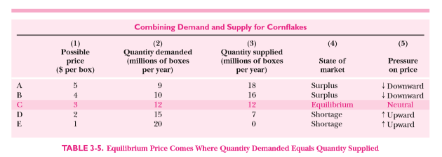
The table shows the quantities supplied and demanded at different prices. Only at the equilibrium price of $3 per box does amount supplied equal amount demanded. At too low a price there is a shortage and price tends to rise. Too high a price produces a surplus, which will depress the price.
Let us work through the cornflakes example in Table 3-5 to see how supply and demand determine a market equilibrium; the numbers in this table come from Tables 3-1 and 3-3 . To find the market price and quantity, we find a price at which the amounts desired to be bought and sold just match. If we try a price of $5 per box, will it prevail for long? Clearly not. As row A in Table 3-5 shows, at $5 producers would like to sell 18 million boxes per year while demanders want to buy only 9. The amount supplied at $5 exceeds the amount demanded, and stocks of cornflakes pile up in supermarkets. Because too few consumers are chasing too many cornflakes, the price of cornflakes will tend to fall, as shown in column (5) of Table 3-5.
Say we try $2. Does that price clear the market? A quick look at row D shows that at $2 consumption exceeds production. Cornflakes begin to disappear from the stores at that price. As people scramble around to find their desired cornflakes, they will tend to bid up the price of cornflakes, as shown in column (5) of Table 3-5.
We could try other prices, but we can easily see that the equilibrium price is $3, or row C in Table 3-5. At $3, consumers’ desired demand exactly equals producers’ desired production, each of which is 12 units. Only at $3 will consumers and suppliers both be making consistent decisions.
A market equilibrium comes at the price at which quantity demanded equals quantity supplied. At that equilibrium, there is no tendency for the price to rise or fall. The equilibrium price is also called the market-clearing price. This denotes that all supply and demand orders are filled, the books are “cleared” of orders, and demanders and suppliers are satisfied.

EQUILIBRIUM WITH SUPPLY AND DEMAND CURVES

We often show the market equilibrium through a supply-and-demand diagram like the one in Figure 3-7; this figure combines the supply curve from Figure 3-5 with the demand curve from Figure 3-2. Combining the two graphs is possible because they are drawn with exactly the same variables and units on each axis. We find the market equilibrium by looking for the price at which quantity demanded equals quantity supplied. The equilibrium price comes at the intersection of the supply and demand curves, at point C.

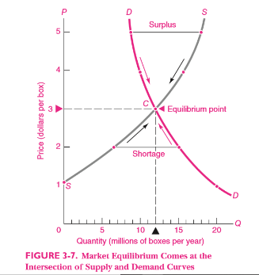

Start with the initial high price of $5 per box, shown at the top of the price axis in Figure 3-7. At that price, suppliers want to sell more than demanders want to buy. The result is a surplus, or excess of quantity supplied over quantity demanded, shown in the figure by the blue line labeled “Surplus.” The arrows along the curves show the direction that price tends to move when a market is in surplus.
At a low price of $2 per box, the market shows a shortage, or excess of quantity demanded over quantity supplied, here shown by the blue line labeled “Shortage.” Under conditions of shortage, the competition among buyers for limited goods causes the price to rise, as shown in the figure by the arrows pointing upward.
We now see that the balance or equilibrium of supply and demand comes at point C, where the supply and demand curves intersect. At point C, where the price is $3 per box and the quantity is 12 units, the quantities demanded and supplied are equal: there are no shortages or surpluses; there is no tendency for price to rise or fall. At point C and only at point C, the forces of supply and demand are in balance and the price has settled at a sustainable level.

The equilibrium price and quantity come where the amount willingly supplied equals the amount willingly demanded. In a competitive market, this equilibrium is found at the intersection of the supply and demand curves. There are no shortages or surpluses at the equilibrium price.

Effect of a Shift in Supply or Demand

Let’s change our example to the staff of life, bread. Suppose that a spell of bad weather raises the price of wheat, a key ingredient of bread. That shifts the supply curve for bread to the left. This is illustrated in Figure 3-8 (a), where the bread supply curve has shifted from SS to S’S’. In contrast, the demand curve has not shifted because people’s sandwich demand is unaffected by farming weather.
What happens in the bread market? The bad harvest causes profit-maximizing bakers to produce less bread at the old price, so quantity demanded exceeds quantity supplied. The price of bread therefore rises, encouraging production and thereby raising quantity supplied, while simultaneously discouraging consumption and lowering quantity demanded. The price continues to rise until, at the new equilibrium price, the amounts demanded and supplied are once again equal.
As Figure 3-8 (a) shows, the new equilibrium is found at E’, the intersection of the new supply curve S’S’ and the original demand curve. Thus a bad harvest (or any leftward shift of the supply curve) raises prices and, by the law of downward-sloping demand, lowers quantity demanded. Suppose that new baking technologies lower costs and therefore increase supply. That means the supply curve shifts down and to the right. Draw in a new S’’’ S’’’ curve, along with the new equilibrium E’”. Why is the equilibrium price lower? Why is the equilibrium quantity higher? We can also use our supply-and-demand apparatus to examine how changes in demand affect the market equilibrium. Suppose that there is a sharp increase in family incomes, so everyone wants to eat more bread.
This is represented in Figure 3-8 (b) as a “demand shift” in which, at every price, consumers demand a higher quantity of bread. The demand curve thus shifts rightward from DD to D’D’. The demand shift produces a shortage of bread at the old price. A scramble for bread ensues. Prices are bid upward until supply and demand come back into balance at a higher price. Graphically, the increase in demand has changed the market equilibrium from E to E” in Figure 3-8 (b).

For both examples of shifts—a shift in supply and a shift in demand—a variable underlying the demand or supply curve has changed. In the case of supply, there might have been a change in technology or input prices. For the demand shift, one of the influences affecting consumer demand—incomes, population, the prices of related goods, or tastes—changed and thereby shifted the demand schedule (see Table 3-6 ).
When the elements underlying demand or supply change, this leads to shifts in demand or supply and to changes in the market equilibrium of price and quantity.

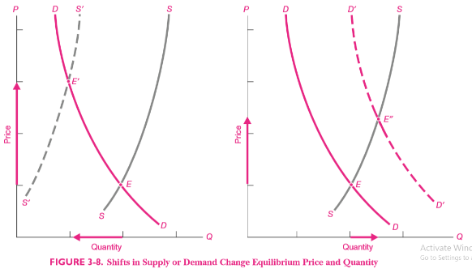

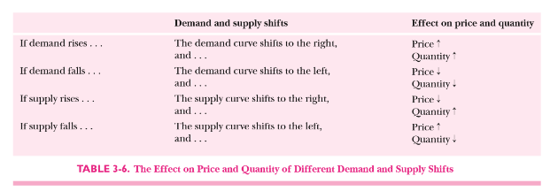

Interpreting Changes in Price and Quantity
An important issue that arises is how to interpret price and quantity changes. We sometimes hear, “Gasoline demand does not obey the law of downward-sloping demand. From 2003 to 2006 prices rose sharply [as shown in Figure 3 -1], yet U.S. gasoline consumption went up rather than down. What do you economists say about that!” We cannot provide a definitive explanation without a careful look at the forces affecting both supply and demand. But the most likely explanation for the paradox is that the rise in gasoline prices over this period was due to shifts in demand rather than movements along the demand curve. Sometimes, in simple situations, looking at price and quantity simultaneously gives you a clue about whether it is the supply curve or the demand curve that has shifted. For example, a rise in the price of bread accompanied by a decrease in quantity suggests that the supply curve has shifted to the left (a decrease in supply). A rise in price accompanied by an increase in quantity indicates that the demand curve for bread has probably shifted to the right (an increase in demand).

Figure 3-9 illustrates the point. In both panel ( a ) and panel ( b ), quantity goes up. But in ( a ) the price rises, and in ( b ) the price falls. Figure 3-9 ( a ) shows the case of an increase in demand, or a shift in the demand curve. As a result of the shift, the equilibrium quantity demanded increases from 10 to 15 units. The case of a movement along the demand curve is shown in Figure 3-9 ( b ). In this case, a supply shift changes the market equilibrium from point E to point E”. As a result, the quantity demanded changes from 10 to 15 units. But demand does not change in this second case; rather, quantity demanded increases as consumers move along their demand curve from E to E” in response to a price change.

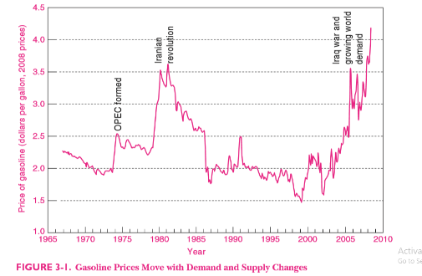
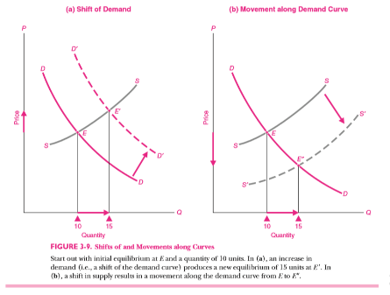

Supply, Demand, and Immigration

A fascinating and important example of supply and demand, full of complexities, is the role of immigration in determining wages. If you ask people, they are likely to tell you that immigration into California or Florida surely lowers the wages of people in those regions. It’s just supply and demand.

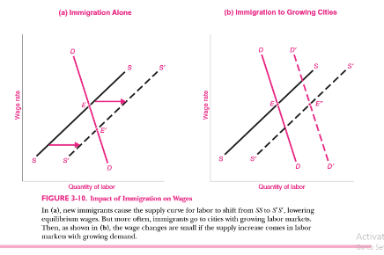

They might point to Figure 3-10 ( a ), which shows a supply-and- demand analysis of immigration. According to this analysis, immigration into a region shifts the supply curve for labor to the right and pushes down wages.
How can we explain the small impact of immigration on wages? Labor economists emphasize the high geographic mobility of the American population. This means that new immigrants will quickly spread around the entire country. Once they arrive, immigrants may move to cities where they can get jobs—workers tend to move to those cities where the demand for labor is already rising because of a strong local economy. This point is illustrated in Figure 3-10 ( b ), where a shift in labor supply to S’ S’ is associated with a higher demand curve, D’ D’. The new equilibrium wage at E” is the same as the original wage at E . Another factor is that native-born residents may move out when immigrants move in, so the total supply of labor is unchanged. This would leave the supply curve for labor in its original position and leave the wage unchanged. Immigration is a good example for demonstrating the power of the simple tools of supply and demand.

RATIONING BY PRICES

Let us now take stock of what the market mechanism accomplishes. By determining the equilibrium prices and quantities, the market allocates or rations out the scarce goods of the society among the possible uses. Who does the rationing? A planning board? Congress? The president? No. The marketplace, through the interaction of supply and demand, does the rationing. This is rationing by the purse.
What goods are produced? This is answered by the signals of market prices. High corn prices stimulate corn production, whereas falling computer prices stimulate a growing demand for computation. Those who have the most dollar votes have the greatest influence on what goods are produced.
For whom are goods produced? The power of the purse dictates the distribution of income and consumption. Those with higher incomes end up with larger houses, fancier cars, and longer vacations. When backed up by cash, the most urgently felt needs get fulfilled through the demand curve.
Even the how question is decided by supply and demand. When corn prices are high, farmers buy expensive tractors and more fertilizer and invest in irrigation systems. When oil prices are high, oil companies drill in deep offshore waters and employ novel seismic techniques to find oil.
With this introduction to supply and demand, we begin to see how desires for goods, as expressed through demands, interact with costs of goods, as reflected in supplies. Further study will deepen our understanding of these concepts and will show how these tools can be applied to other important areas. But even this first survey will serve as an indispensable tool for interpreting the economic world in which we live.

------------------------

